Erasmus+ Programme
Project title: "Ecological and environmental protection education in a European context!"
No. 2021-1-RO01-KA220-SCH-000035907



Ecological and environmental protection
education in a European context!

Good Practice Guide

COORDINATORS

- Claudia COZLOSCHE - Liceul Tehnologic Costesti, Romania
- Kornélia LOHYŇOVÁ - Hotelová Akadémia, Slovakia
- Georgia MOUSELIMI - 5th Gymnasio Kalamatas, Greece
- Gülden AKAR - Gölcük İhsaniye Anadolu Lisesi, Türkiye
- Veneta VELKOVA - 32 Secondary Language School „St. Kliment Ohridski”, Bulgaria

“The European Commission support for the production of this publication does not constitute an endorsement of the contents which reflects the views only of the authors, and the National Agency and Commission cannot be held responsible for any use which may be made of the information contained therein”.

Authors take responsibility for articles.

Introduction

GOOD PRACTICE GUIDE is a result, developed within the Erasmus+ project, "Ecological and environmental protection education in a European context!", No. 2021-1-RO01-KA220-SCH-000035907.
The Good Practices Guide includes a series of activities that can be organized by teachers, together with students. There are activities that can be organized outdoors or in classrooms, with visits to different educational centers or with activities in the school yard.
Learning activities value creativity, imagination, team spirit, competition. In carrying out the activities, the students have the opportunity to assume roles and responsibilities, to offer viable solutions for maintaining an optimal living environment.
This guide wants to be a useful tool for teachers, in dealing with the experiences offered by the 5 partner schools during the implementation of the project.
The activities, methods, tools proposed in this guide can represent a starting point for teachers who want a source of inspiration.
The activities proposed in the guide can be implemented by any teacher regardless of specialty.

Prof. coordonator, Cozlosche Claudia

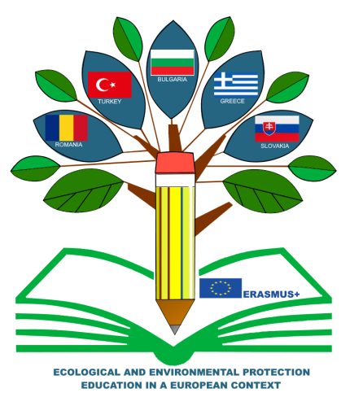

CONTENTS

Introduction – Cozlosche Claudia
Erasmus+ Project, KA2 - "Ecological and environmental protection education in a European context! | 4
Examples of good practices in education for ecology and environmental protection
● Mobility in Slovakia
The Importance of Food Waste Awareness Among Students:  A Step Towards a Sustainable Future  Teacher, Kornélia Lohyňová, Hotelová akadémia, Slovakia | 6
Zero food waste campaign activity  Teacher Kornélia Lohyňová, Hotelová akadémia, Slovakia | 14
Upcycling clothes and creating art with food waste  Teacher, Kornélia Lohyňová, Hotelová akadémia, Slovakia | 16
Creative Recycling and Design Thinking  Teacher, Kornélia Lohyňová, Hotelová akadémia, Slovakia | 19
● Mobility in Greece
Sustainability lessons from the past: A Visit to ancient Messini  Teacher, Georgia Mouselimi, 5th Gymnasio Kalamatas, Greece | 21
Collaborative solutions on energy consumption  Teacher, Georgia Mouselimi, 5th Gymnasio Kalamatas, Greece | 24
Sustainable School Training Session  Teacher, Georgia Mouselimi, 5th Gymnasio Kalamatas, Greece | 27
Ecological Footprint Awareness  Teacher, Georgia Mouselimi, 5th Gymnasio Kalamatas, Greece | 30
- Mobility in Türkiye
Ecological Education through Recycling Activity to Reduce Carbon Footprint  Teacher, Gülden Akar- Gölcük İhsaniye Anatolian High School, Türkiye | 34
Thematic Visit to Nezahat Gökyiğit Botanical Park  Teacher Gülden Akar- Gölcük İhsaniye Anatolian High School, Türkiye | 39
Thematic Visit to İzaydaş (Solid Waste Treatment Center)  Teacher Gülden Akar- Gölcük İhsaniye Anatolian High School, Türkiye | 42
Greening Activity  Teacher, Gülden Akar - Gölcük İhsaniye Anatolian High School, Türkiye | 43
● Mobility in Romania
Ecological education through the ECO workshop  Teacher, Claudia Cozlosche, Liceul Tehnologic Costesti, Romania | 47
Thematic visit to the Visitor Center of Piatra Craiului National Park  Teacher, Claudia Cozlosche, Liceul Tehnologic Costesti, Romania | 49
Greening activities  Teacher, Claudia Cozlosche, Liceul Tehnologic Costesti, Romania | 52
Thematic visit. "Alexandru Beldie" Visiting Center of Bucegi Natural Park - Natura 2000 Sit  Teacher, Alexandra Oprea, Liceul Tehnologic Costesti, Romania | 54
● Mobility in Bulgaria
“Who needs Nature most?”, “Planet vs. Plastics”  (Global Theme for Earth Day 2024) Workshop  Teacher, Veneta Velkova, 32. SUICHE “Sveti Kliment Ohridski”, Bulgaria | 57
"I Am What I Eat"  Intercultural Cuisine Presentations on Balanced Diet  Teacher, Veneta Velkova, 32. SUICHE “Sveti Kliment Ohridski”, Bulgaria | 60
Workshop: “Recycled Art”  Teacher, Veneta Velkova, 32. SUICHE “Sveti Kliment Ohridski”, Bulgaria | 62
Thematic visit to Koprivshtitsa. Visiting the Museum of bread.  Workshop  Teacher,Veneta Velkova, 32. SUICHE “Sveti Kliment Ohridski”, Bulgaria | 64
“Life needs to be healthy”  Outdoor activities in the Mountain Vitosha and around Lake Pancharevo. Observation of the biodiversity. Workshop – using digital tools to identify different plant species.  Teacher, Veneta Velkova, 32. SUICHE “Sveti Kliment Ohridski”, Bulgaria | 65
"We can Make a Difference!”  Workshop: Global Warming - Educate Yourself  Teacher, Veneta Velkova, 32. SUICHE “Sveti Kliment Ohridski”, Bulgaria | 67
Other activities related to environmental protection
DETERMINATION OF SOIL pH USING THE DIGITAL pH meter  Teacher, Georgeta MURESAN, Liceul Tehnologic Costesti, Romania | 69
PET WASTE RECYCLING,  Teacher, Alexandra OPREA, Liceul Tehnologic Costesti, Romania | 75

Proiect Erasmus+, KA2 - “Ecological and environmental protection
education in a European context!”

Liceul Tehnologic Costești, Romania is the European coordinator of the project "Ecological and environmental protection education in a European context!", with no. 2021-1-RO01-KA220-SCH-000035907.
The project is financed by the European Union through the Erasmus+ program. It is a cooperative partnership project in the field of school education for the exchange of good practices that focuses on the learning process and the activities themselves.
The partner schools are: Hotelová akademia – Slovakia, 5th Gymnasio Kalamatas – Greece, Gölcük Ihsanıye Anadolu Lısesı – Turkey and 32 SU s izuchavane na chuzhdi ezici "Sv.Kliment Ohridski" – Bulgaria.
The implementation period is: 28.02.2022 – 27.06.2024.
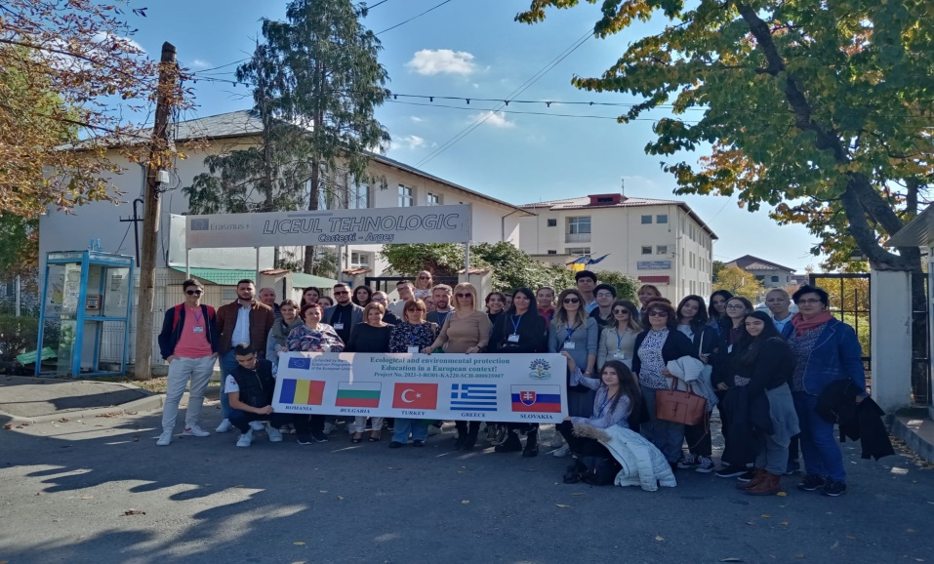

The project offers the possibility for the organizations involved to work at a transnational level, sharing and confronting ideas, practices or working methods, also producing tangible results. Both students and teachers from the 5 partner schools will be involved in the project. The activities that will be carried out within the project are in the field of environmental protection. The project aims to form a responsible attitude of students, in terms of keeping the environment clean through the correct storage of waste and maintenance of green spaces, involvement in large-scale actions to preserve the environment and solving environmental problems. Also, the project contributes to educating students in the spirit of sustainable development by producing changes in their behavior in terms of saving energy in everyday life, to strengthening the European dimension of education by developing skills necessary for lifelong education and to promoting the values ​​of European citizenship such as responsibility against the environment.
The objective of the project is to improve skills, training skills and work skills for teachers and students from the 5 partner countries, in the field of ecological education and environmental protection, in order to implement educational activities in the schools where they come from.
The project aims to support sustainable lifestyle education in schools and to make students aware of climate and environmental changes.
From the beginning, a close cooperation between the project partners was established, so that the planned activities will achieve the specified objectives. Activities, both local and transnational, will involve both students and teachers.

Project Coordinator,
Teacher, Cozlosche Claudia

EXAMPLES OF GOOD PRACTICES IN EDUCATION FOR ECOLOGY AND ENVIRONMENTAL PROTECTION

Mobility in SLOVAKIA
The Importance of Food Waste Awareness Among Students:
A Step Towards a Sustainable Future

Teacher, Kornélia Lohyňová, Hotelová akadémia, Slovakia

In recent years, the issue of food waste has become a pressing concern worldwide. With millions of tons of food discarded annually, the environmental, economic, and social impacts are profound. One significant step towards mitigating this issue is raising awareness, particularly among the younger generation. By participating in this survey, students are encouraged to reflect on their food consumption habits both at home and at school, paving the way for more conscientious behavior and sustainable practices.
The questionnaire, accessible here, serves several crucial purposes in tackling food waste:
- Raising Awareness: Awareness is the first step towards change. By filling out the questionnaire, students are prompted to think about their daily habits and the impact of their actions.
- Educational Tool: The process of responding to questions about food waste educates students and can introduce concepts such as sustainability, responsible consumption, and the importance of reducing waste.
- Behavioral Change: Awareness often leads to action. When students become more conscious of their wasteful habits, they are more likely to adopt better practices, such as planning meals, proper storage, and mindful consumption both at home and in school cafeterias.
- Data Collection: The aggregated data from these questionnaires can provide valuable insights into the habits and attitudes of young people regarding food waste. This information can be used by schools, policymakers, and environmental organizations to design targeted interventions and educational programs.
The questionnaire was created by the teachers of this Erasmus+ project and was given to the students before the mobility in Slovakia. 57 students from Hotelová akadémia in Slovakia answered and here are the results.
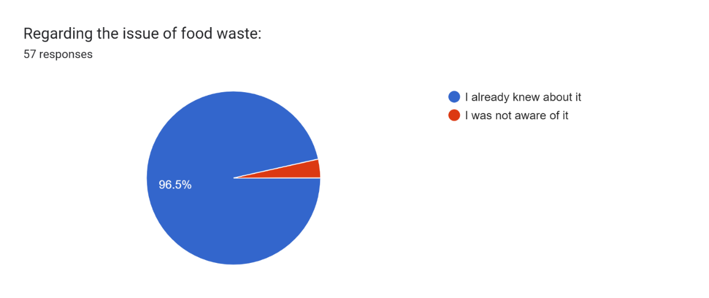
96,5 % of Slovak students have already heard about the food waste which is a high number.
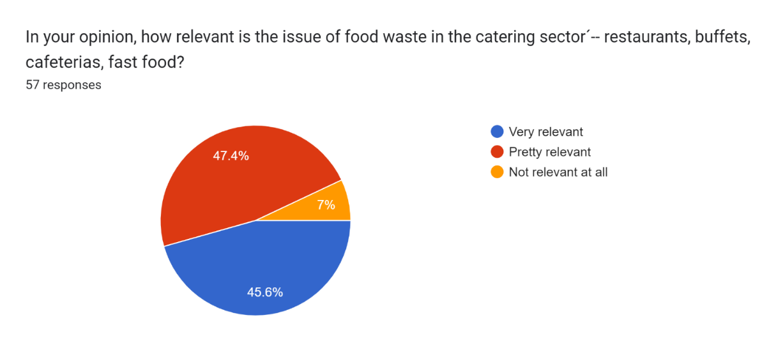
Our students are studying catering, so the question about the relevance of the food waste in the catering sector was very relevant, but still, 7% of the students don’t think that the food waste matters in this sector.
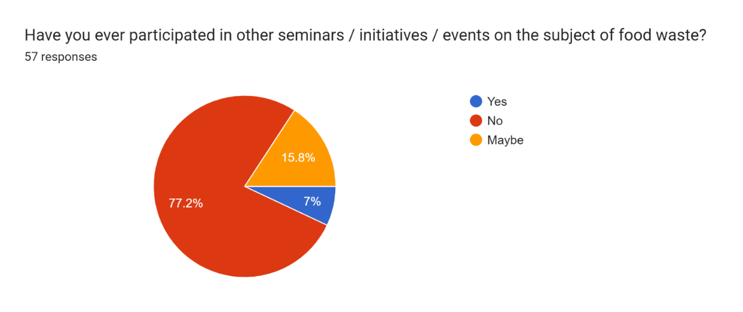
77% of the students declared that they have never participated in the events on the food waste, which is a high number and we need to work on it and involve students more.
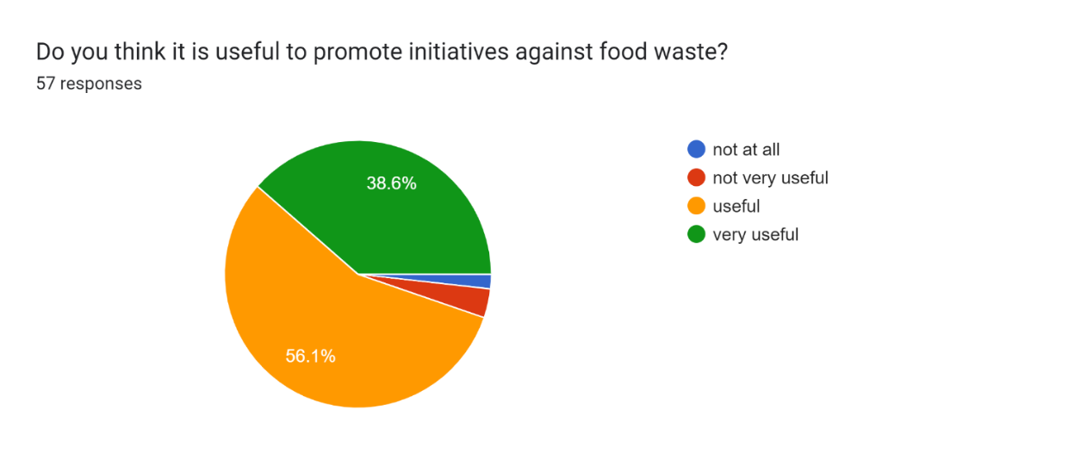

The promotion of the initiatives against food waste is approved by 95% of the students which is a promising number, we need to turn this approval into action.
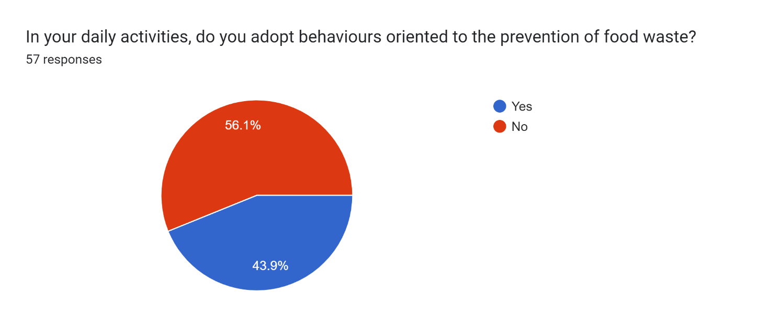

Only 44% of Slovak students care about food waste in their daily activites, which is not a high number.
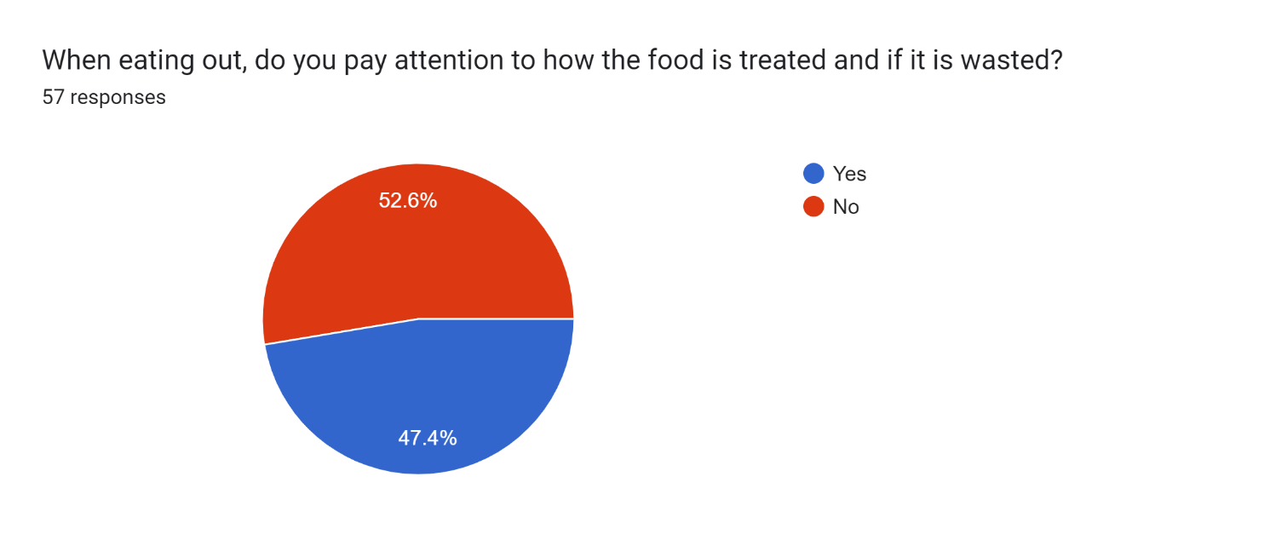

Almost half of the students don’t care about the food treatment when eating out, this fact needs more awareness because of their profesion.
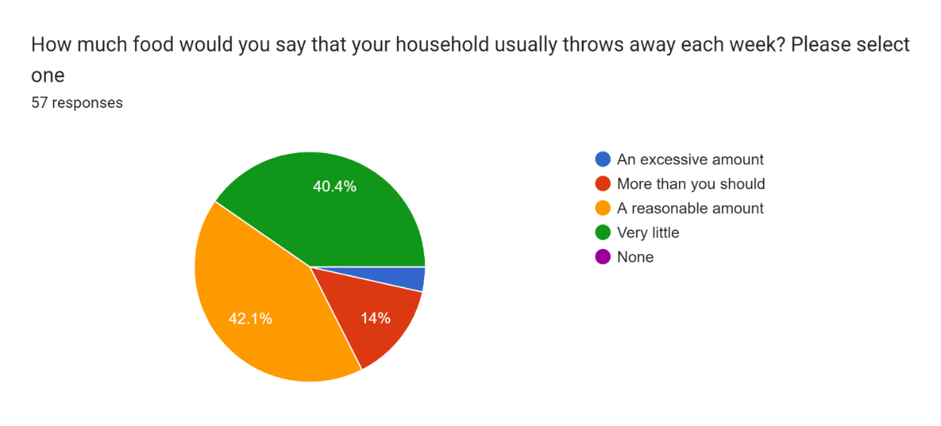

82% students think that little or a reasonable amount of food is thrown away in their household.
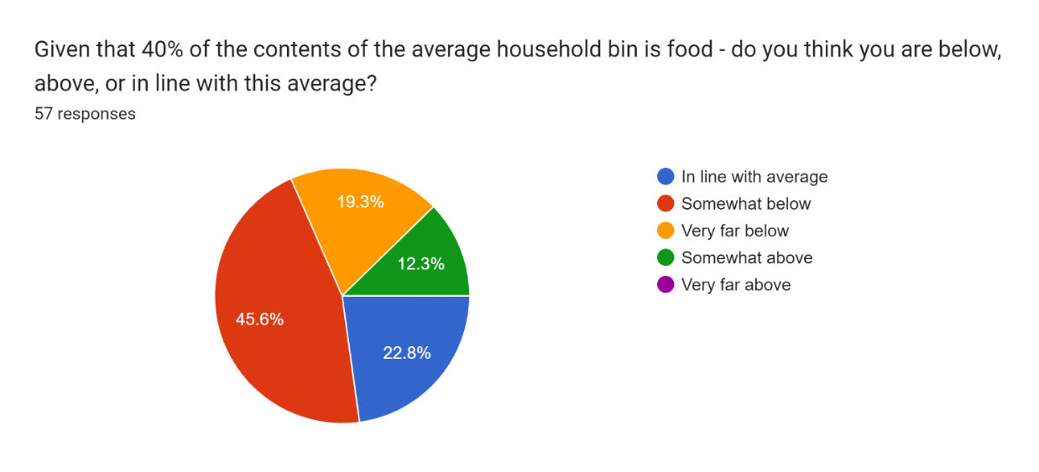
Only 65% of the households of Slovak students are below the average of 40% of the food thrown away, 12% throw away even more.
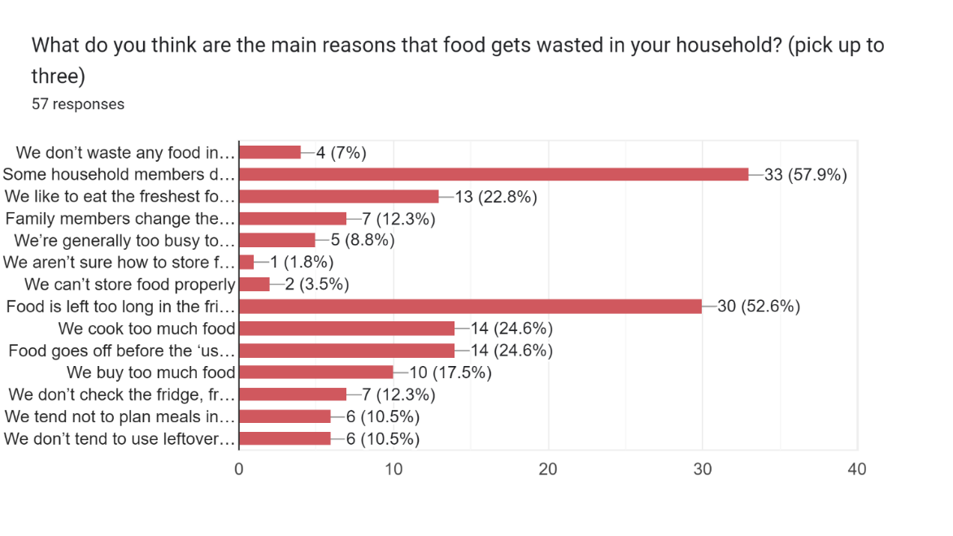
The main reasons why housholds throw away food are the fact that family mambers eat not at home and thus their food remains and the fact that the food stays in the fridge for too long and then gets thrown away.
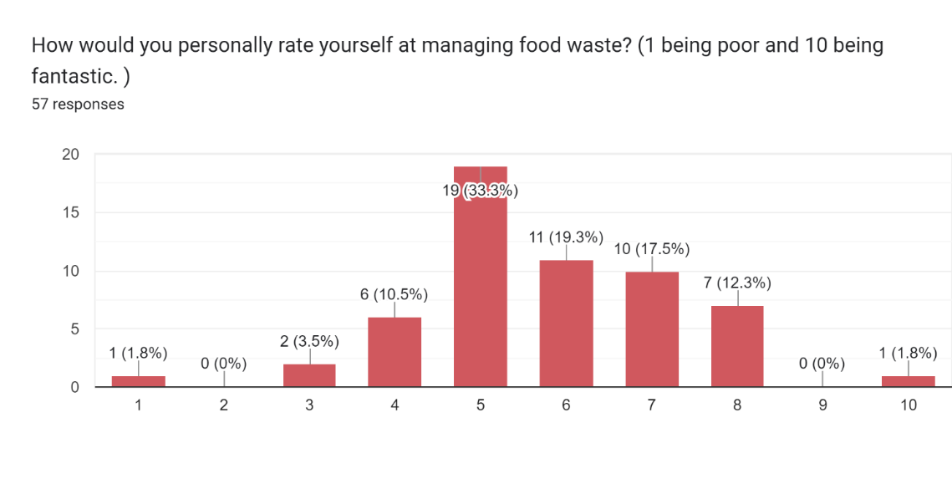
81% of the students consider that they are dealing with combating food waste, scoring between 5 and 8 on the scale, only 1% considering that they are fantastic.
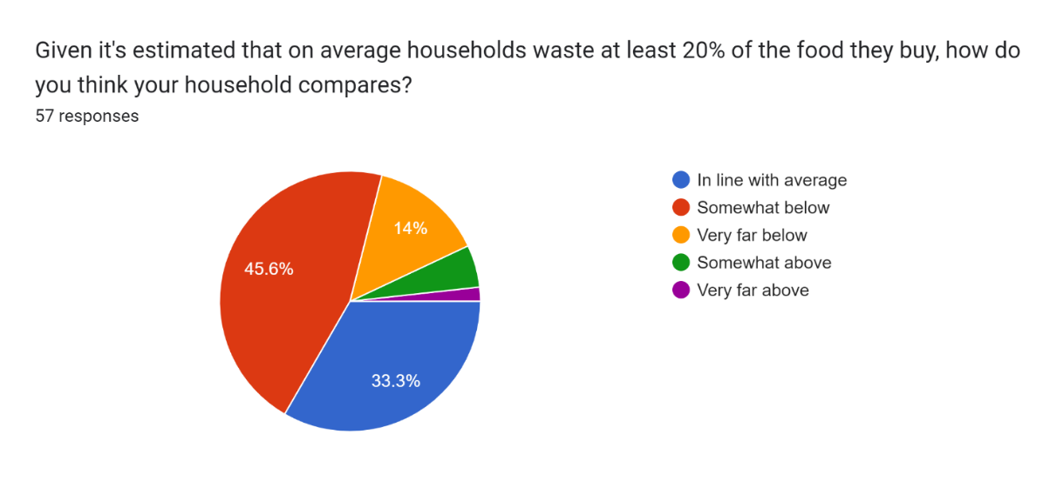

The 59% of the hoouseholds of our students waste less than 20% of the food they buy, 33% are in line with the average of at least 20%.
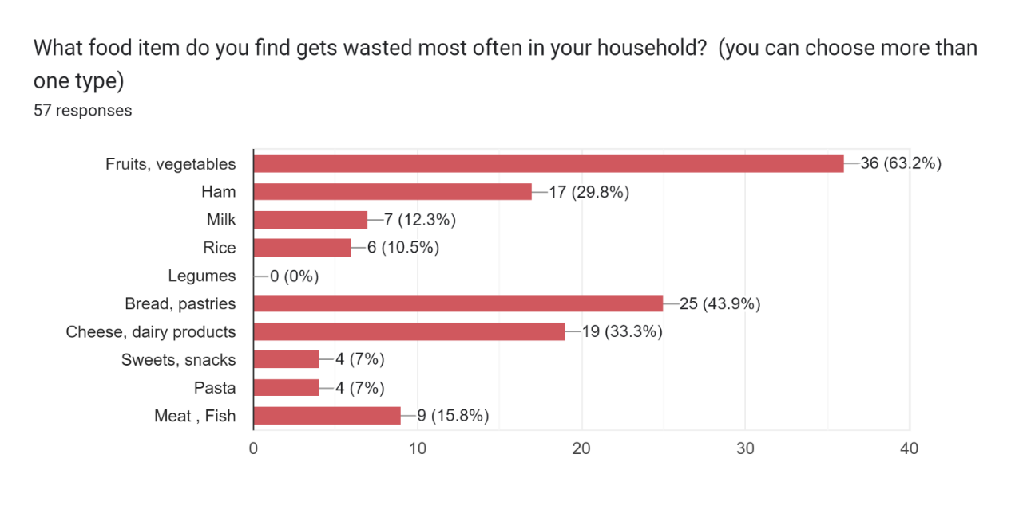

Fruits and vegetables, bread and pastries and dairy products are wasted mostly in the households of Slovak students.
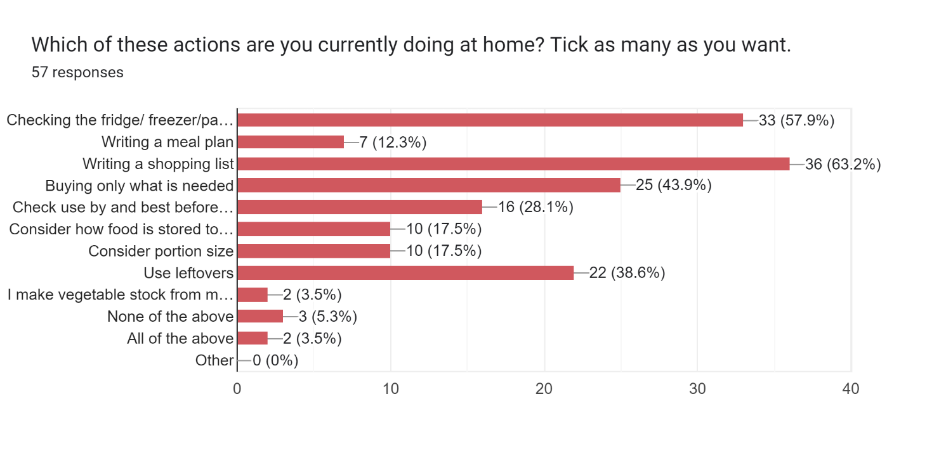
The current actions against food waste in the students families are: writing a shopping list, checking the fridge before going shopping and buying only what is needed.
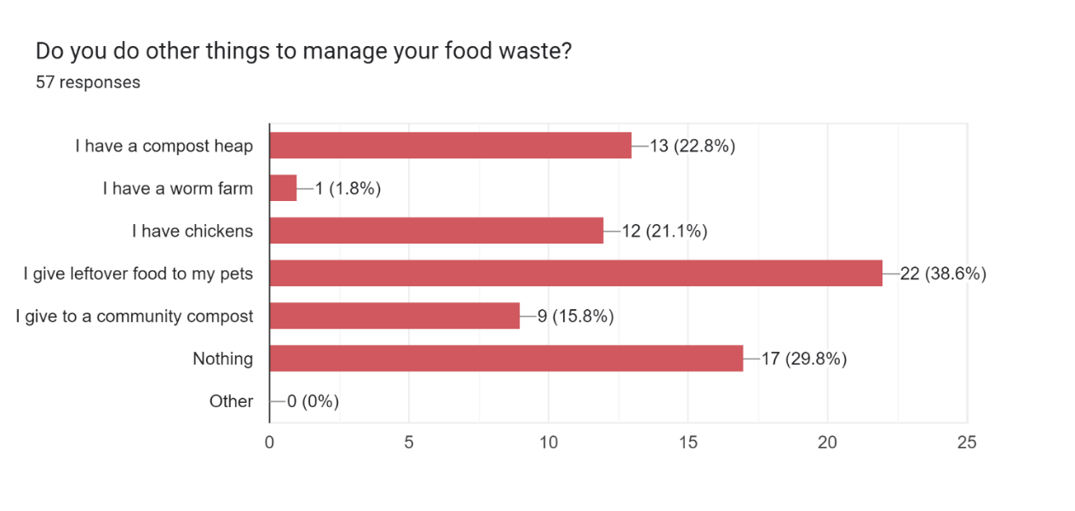

Other possibilities are giving leftovers to animals or turned into compost.
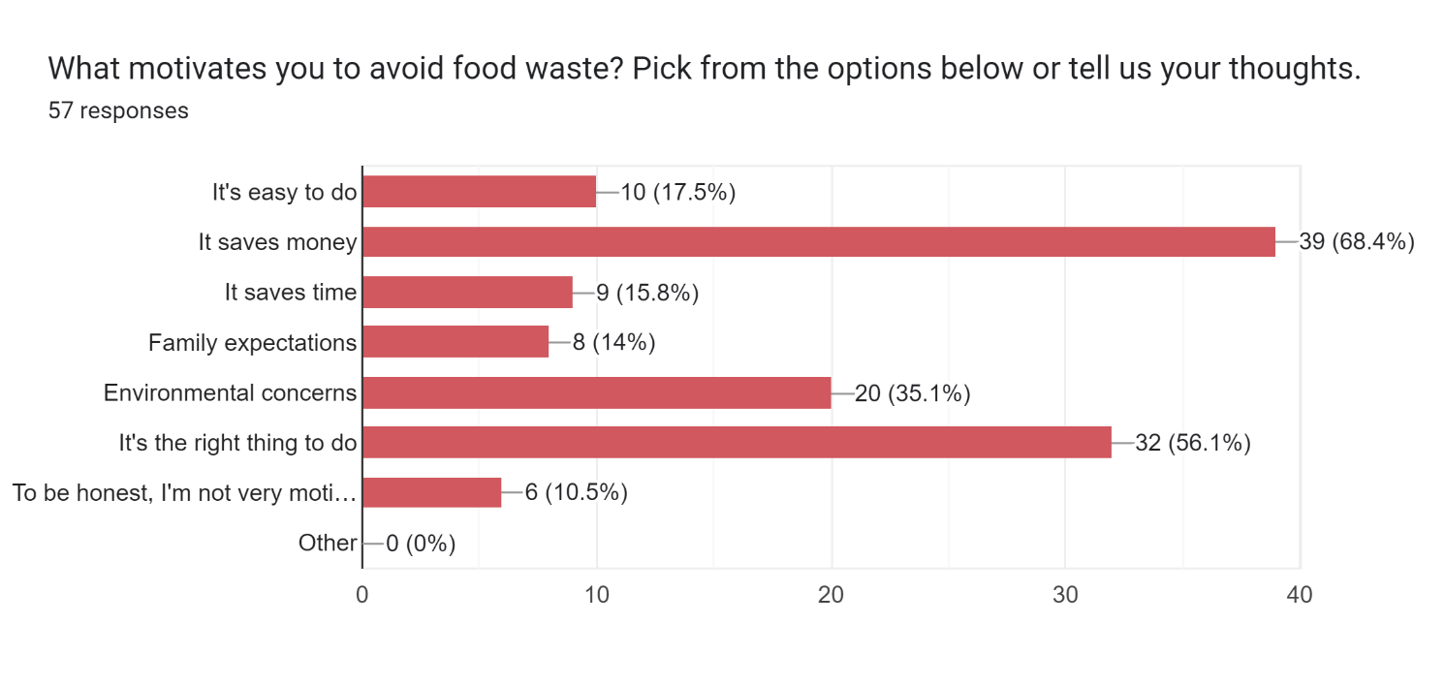

Saving money is the first motivator for the students to avoid food waste, followed by the fact that it is right thing to do, but 10% of the students are not motivated.
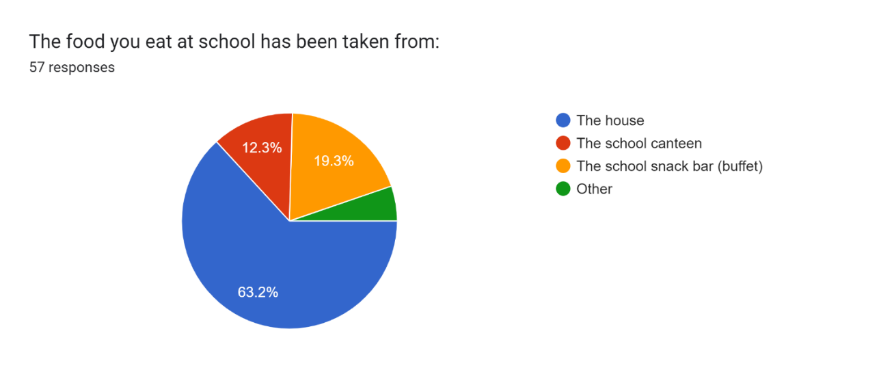

Most of the students bring takeaway food from home, followed by bying food at the school buffet.
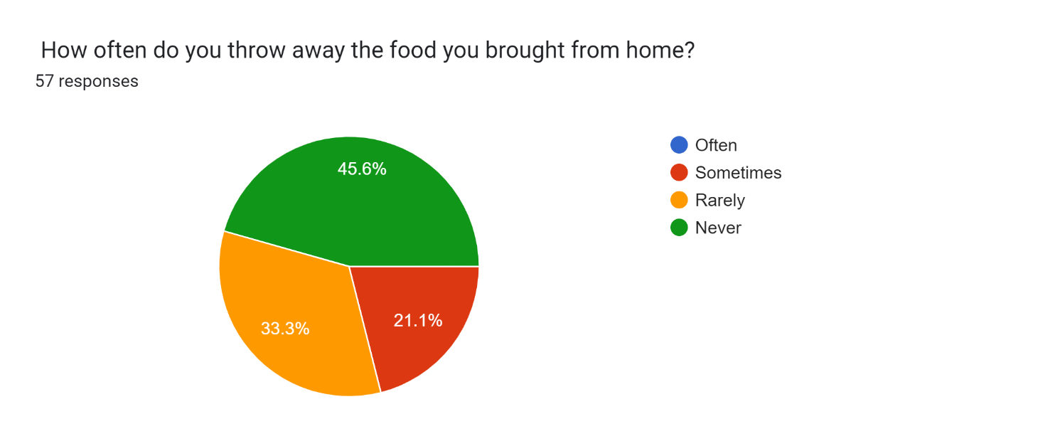
78% of the students never of rarely throw away the food brought from home.
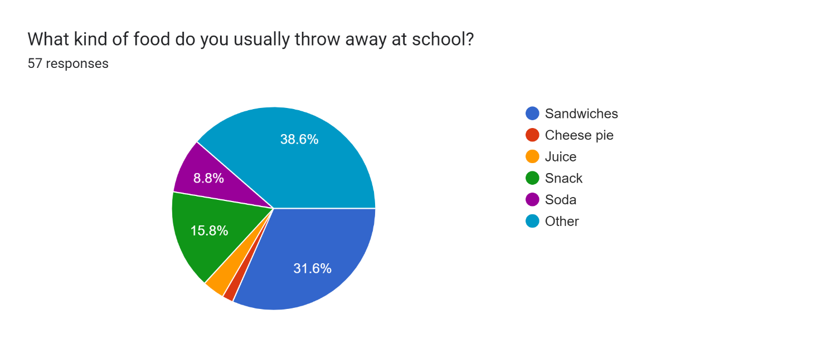

They usually throw away other stuff that is specified below, then sandwiches and snacks.

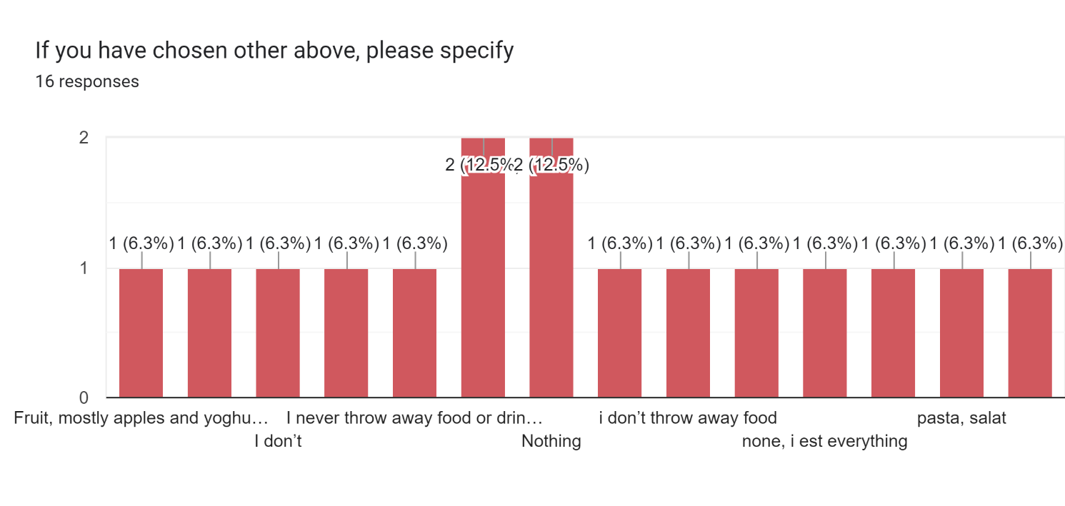
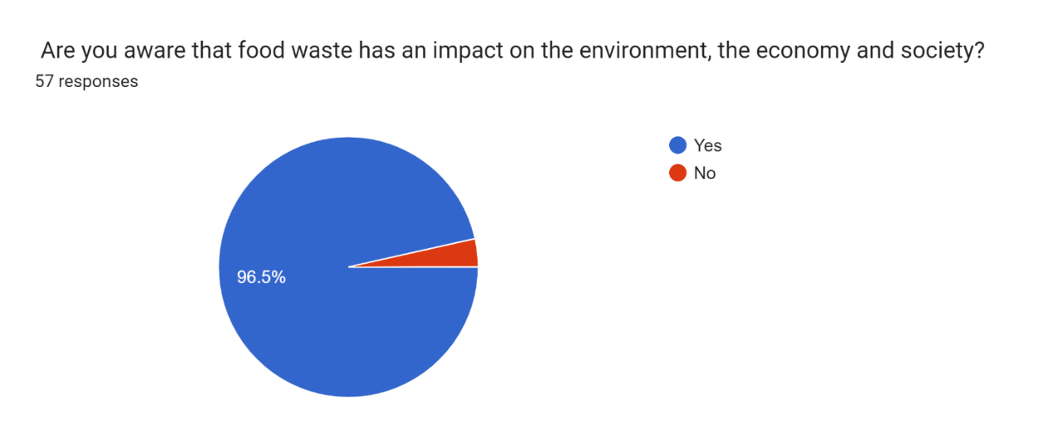
96% of the students are aware of the impact of the food waste on the environment and economy, but now the next steps are needed.
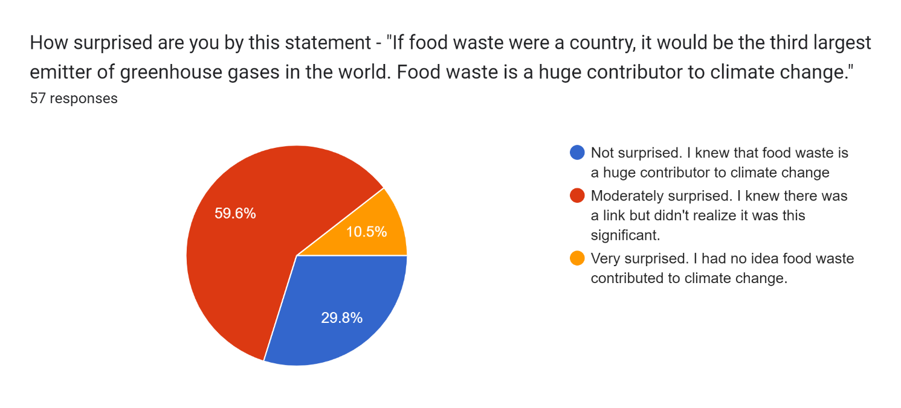

Only 30% of the students know that food waste is a huge contributor to climate change and 10% os Slovak students had no idea that food waste contributed to climate change.

The food waste questionnaire for students is a vital tool in fostering a generation that is not only aware of the issues but is also equipped to act upon them. By understanding their habits and the broader implications of food waste, students can play a pivotal role in building a more sustainable future. Encouraging such initiatives in educational settings is crucial for long-term environmental stewardship and social responsibility and our project was one os such initiatives and will be followed by many more.

Zero food waste campaign activity

Teacher Kornélia Lohyňová, Hotelová akadémia, Slovakia

After presenting the results of the questionnaires on food waste across different countries, the initiative aimed to create a comprehensive campaign involving students, families, and schools to reduce food waste.
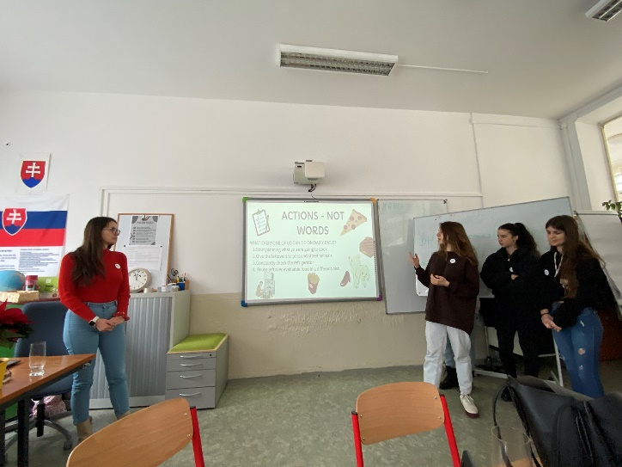
Students collaborated in international teams to develop innovative ideas and strategies to raise awareness and implement actionable solutions.

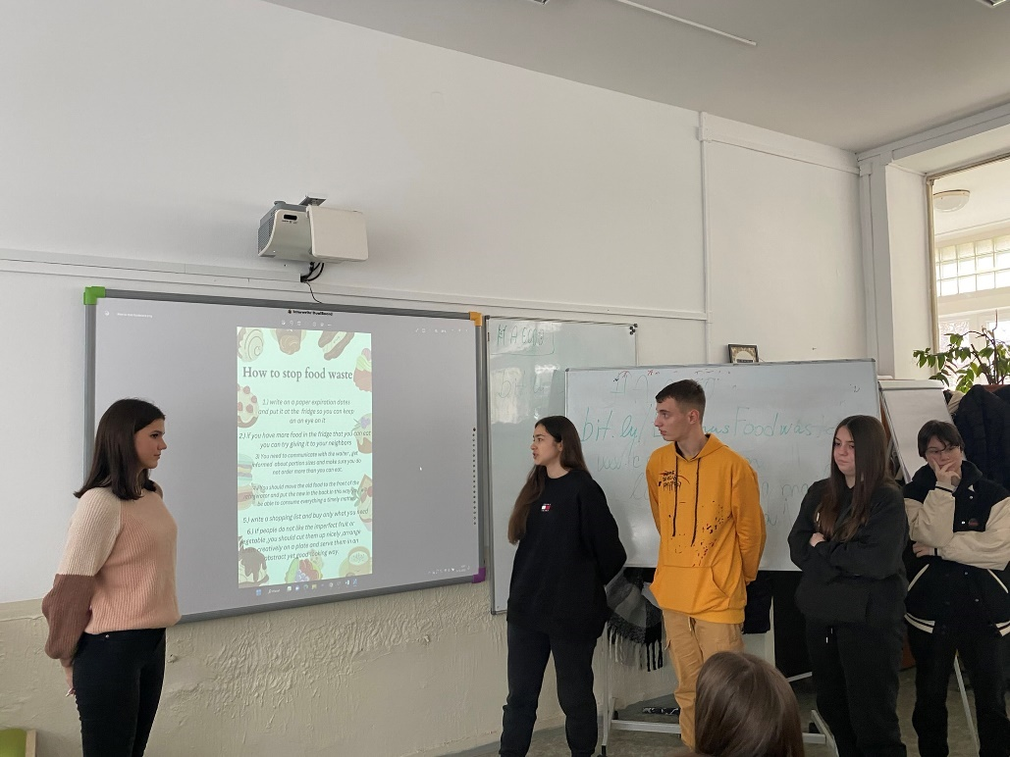
We stressed the importance of the mixed international teams to encourage cross-cultural collaboration and the exchange of ideas. Students were given the choise to use their preferable tool for collaboration and presentation. They had time to brainstorm, research and develop their campaign ideas. Teachers were there to help and encourage creativity and practical solutions.

The activity culminated in presentations by student teams, highlighting their creative approaches and calls to action.

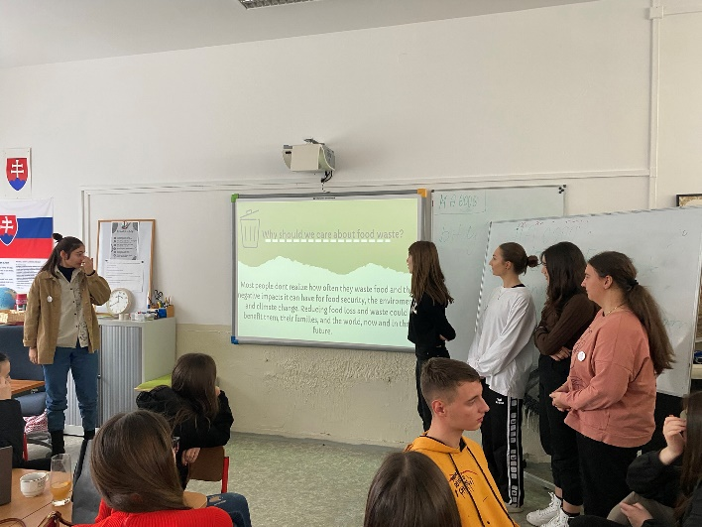

The primary goals of this activity were to:
- Raise Awareness: Educate students, families, and school communities about the issue of food waste and its impacts.

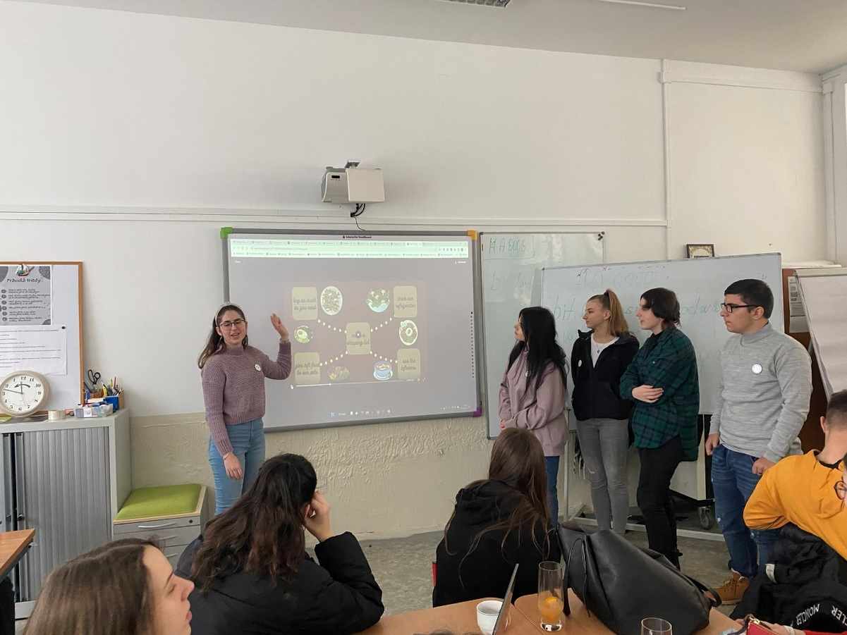

- Encourage Collaboration: Foster international collaboration among students to share diverse perspectives and solutions.
- Promote Actionable Change: Develop and implement practical strategies to reduce food waste at home and in schools.
- Empower Students: Empower students to take leadership roles in advocating for sustainable practices and influencing their communities.

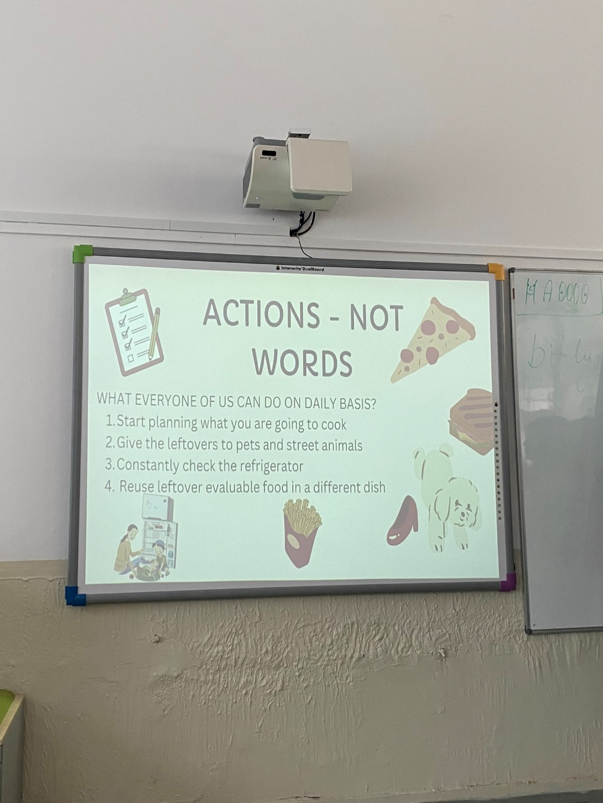
This guided activity not only educates and raises awareness about food waste but also actively engages students in creating and implementing solutions. By working in international teams, students gain valuable collaboration skills and cultural insights, while their presentations and calls to action serve to inspire real change in their communities.

Upcycling clothes and creating art with food waste

Teacher, Kornélia Lohyňová, Hotelová akadémia, Slovakia

During mobility in Slovakia, we wanted to bring the topic of the fast fashion and to show students and teachers that food waste can be used also for recycling and upcycling to minimize waste. We discussed the environmental impact of the fast fashion and textile waste and the benefits of using natural dyes.
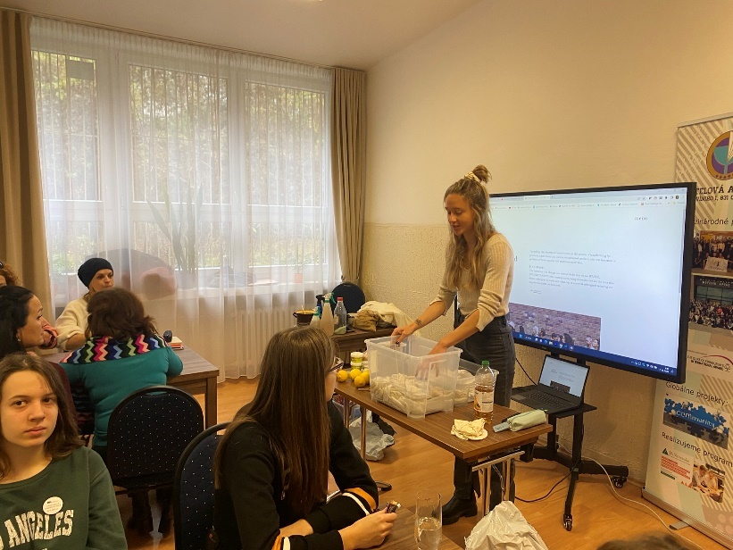
Then the students were engaged in a hands-on learning activity where they created dyed socks using recycled natural ingredients and food waste, such as spices, herbal teas, onion peels, and flower petals. Additionally, students used these same ingredients to create artistic pictures. We used the cotton socks that were preprepared for the dying so that they can absorb the pigment and create such strong bond that will not be disrupted by washing. It is done by mordanting in soya milk.
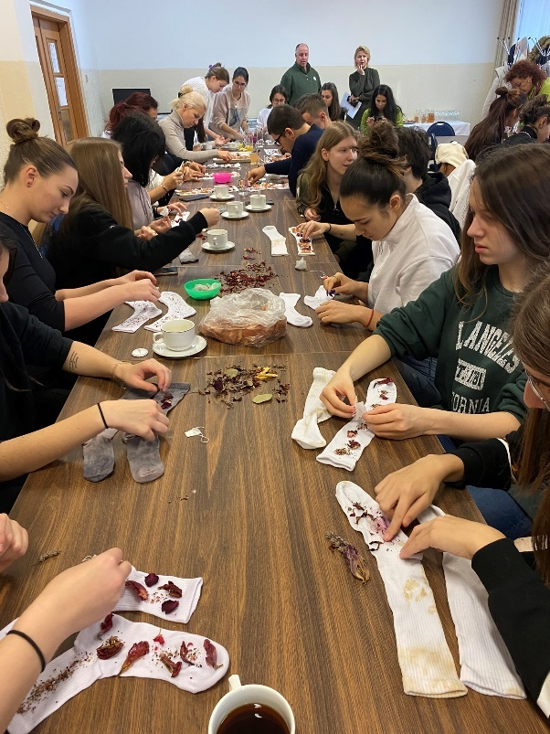
This activity not only teaches sustainable practices but also encourages creativity and environmental awareness.
The main objectives of this activity were to:
- Promote Sustainability: Demonstrate how everyday food waste can be repurposed creatively, reducing environmental impact.
- Encourage Creativity: Inspire students to explore artistic expression using natural materials.
- Educate on Natural Dyeing: Teach students the process of natural dyeing using food waste and organic materials.
- Raise Environmental Awareness: Highlight the importance of recycling and upcycling to minimize waste.
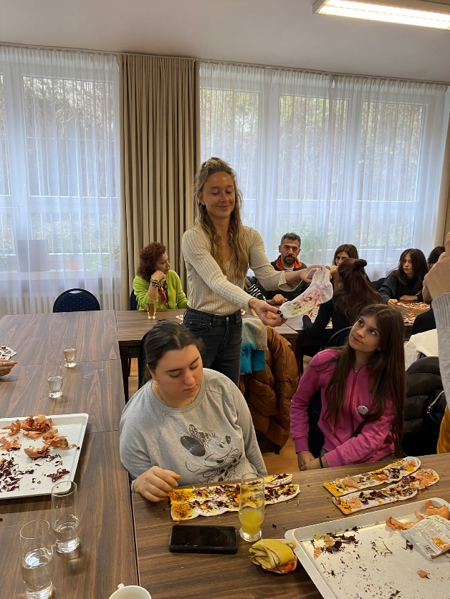
First students soaked the socks in water and then sprayed the socks with vinegar to ensure the pigments adhere to the fabric. Then students placed the dye materials on top and pressed another sock over it and rolled socks, transferring the dye to the fabric. Materials used could be: spices, avocado and onion skin, coffee, flower petals, herbal teas.

The rolled socks were placed in a sieve and left to steam for about an hour. This process helped the colors set. After steaming, students removed the socks from the sieve and let them dry completely.

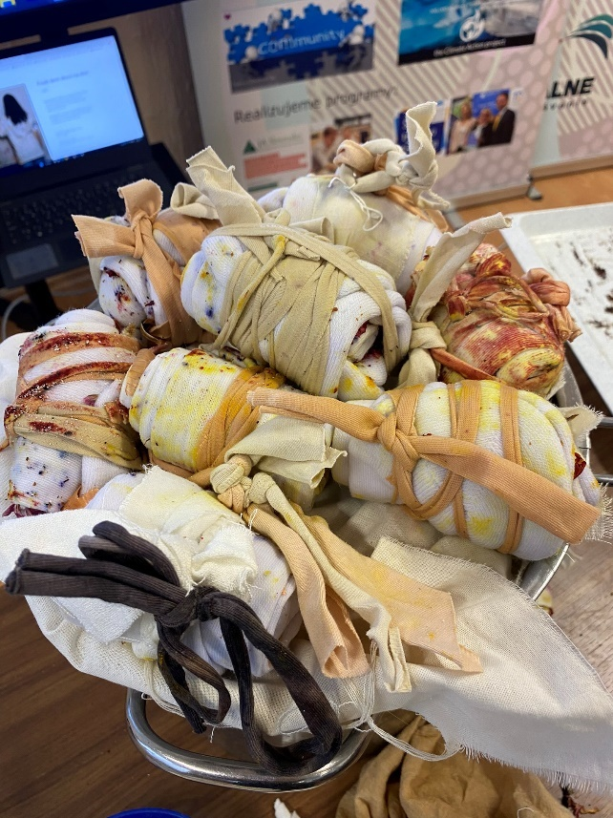
While waiting for the socks, they had time to create pictuers on paper or canvas using the leftover dye materials. The last step was sharing creations, and discuss experiences.
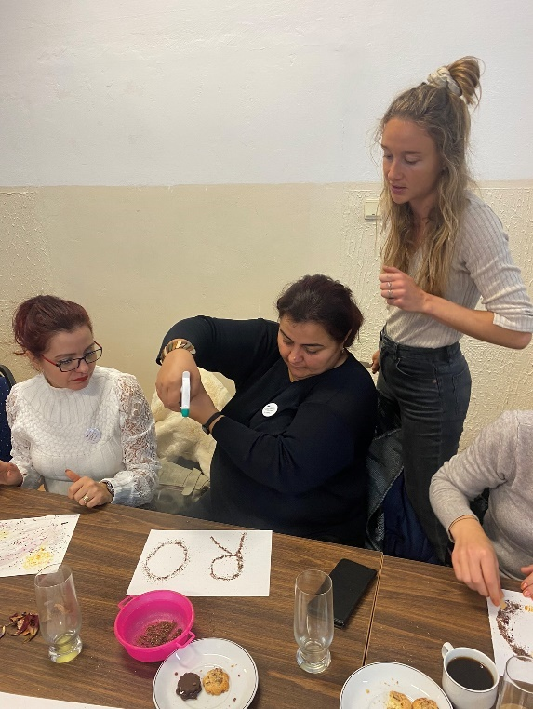
This learning activity not only teaches students about the environmental benefits of upcycling and natural dyeing but also encourages them to express their creativity through sustainable practices. By transforming food waste into beautiful, functional items and art, students gain a deeper understanding of how they can contribute to reducing waste and promoting a more sustainable lifestyle.
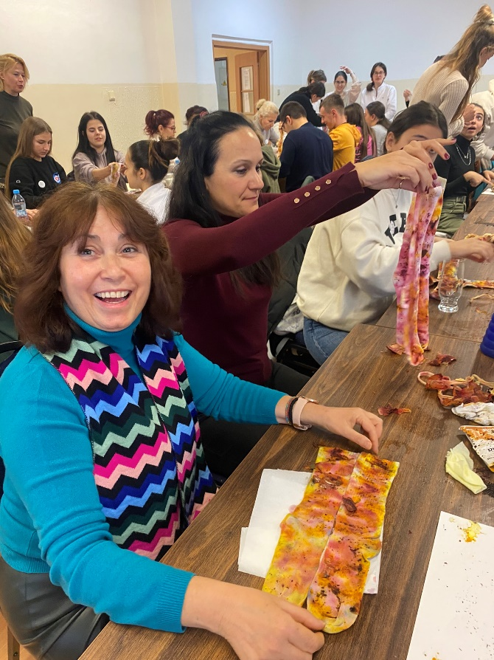
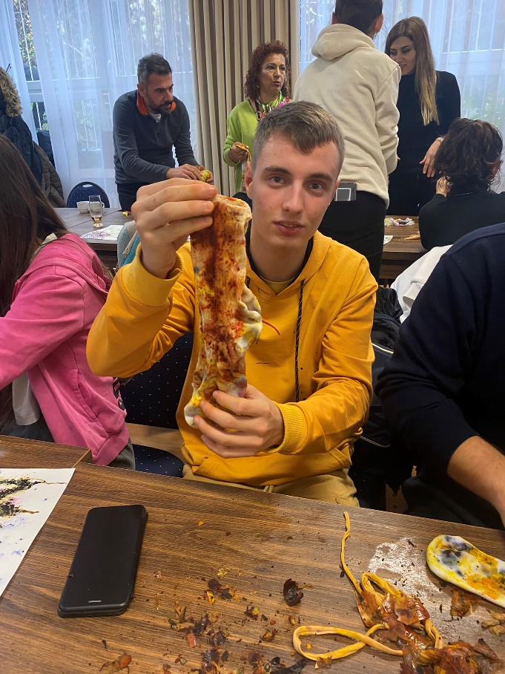
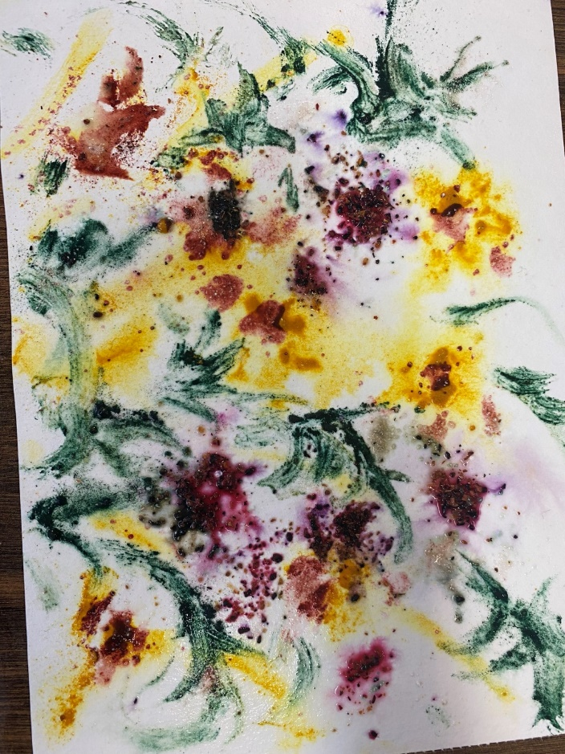

Creative Recycling and Design Thinking

Teacher, Kornélia Lohyňová, Hotelová akadémia, Slovakia

This activity is designed to engage students in creative recycling and design thinking by challenging them to create a toy from recycled items. It was done during the mobility in Slovakia. Students were working in international teams, promoting cross-cultural collaboration and communication. Each team would not only build a prototype of their toy but also develop a simple marketing plan. The activity culminated in pitch presentations where teams presented their products followed by a voting session to decide which product is the most compelling.
The primary goals of this workshop were to:
- Promote Sustainability: Educate students on the importance of recycling and repurposing materials to reduce waste and environmental impact.
- Encourage Creative Problem-Solving: Apply the principles of design thinking to solve a practical problem, fostering innovation and creativity.
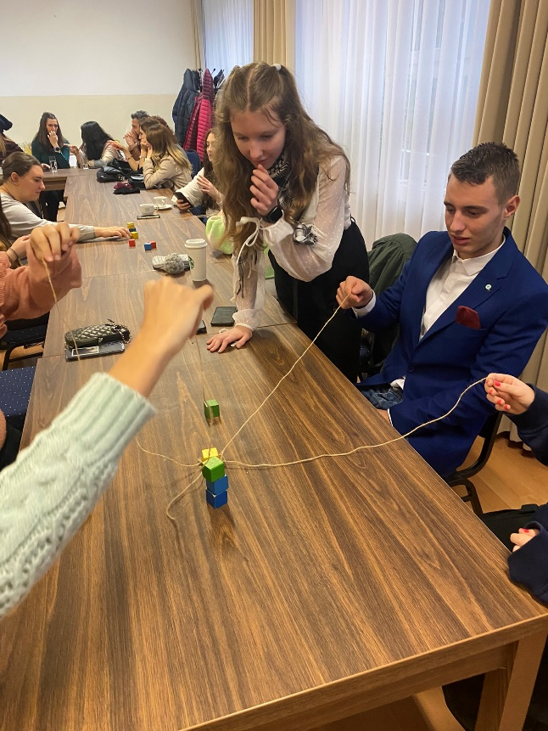
- Enhance Teamwork and Communication: Develop teamwork skills and cross-cultural communication by working in international teams, enhancing students' ability to collaborate effectively with peers from different backgrounds.
- Develop Entrepreneurship Skills: Introduce students to the basics of marketing, helping them to understand how to create and promote a product.
- Foster Reflective Learning: Encourage students to reflect on their learning experience, the challenges they faced, and the skills they developed during the workshop.
Students were working on the principles of design thinking, first they had a teambuilding activity to get to know each other and understand the importance of collaboration.

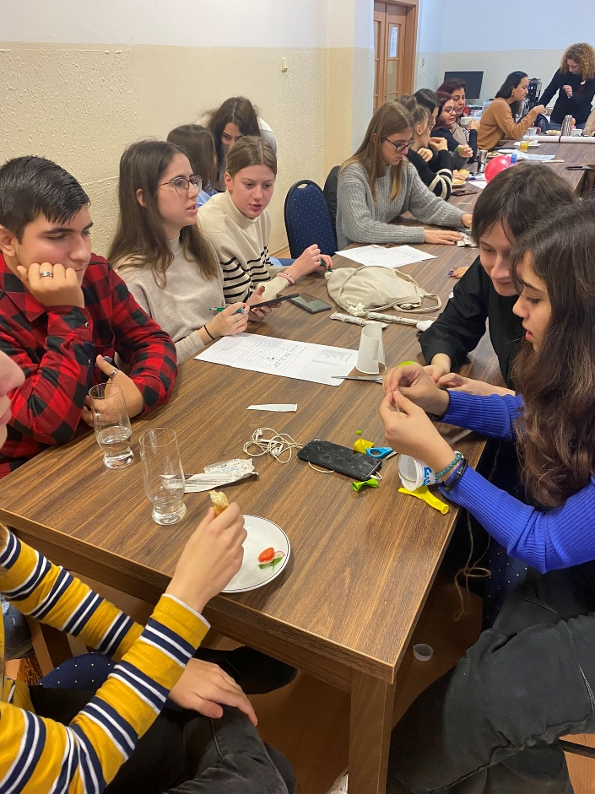
Then they discussed and defined the problem, hot wo create and engaging toy using recycled materials. Teachers encouraged them to consider the needs and preferences of their target audience – children and/or parents. Teams brainstormed various toy ideas using the available tecycled materials. Then they started building their toy prototype while teachers provided guidance and support and team work. They tested their prototypes and then had time to think about their pitch. Teachers encouraged students to think about how they would communicate the benefits and uniqueness of their product.
Teams prepared a pitch for their toy that lasted one minute. After each presentation, students and teachers voted on which toy they would buy based on the presentations.
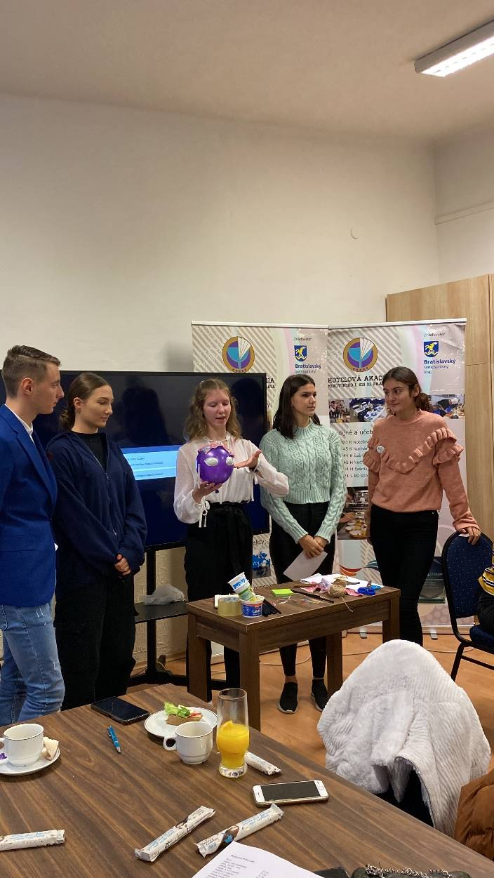
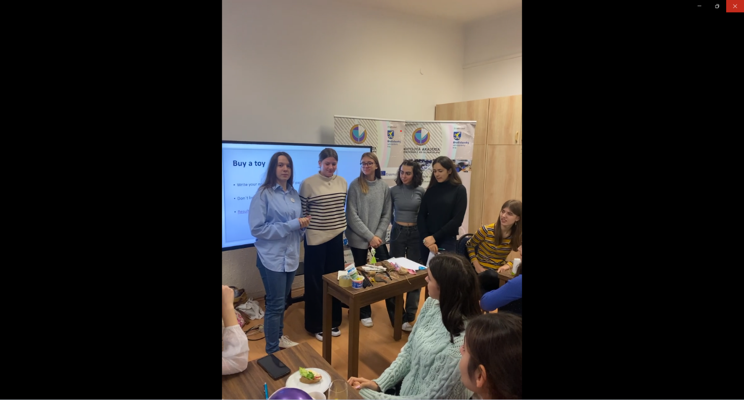

The last step was reflection, students shared their thoughs about what went well and what could be improved for future activites.
This activity aimed to provide an educational experience that combines creativity, sustainability and practic al entrepreneurship skills.
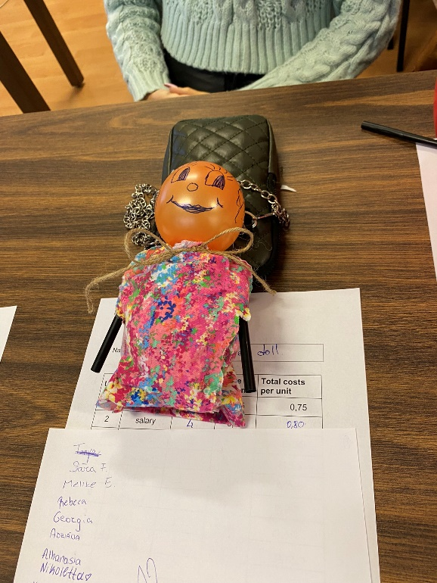
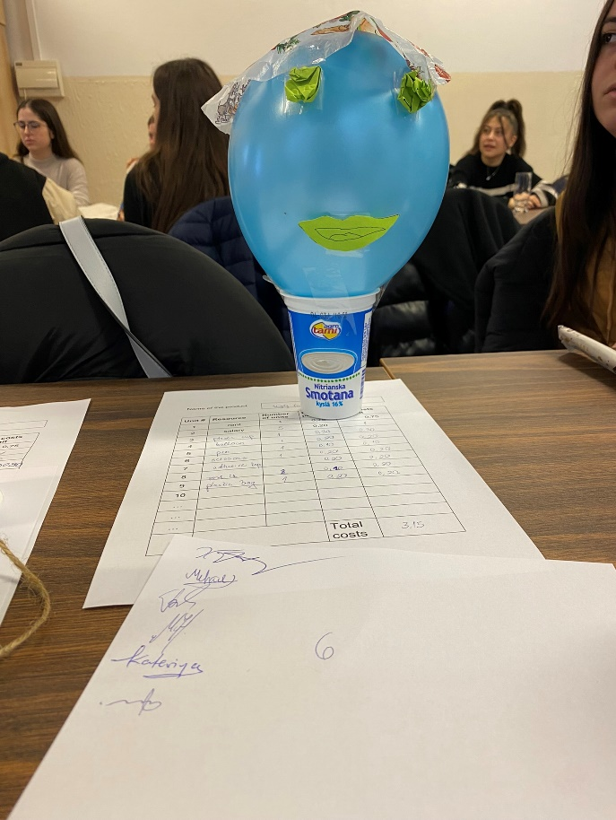
EXAMPLES OF GOOD PRACTICES IN EDUCATION FOR ECOLOGY AND ENVIRONMENTAL PROTECTION

Mobility in GREECE

Sustainability lessons from the past:
A Visit to ancient Messini

Teacher, Georgia Mouselimi, 5th Gymnasio Kalamatas, Greece
Introduction
During the Erasmus mobility in Greece, students had the opportunity to visit the ancient site of Messini. This excursion provided a unique chance for students to delve into sustainability lessons derived from the past while engaging in various activities within the archaeological site.
Objectives
The primary purpose of the visit was to inform students about ancient sustainable practices and their connection with current global environmental issues. By exploring the ruins of ancient Messini, students:
- Understood the architectural marvels and urban planning techniques of the past.
- Discovered ancient sustainable agricultural practices
- Learned about ancient resource management
- Thought about the effect of tourism on historical sites.
- Developed skills in critical thinking, communication, teamwork and cultural sensitivity.
Description
Materials Used in the Workshop:
- Notebooks and pens for taking notes
- Cameras or phones for documenting the visit
- Maps of the archaeological site
- Artifacts provided by the site’s educational program
Students were split into small groups and taken around the ancient ruins of Messini by an experienced tour guide. They examined the layout of the city, learning about principles of sustainability embedded in ancient urban design, such as efficient land use and water management. They also learned some ancient agricultural techniques used there as well.
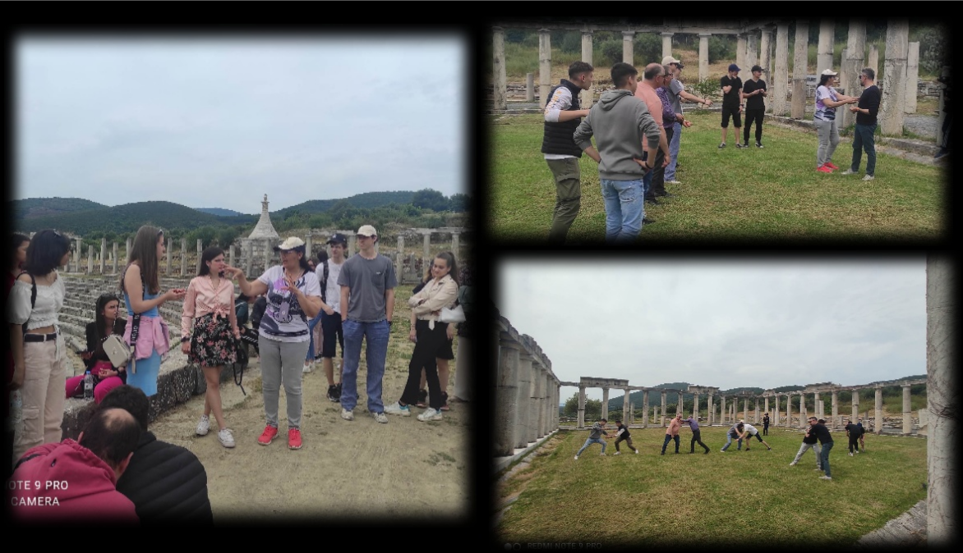
Practical activities (such as inspecting and observing the structure of construction materials) enabled students connect theoretical knowledge with real-world practices. Through this, they realized how materials such as stone, clay and wood were sourced, utilized and recycled, highlighting the importance of resource conservation and waste reduction in ancient societies.
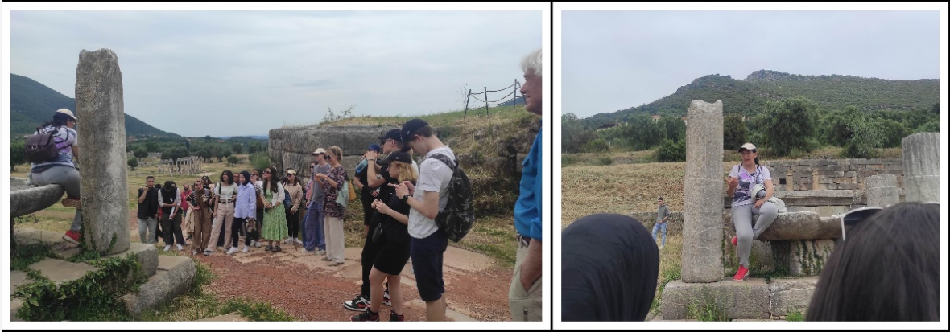
After the guided tours, students participated in group discussions to share their observations and insights.
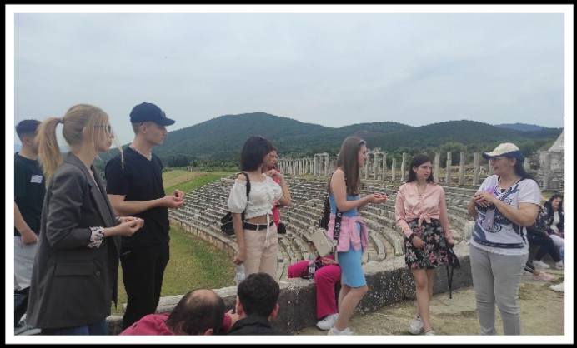
At the end, students gathered for a reflection session to discuss their learning experiences and brainstorm ideas for applying ancient sustainability lessons to modern-day challenges.
Throughout their visit, students explored concepts of responsible tourism and cultural preservation, developing an appreciation for the importance of sustainable tourism practices in safeguarding historical sites for future generations.
Skills Development
- Engaging with historical evidence and archaeological findings stimulated students' critical thinking skills as they evaluated the sustainability practices of ancient civilizations in relation to contemporary challenges.
- Working with their peers from different cultural backgrounds gave students the chance to cultivate their communication skills, intercultural understanding and cooperation within international teams. They also developed teamwork skills by effectively coordinating tasks and sharing responsibilities
- The rich cultural heritage of Messini fostered an appreciation for diverse cultural traditions and historical legacies, promoting cultural sensitivity and respect for cultural diversity. Students gained a deeper understanding of ancient Mediterranean civilizations and their sustainable practices.
- Lastly, but not least, exploring sustainability lessons from the past raised students' awareness of environmental issues and the interconnections between human societies and the natural world. Students also acquired practical skills related to archaeological interpretation, heritage conservation and sustainable living practices.

Collaborative solutions on energy consumption

Teacher, Georgia Mouselimi, 5th Gymnasio Kalamatas, Greece
Introduction
As part of the Erasmus mobility in Greece, students engaged in activities focused on energy consumption within mixed international teams. These activities provided a platform for collaborative problem-solving and knowledge exchange, emphasizing, identifying and presenting strategies for reducing energy consumption in each partner's country.
Objectives
The primary objective of these activities was to educate students on energy consumption patterns and equip them with strategies to reduce energy usage in their respective countries. The specific goals included:
- Analyzing energy consumption patterns in participating countries.
- Identifying potential energy efficiency measures across different sectors.
- Formulating action plans tailored to the energy challenges and opportunities in each country.
- Presenting findings and recommendations for reducing energy consumption.
- Developing skills in research, critical thinking, communication and teamwork.
Description
Materials Used in the Workshop:

• Laptops and internet access for research
• Presentation tools such as PowerPoint or Google Slides
• Whiteboards and markers for brainstorming sessions

Students of each country began by presenting energy consumption patterns in their respective countries, examining factors such as energy sources, consumption trends and environmental impacts.This initial phase enabled students from all partners schools to gain an understanding of the diverse energy landscapes across participating countries.
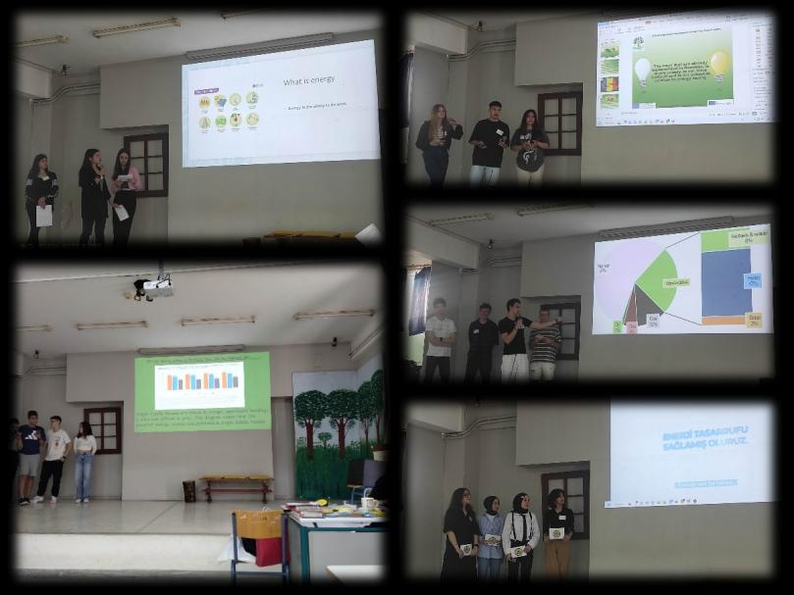

After they were divided into international teams, they started analyzing energy consumption patterns. Each team conducted research on energy efficiency measures and explored strategies such as energy-efficient appliances, renewable energy adoption and behavioral changes to reduce energy consumption and carbon emissions.

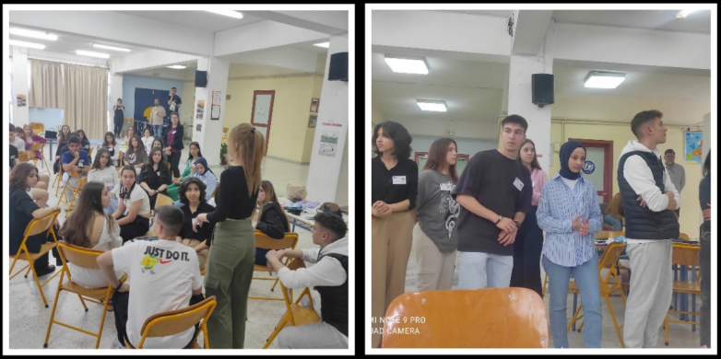

Then, they started formulating their action plans where they integrated innovative solutions and best practices gathered from their research, considering factors such as policy frameworks, technological advancements and socio-economic contexts to maximize effectiveness and feasibility.

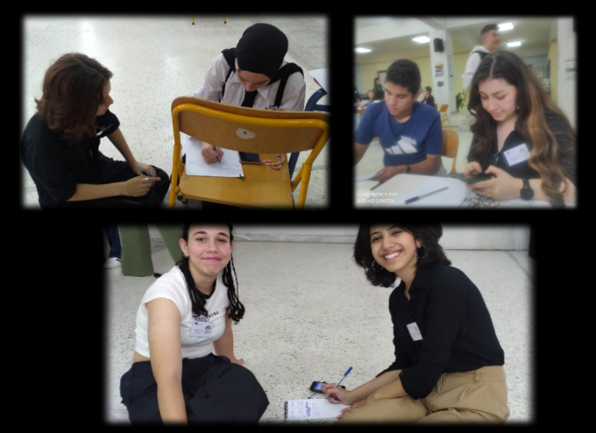

International teams presented their findings and recommendations for reducing energy consumption in partner countries to their peers and teachers and received valuable feedback by engaging in discussions.

Skills Development
- Students deepened their understanding of energy systems, gaining knowledge into global energy production, distribution and consumption patterns.
- Exploring energy efficiency technologies and practices exposed students to best practices for reducing energy consumption
- Interacting with peers from other cultural backgrounds, enriched students' cross-cultural awareness, fostering a sense of interconnectedness in addressing shared environmental challenges.
- Collaborating in mixed international teams facilitated the development of collaboration and conflict resolution skills.
- Presenting recommendations enhanced their communication skills
- Research and analysis of data in order to gather information on energy consumption trends and policy frameworks developed their research skills
- Evaluating the feasibility and effectiveness of energy efficiency measures helped them develop their critical thinking

Sustainable School Training Session

Teacher, Georgia Mouselimi, 5th Gymnasio Kalamatas, Greece
Introduction
Students participated in a training session focused on creating sustainable schools. This activity aimed to empower students with the knowledge and skills necessary to promote sustainability within their school communities.

Objectives
The objectives of the sustainable school training session were to:
- Provide students with the knowledge and skills to promote sustainability within their schools.
- Encourage a culture of environmental responsibility.
- Equip students with practical skills in energy efficiency, waste reduction and eco-friendly transportation.
- Promote teamwork and collaborative problem-solving through group activities.
- Improve students' ability to communicate their ideas
Description
Materials Used in the Session:
- Presentation Slides
- Materials for collaborative exercises, including large sheets of paper, markers, sticky notes
- Presentation tools (e.g., projector, screen)
The session started with a PowerPoint presentation on the circular economy (by Nasos Makios, Environmental Manager with MSc in Bioeconomy, Circular Economy and Sustainable Development), highlighting how reducing waste and reusing materials can create a more sustainable system.
The training continued with an exploration of sustainable school practices, focusing on Energy Efficiency, Waste Reduction, Eco-Friendly Transportation, etc. Students learned from successful practices worldwide, inspiring them to imagine sustainable changes in their own schools. Τhen they were divided into international teams and each team focused on one specific aspect of creating a sustainable school.
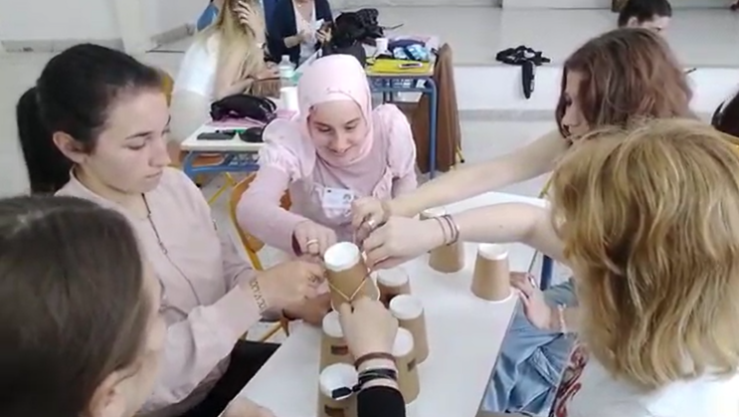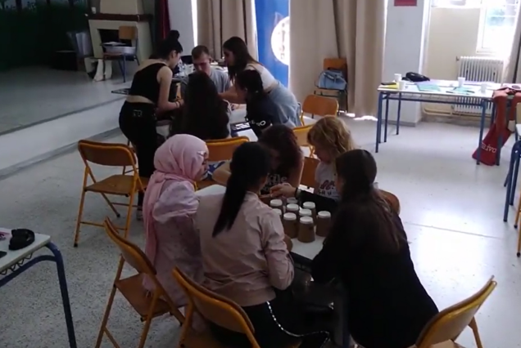
One team dealt with sustainable architecture by exploring energy-efficient building materials and design principles. Another team focused on incorporating renewable energy sources such as solar and wind power into school operations. Another one designed sustainable transportation plans, such as bike-to-school programs. The last international team developed effective waste management practices, including recycling, composting and waste reduction aligned with circular economy concepts. After developing their action plans, students shared their ideas with peers in feedback sessions.
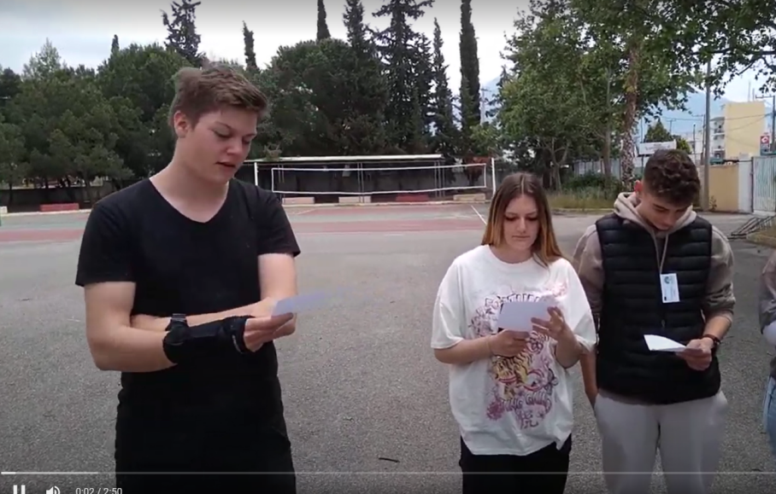
This practical approach ensured that students not only learned about sustainability and the circular economy but also applied their knowledge to real-world scenarios.

Skills Development
- Students developed their analytical thinking by understanding the principles of the circular economy and its application in reducing waste and reusing materials, by evaluating waste production and developing strategies for reduction and by analyzing current energy use and identifying ways to improve efficiency.
- Designing sustainable transportation plans, such as bike-to-school programs, incorporating renewable energy sources such as solar into their sustainable school plan and by exploring energy-efficient building materials and design principles they developed creativity and innovation skills.
- Their collaboration and teamwork skills were also enhanced by working in international teams and developing solutions for sustainable school practices.
- Presenting their action plans and sustainability ideas improved also their communication skills

Ecological Footprint Awareness

Teacher, Georgia Mouselimi, 5th Gymnasio Kalamatas, Greece

Introduction
The final day of the mobility focused on raising awareness about the ecological footprint and understanding the impact of individual actions on the planet. With this activity students were introduced to the concept of the ecological footprint and explored practical ways to reduce it. Additionally, it served as a precursor to the next mobility in Turkey, which focused on the topic of carbon footprint.
Objectives
The objectives were to:
- Educate students on the concept of ecological footprint and how individual actions contribute to environmental impact.
- Develop understanding of how everyday actions affect the environment locally and globally.
- Equip students with the skills to identify and propose practical ways to reduce ecological footprint in various sectors of everyday life.
- Encourage students to critically evaluate sustainability proposals and understand the implications of their choices and the environmental consequences of their actions.
- Facilitate effective teamwork through group activities and discussions
- Improve students' ability to express their opinions and enhance their presentation skills
Description
Materials Used in the Session:
- Slides about ecological footprint
- Online tool to calculate ecological footprint
- A tape to create a line on the floor for students to move along
- Sets of cards with actions and their environmental consequences
- Instructions for ordering the cards correctly to form a coherent story
- Designated areas in the room for each group (corners)
- Pens, pencils, and paper for note-taking
- Projector and screen for the PowerPoint presentation
- Internet access for the online ecological footprint calculator
The session began with an explanation of the ecological footprint, emphasizing how human activities impact the environment. Using an online calculator, everyone in the room calculated their own ecological footprint and realized the significant mark they leave on the planet.
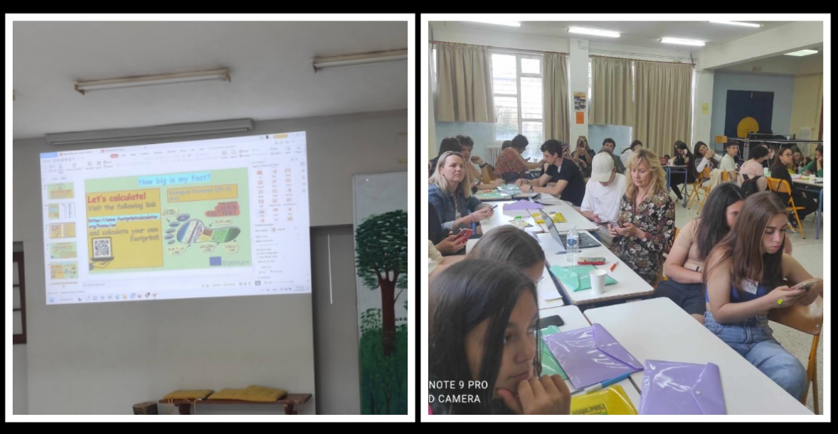
Students then participated in an activity where they physically expressed their agreement or disagreement with various proposals related to reducing the ecological footprint. They stood in a line, and as each proposal was read, they moved to the right if they agreed and to the left if they disagreed. This activity fostered critical thinking and group discussion on sustainability practices.
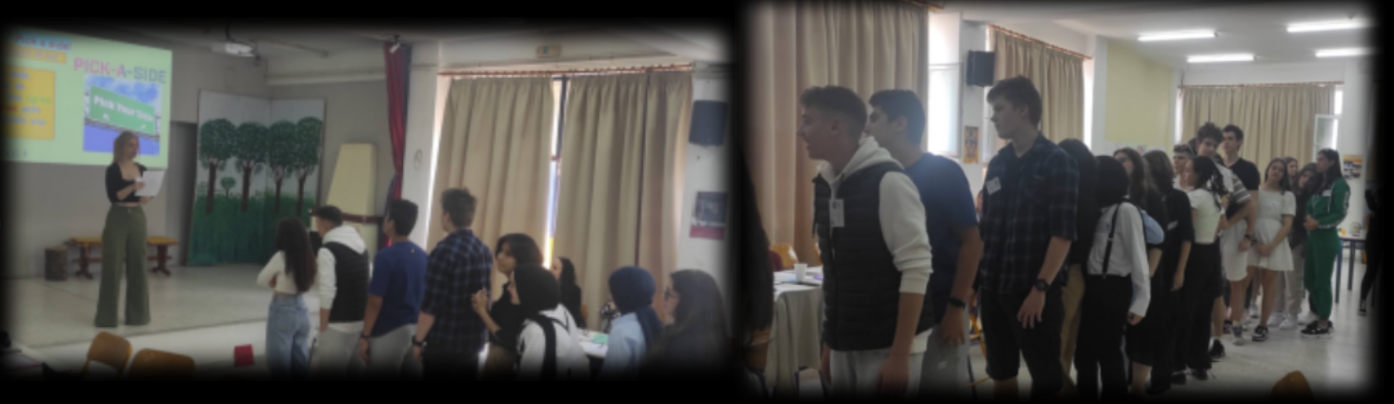
In the Reaction Chain activity, students were divided into teams and given cards with various actions and consequences. They had to put the cards in the correct order to understand the sequence of events and the environmental impact of each action. The stories on the cards illustrated that our reactions affect the environment either locally or globally.
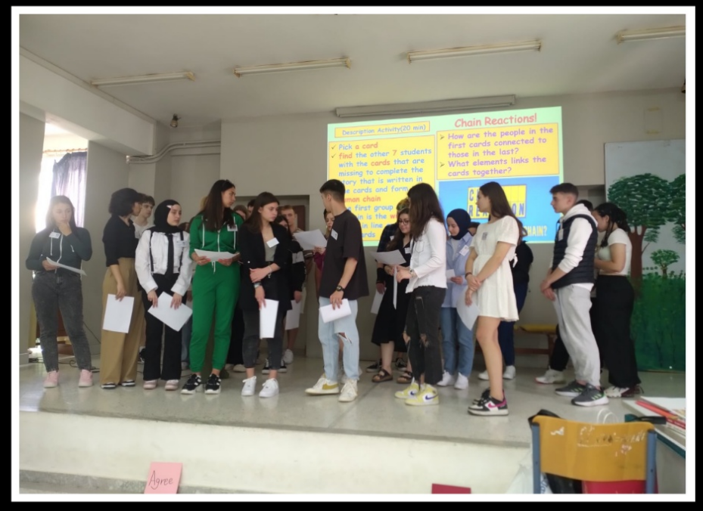
At the end, for the Four Corners activity, each one of the four international group of students, stood in a designated corner of the room. Each group focused on a specific sector of everyday life (e.g., transportation, personal actions, etc.). They discussed and proposed ways to reduce our ecological footprint in their assigned sector. This activity encouraged students to think critically about everyday actions and their environmental impact.
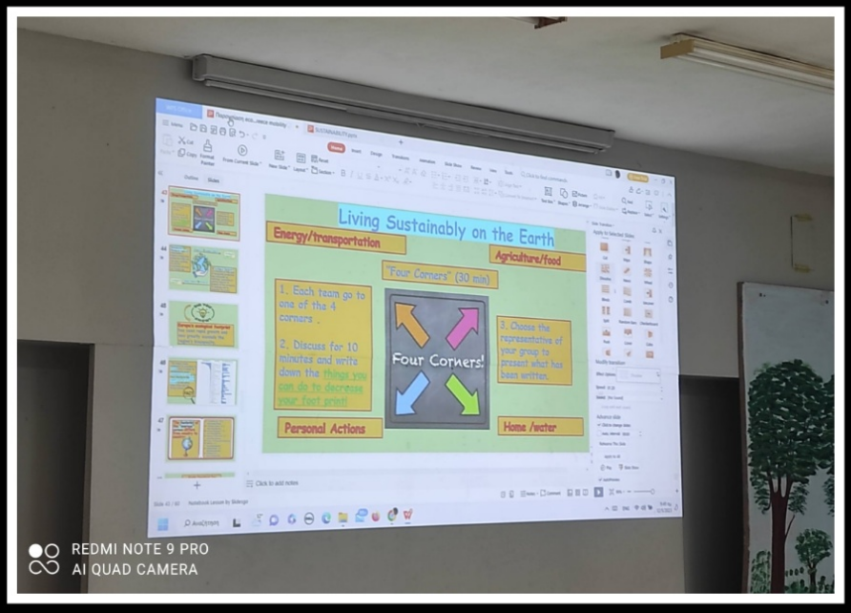
The session concluded with a reflective discussion, where students discussed the importance of understanding and reducing their ecological footprint and how they could apply what they learned to their daily lives and school environments. The facilitator summarized the key takeaways from the session and highlighted the connection to the upcoming mobility session in Turkey, where the focus would shift to carbon footprint.
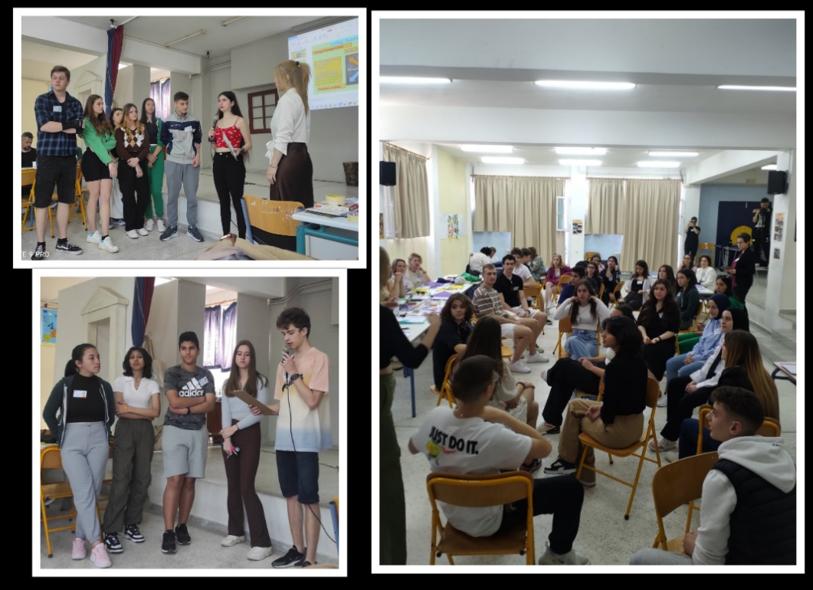
Skills Development
- Students, through the ecological footprint calculation, understood the personal and collective impact on the planet, realizing how actions affect the environment locally and globally.
- Through the Reaction Chain activity learned to analyze sequences of actions and their environmental consequences and simultaneously collaborated in teams to correctly order the reaction chain cards.
- Through the Agree/Disagree Line Activity they evaluated and formed opinions on sustainability proposals.
- Through the Four Corners activity they worked together to discuss and propose solutions, enhancing their critical thinking and problem solving skills as well.
- They also developed their communication skills by expressing their agreement or disagreement (line activity) and by presenting their ideas and solutions (Four Corners discussions) to reduce the ecological footprint in various sectors of everyday life.
EXAMPLES OF GOOD PRACTICES IN EDUCATION FOR ECOLOGY AND ENVIRONMENTAL PROTECTION

Mobility in TÜRKIYE

Ecological Education through Recycling Activity to Reduce Carbon Footprint

Teacher, Gülden Akar- Gölcük İhsaniye Anatolian High School, Türkiye

The project meeting of the Erasmus+ Ecological and environmental protection education in a European context! in Türkiye took place in November 2023. In the project meeting the participants experienced many learning experiences together with many good practices.
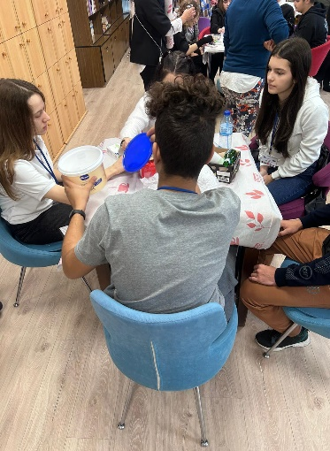
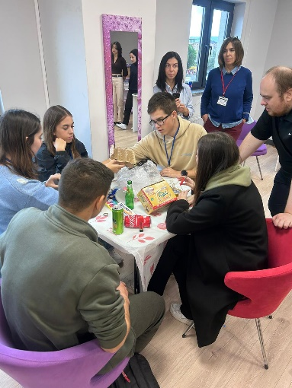
One of them was Environmental education through recycling activities.
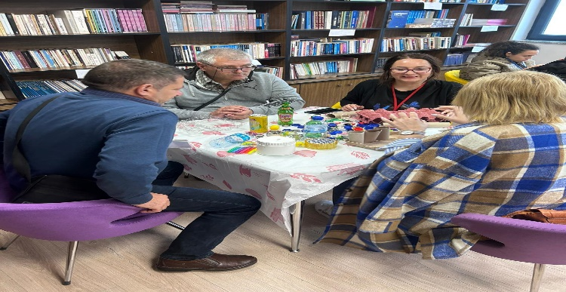
Environmental education through recycling activities can be a powerful way to teach individuals, especially children, about the importance of sustainability and conservation. Along with many ideas for incorporating recycling activities into environmental education, school programs can be very educative. So, we chose recycling workshops to reach that aim.

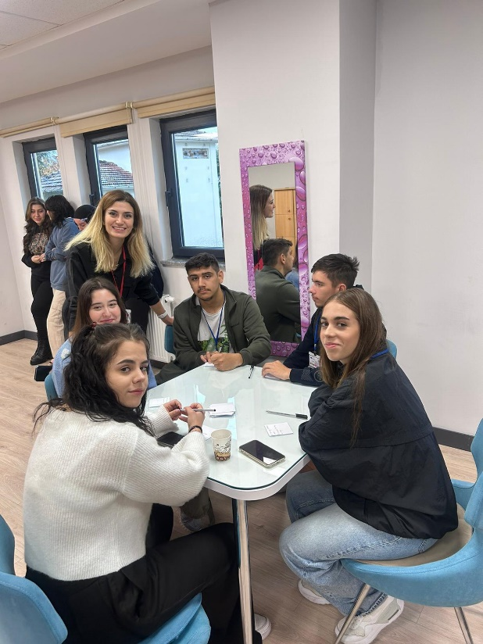
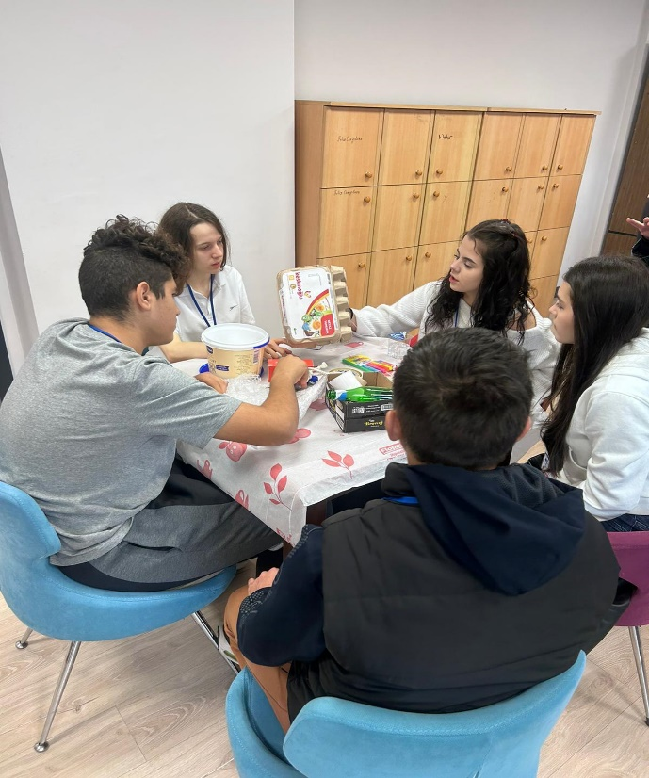
We gave training on recycling and then guided them to use their creativity to produce new items using recycled metarials even for art projects to show how waste can be repurposed creatively.
Of course before that we organized community clean-up events with our students where they can collect and sort recyclable metarial.
Another way to collect all these recyclable metarial was the home activities. We wanted our students to involve all family members to sort and bring recyclable waste to school.
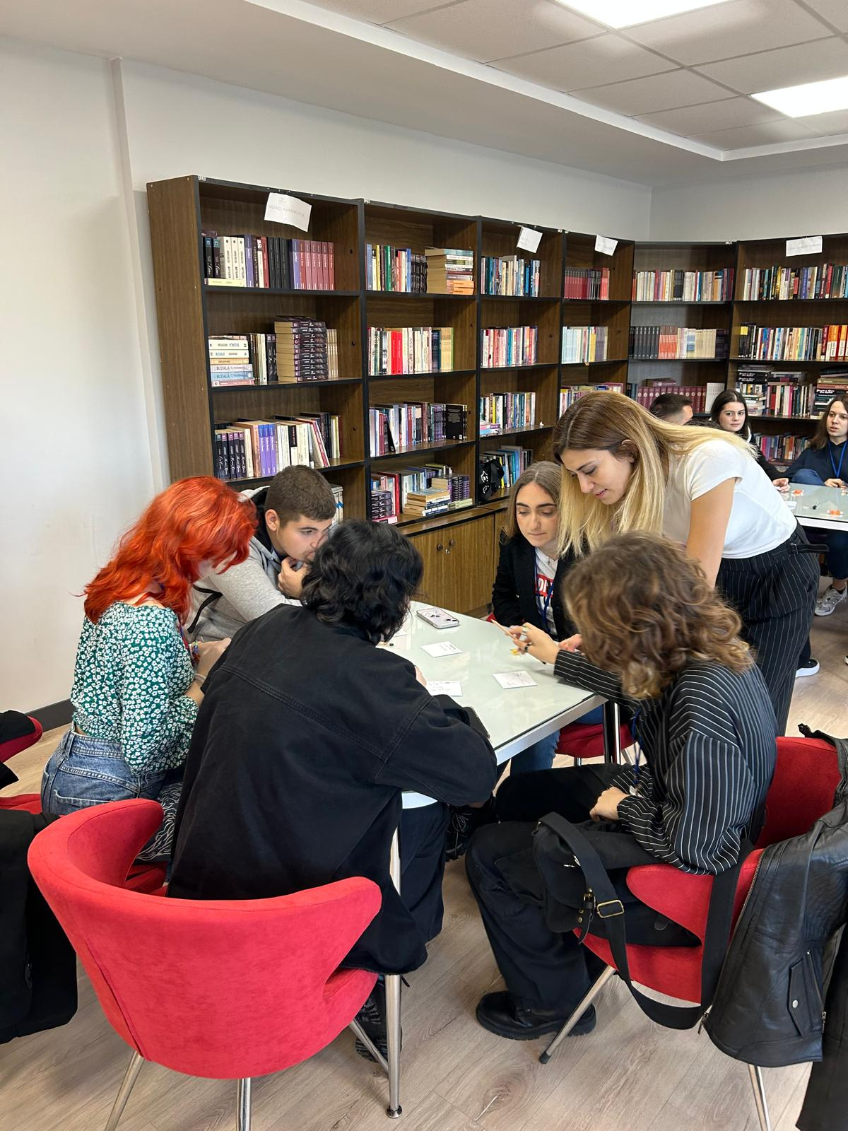
These activities can help individuals understand the importance of recycling, develop good habits, and contribute to a more sustainable future.

Recycling activities can help students develop good habits for the environment by fostering awareness, responsibility, and practical skills. Here are several ways these activities can have a positive impact:

1. Awareness and Education:
- Understanding Impact: Students learn about the environmental impact of waste and the benefits of recycling, fostering a sense of responsibility towards the planet.
- Knowledge of Materials: Activities teach students to identify recyclable materials and understand the recycling process.

2. Habit Formation:
- Routine Practice: Regular participation in recycling activities helps students develop the habit of sorting and disposing of waste properly.
- Consistency: Consistent reinforcement at school and home makes recycling a natural part of daily life.

3. Critical Thinking and Problem-Solving:
- Identifying Waste: Students learn to distinguish between recyclable and non-recyclable materials, enhancing their analytical skills.
- Creative Solutions: Recycling activities often involve creative projects, encouraging students to find innovative ways to repurpose materials.

4. Community and Collaboration:
- Group Projects: Collaborative recycling projects promote teamwork and a sense of community.
- Community Initiatives: Involvement in community recycling programs instills a sense of civic duty and environmental stewardship.

5. Responsibility and Ownership:
- Accountability: Students take responsibility for their waste and understand the consequences of their actions on the environment.
- Leadership: Older students can mentor younger ones, fostering leadership and a culture of sustainability.

6. Practical Skills:
- Sorting and Organizing: Hands-on activities teach students practical skills in sorting and organizing materials.
- DIY Projects: Creating new items from recycled materials helps develop craft and construction skills.

7. Long-Term Impact:
- Behavioral Change: Early education on recycling can lead to long-term behavioral changes, making students more likely to continue these practices into adulthood.
- Environmental Advocacy: Educated students may become advocates for environmental causes, influencing their peers and communities.

8. Health and Well-being:
- Cleanliness: Learning to manage waste properly contributes to a cleaner and healthier environment.
- Engagement with Nature: Recycling activities often tie into broader environmental education, fostering a connection with nature and a desire to protect it.

By integrating recycling into the curriculum and everyday activities, schools can help students develop a lifelong commitment to environmental sustainability.

Recycling affect carbon footprint, the theme of our mobility week was Carbon Footprint and the ways to reduce it. So recycling was the very activity to carry out.

Recycling can significantly affect the carbon footprint by reducing greenhouse gas emissions through various mechanisms. Here are some key ways in which recycling impacts the carbon footprint:

1. Energy Savings:
- Lower Energy Consumption: Recycling materials typically require less energy than producing new materials from raw resources. For instance, recycling aluminum saves up to 95% of the energy needed to produce new aluminum from bauxite ore.
- Reduced Fossil Fuel Use: Lower energy consumption means less burning of fossil fuels, which directly reduces carbon dioxide (CO2) emissions.

2. Decreased Landfill Emissions:
- Methane Reduction: Organic waste in landfills decomposes anaerobically (without oxygen), producing methane, a potent greenhouse gas. Recycling organic waste through composting or other means can significantly reduce methane emissions from landfills.

3. Conservation of Resources:
- Less Resource Extraction: Recycling reduces the need for extracting, transporting, and processing raw materials, all of which are energy-intensive and produce significant CO2 emissions.
- Sustainable Resource Management: Using recycled materials helps conserve finite natural resources and reduces the environmental degradation associated with mining, deforestation, and other resource extraction activities.

4. Manufacturing Emissions:
- Lower Industrial Emissions: Manufacturing products from recycled materials often produces fewer CO2 emissions compared to using virgin materials. For example, making paper from recycled paper reduces CO2 emissions by about 60% compared to making it from virgin wood pulp.
- Process Improvements: Recycling processes are continually improving, becoming more efficient and further reducing emissions over time.

5. Transportation Emissions:
- Local Recycling: Recycling materials locally can reduce transportation emissions compared to transporting raw materials from distant locations.
- Efficient Logistics: Centralized recycling facilities can optimize transportation routes and methods, leading to lower overall emissions.

6. Carbon Sequestration:
- Soil Improvement: Composting organic waste improves soil health and can enhance the soil's ability to sequester carbon, removing CO2 from the atmosphere.
- Reduced Deforestation: Recycling paper reduces the demand for new paper, thereby helping to conserve forests, which act as significant carbon sinks.

7. Product Lifecycle:
- Extended Lifespan: Recycling materials often involves creating new products from old ones, extending the lifecycle of the materials and reducing the need for new products, which in turn reduces emissions associated with production.
- Design for Recycling: Encouraging products designed for easier recycling can further reduce the carbon footprint associated with the end-of-life phase of products.

By integrating recycling into waste management and production processes, individuals, communities, and industries can significantly lower their carbon footprint, contributing to the fight against climate change.
The participants ,both the students and the teachers joined the recycling workshop and they created great things and also enjoyed themselves a lot. The most important thing was that after the training sessions on carbon foot print and recycling, they clearly put it into practice. The outcome was really satisfying.

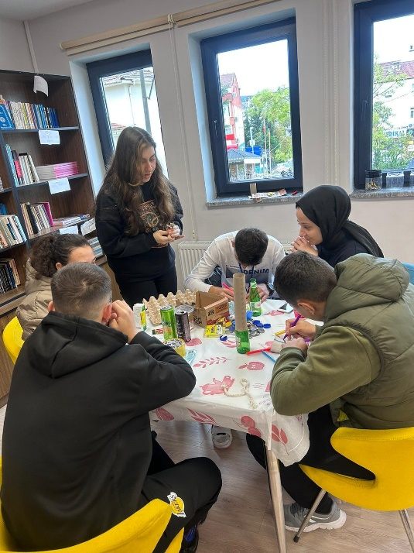
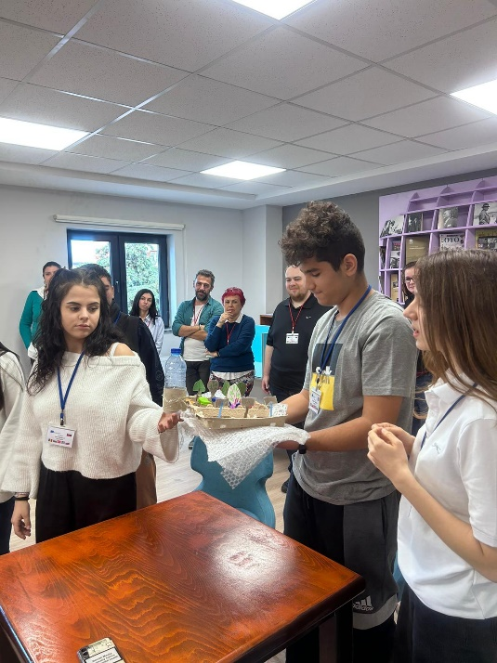
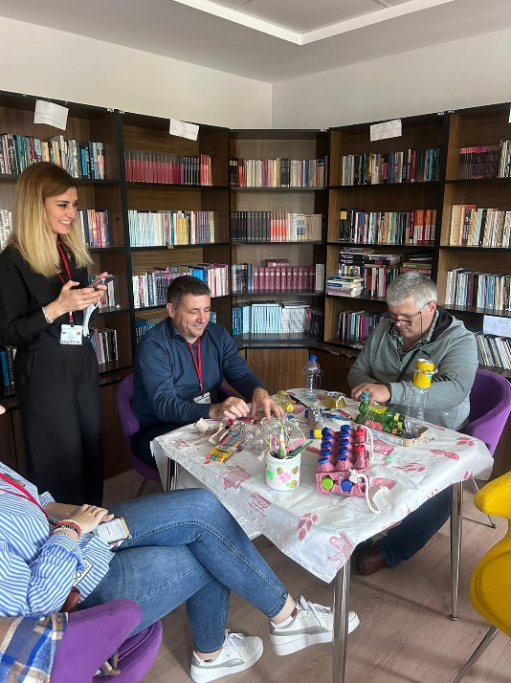
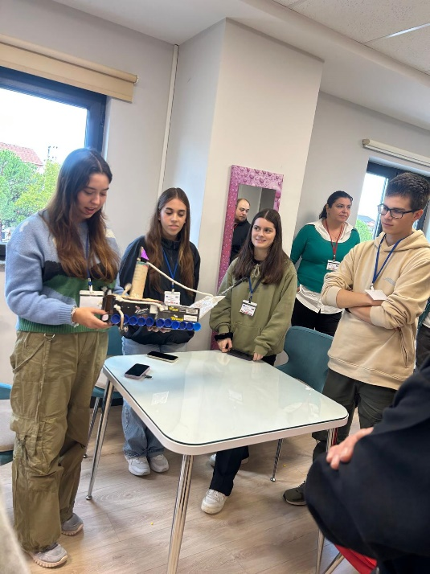

Thematic Visit to Nezahat Gökyiğit Botanical Park

Teacher Gülden Akar- Gölcük İhsaniye Anatolian High School, Türkiye

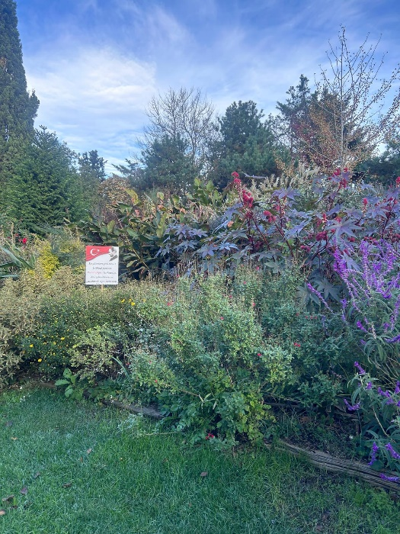
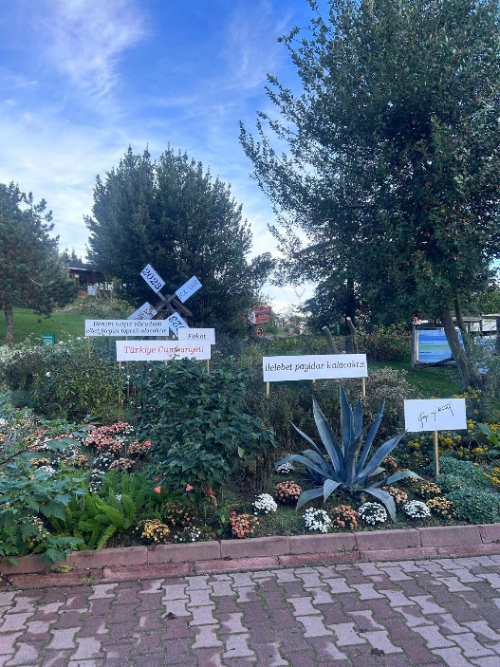
Nezahat Gökyiğit Botanical Park, located in Istanbul, Türkiye, is a significant green space dedicated to the preservation and exhibition of diverse plant species. The park was established by Ali Nihat Gökyiğit in memory of his wife, Nezahat Gökyiğit, and serves as a center for botanical research, education, and recreation.

Key features of the park include:

1. Diverse Plant Collections: The park hosts a wide variety of plants, including native Turkish species and plants from other regions, organized into thematic gardens.

2. Educational Programs: The park offers educational programs and workshops for visitors of all ages, focusing on botany, horticulture, and environmental conservation.

3. Research: It serves as a research center for botanists and horticulturists, contributing to the study and preservation of plant biodiversity.

4. Recreational Areas: Visitors can enjoy walking paths, picnic areas, and scenic spots throughout the park.

5. Conservation Efforts: The park plays a crucial role in the conservation of endangered plant species and promotes sustainable gardening practices.

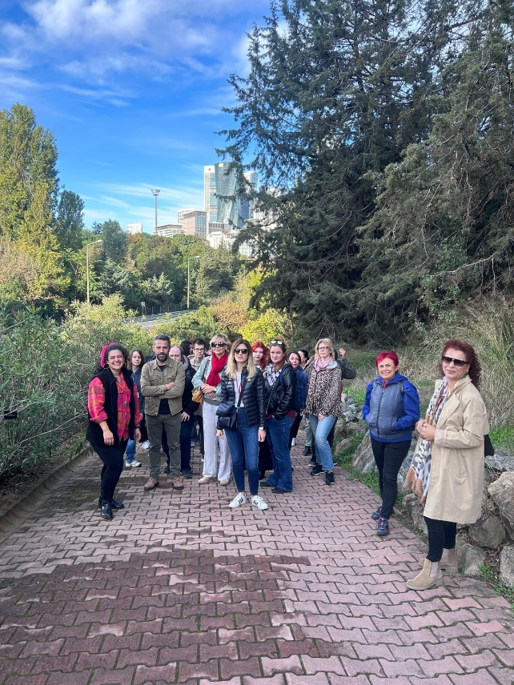
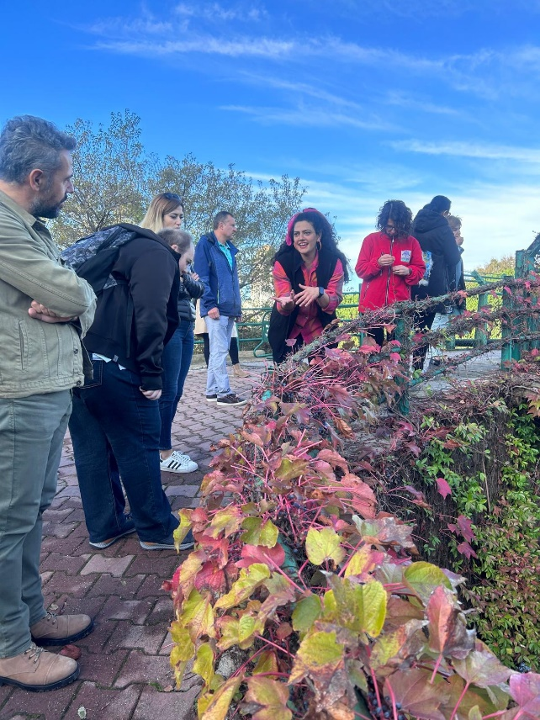

Nezahat Gökyiğit Botanical Park boasts an impressive diversity of plant species, with a focus on both native Turkish plants and exotic species. Here are some highlights of the plant biodiversity within the park:

Native Turkish Species
1. Anatolian Oaks (Quercus spp.): The park features various species of oaks native to Türkiye, showcasing their ecological importance and diversity.
2. Turkish Pine (Pinus brutia): This species is native to the Mediterranean region and is commonly found in Turkish forests.
3. Tulips (Tulipa spp.): Tulips have a historical and cultural significance in Türkiye, and the park displays a range of native tulip species.
4. Cyclamen (Cyclamen spp.): These are native to the Mediterranean region and are notable for their beautiful, distinctive flowers.

Exotic Species
1. Succulents and Cacti: The park has a collection of succulents and cacti from arid regions around the world, displayed in a specially designed garden.
2. Bamboo (Bambusoideae): Various species of bamboo are cultivated, demonstrating the plant’s versatility and importance in different cultures.
3. Ornamental Trees and Shrubs: The park features a wide variety of ornamental trees and shrubs from around the world, providing year-round beauty and ecological value.

Themed Gardens and Collections
1. Rock Garden: This area showcases alpine and rock garden plants, including many drought-tolerant species.
2. Mediterranean Garden: This garden highlights the flora of the Mediterranean region, with species adapted to the climate and soil conditions typical of this area.
3. Herb Garden: A collection of aromatic and medicinal plants used in traditional Turkish and Mediterranean medicine.

Conservation and Rare Species
1. Endangered Plants: The park is involved in the conservation of endangered plant species native to Türkiye and the surrounding regions.
2. Seed Bank: A seed bank has been established to preserve genetic diversity and support the reintroduction of rare and endangered species into their natural habitats.

Seasonal Displays
1. Spring Bulbs: In spring, the park features spectacular displays of bulbs, including tulips, daffodils, and hyacinths.
2. Autumn Foliage: In autumn, visitors can enjoy the vibrant foliage of deciduous trees and shrubs.

Nezahat Gökyiğit Botanical Park not only serves as a sanctuary for plant biodiversity but also educates the public about the importance of plant conservation and sustainable gardening practices.
Nezahat Gökyiğit Botanical Park offers a variety of educational programs aimed at different age groups and interests. These programs are designed to promote awareness and understanding of plant biodiversity, conservation, and sustainable practices. We planned and made a visit to this beautiful park to foster our participants’ interest in nature and environment.

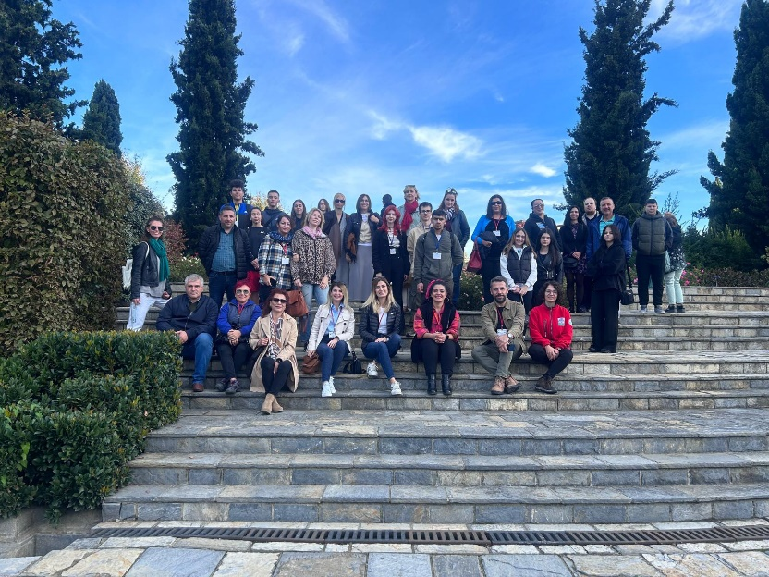
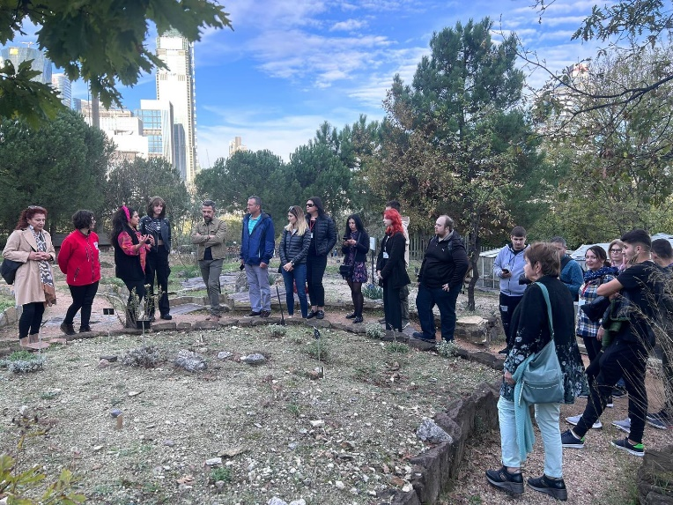

Thematic Visit to İzaydaş (Solid Waste Treatment Center)

Teacher Gülden Akar- Gölcük İhsaniye Anatolian High School, Türkiye

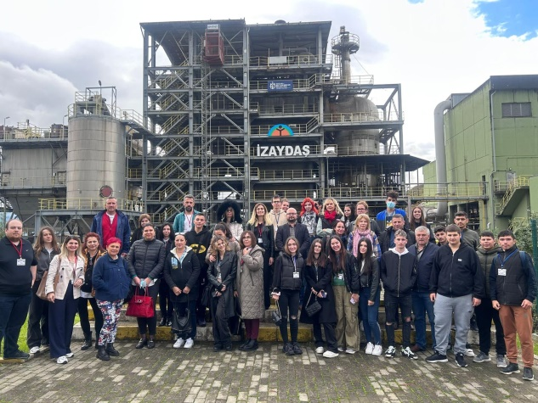
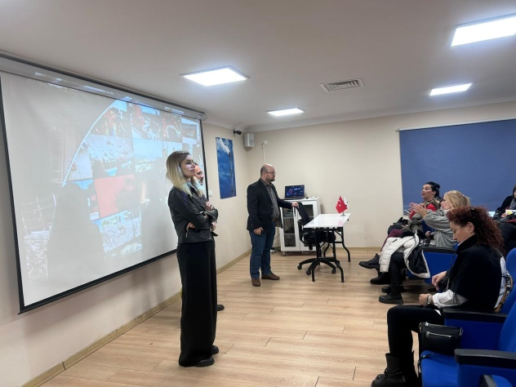
İzaydaş (İzmit Waste and Residue Treatment, Incineration, and Recycling Co.) is a prominent solid waste treatment facility in Türkiye. Located in the Kocaeli province, İZAYDAŞ specializes in the treatment, incineration, and recycling of hazardous and non-hazardous waste. The facility plays a critical role in environmental management by converting waste into energy, reducing landfill use, and promoting sustainable practices. Its operations include thermal treatment, biological treatment, and various recycling processes. The facility also focuses on maintaining high standards of environmental safety and compliance with national and international regulations.

It has many sections such as; Biogas Plant, Energy Production, Wind Turbines, LFG Energy Production Facility, Transportation Services, Regular Landfills, Sterilization Facility, Hydroelectric Power Plant(HEPP), Interim Storage Facility, Waste Water Treatment Plant, Laboratory, Consultancy Services, İzaydaş Academy, Proficiency Tests, Hazardous Waste Incineration Plant.

We took the participants to this center, they got training session on how the waste is collected, converted into energy and how all the processes are carried out. The authorities also ave a trip throughout the center by bus, showed the participants the sections one by one. It was all very informative, interesting and satisfying for all the participants.

Greening Activity

Teacher, Gülden Akar - Gölcük İhsaniye Anatolian High School, Türkiye

Greening activities are initiatives aimed at improving environmental quality and sustainability through various actions.
Greening activities are essential for creating healthier, more sustainable communities and addressing the global challenges of environmental degradation and climate change.
- Environmental: Improve air and water quality, enhance biodiversity, and mitigate climate change.
- Social: Foster community engagement, enhance public health, and provide recreational opportunities.
- Economic: Increase property values, reduce energy costs, and promote sustainable local economies.
Tree Planting is one of those acivities.
- Planting trees in urban, suburban, and rural areas to increase green cover, reduce carbon dioxide levels, and enhance biodiversity.
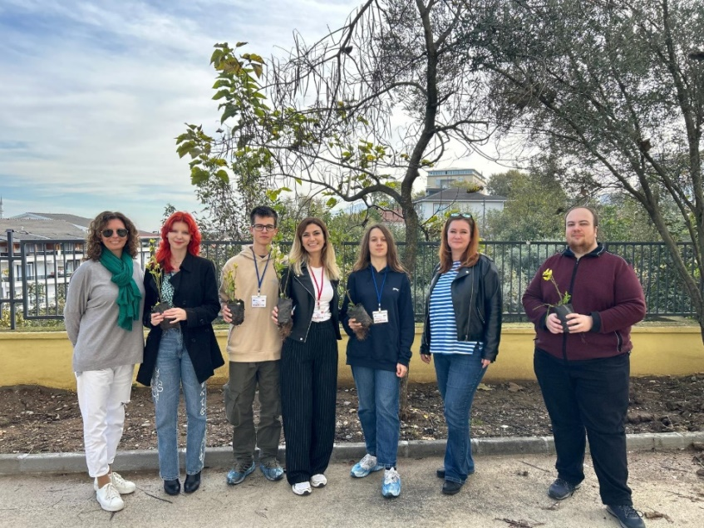
Tree planting is a popular and effective greening activity aimed at enhancing the environment.

Benefits of Tree Planting
- Environmental: Trees absorb carbon dioxide, produce oxygen, improve air quality, and provide habitats for wildlife.
- Social: Trees enhance community spaces, provide shade, and contribute to mental well-being.
- Economic: Trees can increase property values, reduce energy costs, and support local economies through tourism and recreation.

Purpose of Tree Planting

1. Environmental Conservation:
- Enhance air quality by absorbing pollutants and releasing oxygen.
- Mitigate climate change by sequestering carbon dioxide.

2 Community and Urban Improvement:
- Beautify neighborhoods and public spaces.
- Provide shade and cooling, reducing the urban heat island effect.

3. Educational and Social Benefits:
- Raise awareness about environmental stewardship and sustainability.
- Foster community engagement and volunteerism.
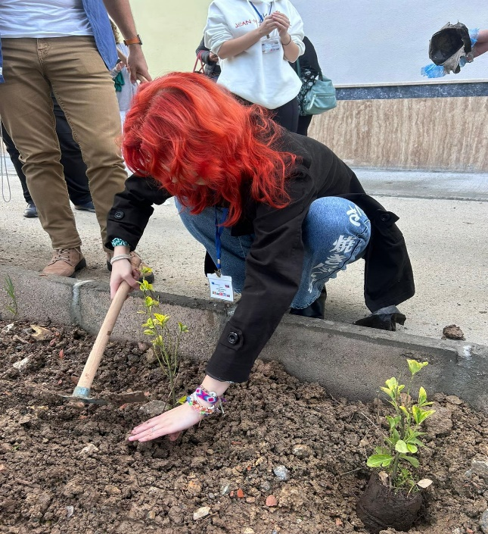
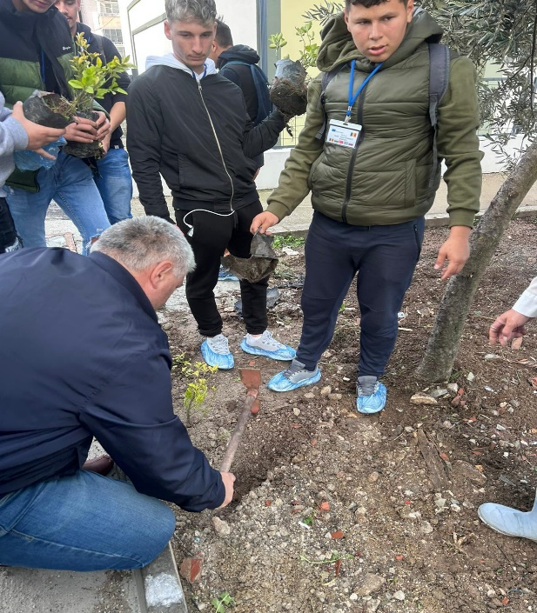
Objectives of Tree Planting

1. Increase Tree Canopy:
- Plant a specific number of trees to expand green cover in urban, suburban, and rural areas.

2. Enhance Biodiversity:
- Select diverse native species to support local wildlife and plant ecosystems.

3. Improve Air and Soil Quality:
- Plant trees to absorb pollutants and improve soil stability and fertility.

4. Provide Educational Opportunities:
- Use tree planting events to educate the public about the importance of trees and environmental conservation.

5. Promote Community Involvement:
- Engage community members in the planning, planting, and maintenance of trees.

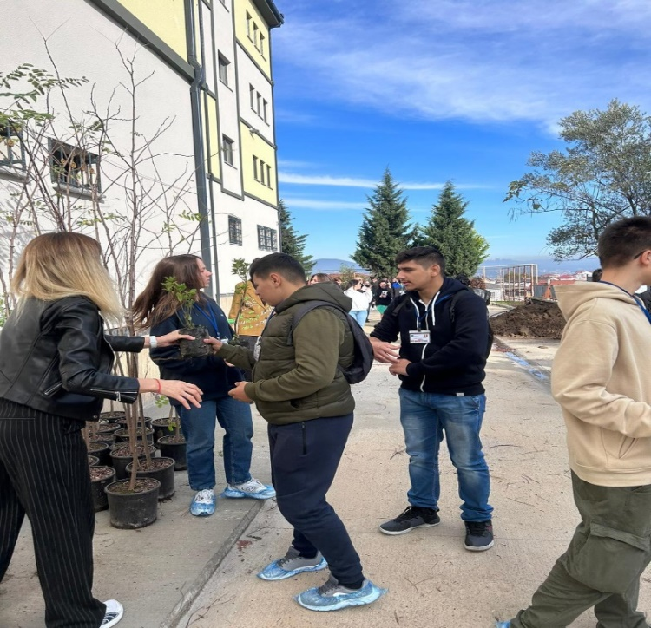
Expected Results of Tree Planting

1. Environmental Benefits:
- Improved air quality through the absorption of pollutants and release of oxygen.
- Enhanced carbon sequestration, contributing to climate change mitigation.
- Reduced soil erosion and improved water retention in soil.

2. Biodiversity Enhancement:
- Increased habitats for birds, insects, and other wildlife.
- Greater plant diversity, contributing to a healthier ecosystem.

3. Social and Community Benefits:
- Increased aesthetic value and attractiveness of neighborhoods and public spaces.
- Enhanced mental and physical health for residents through access to green spaces.
- Strengthened community bonds through collaborative planting and care activities.

4. Economic Advantages:
- Potential increase in property values due to the presence of mature trees.
- Reduced energy costs from the cooling effects of tree shade.
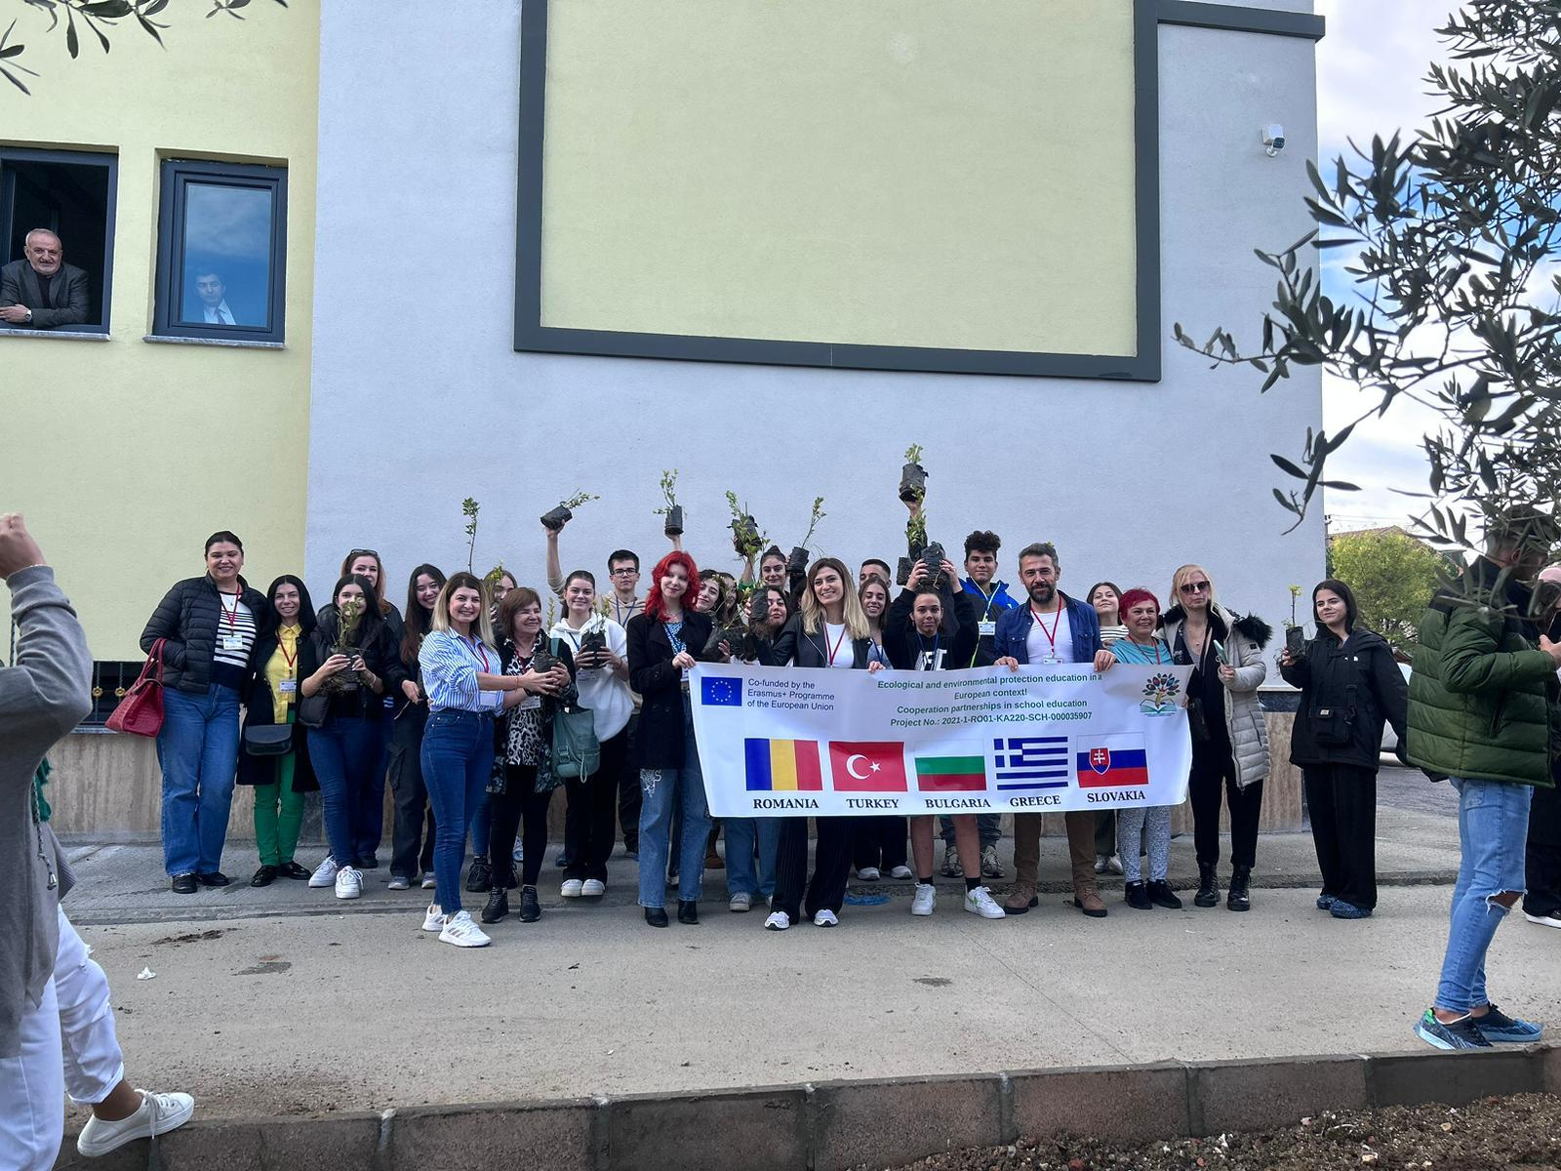

By setting clear objectives and regularly measuring outcomes, tree planting initiatives can significantly contribute to environmental conservation, community well-being, and sustainable development. Aware of this in the school yard, we organized such an activity with the participants
and left unforgettable memories both to the environment and to our lives.

EXAMPLES OF GOOD PRACTICES IN EDUCATION FOR ECOLOGY AND ENVIRONMENTAL PROTECTION

Mobility in ROMANIA

Ecological education through the ECO workshop

Teacher, Claudia Cozlosche, Liceul Tehnologic Costesti, Romania

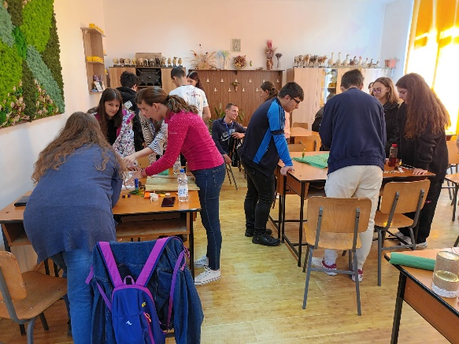
In the project meeting that took place in Romania, in October 2022, within the Erasmus+ Ecological and environmental protection education in a European context!”, the learning experiences, both for students and teachers, included various theoretical and practical activities.
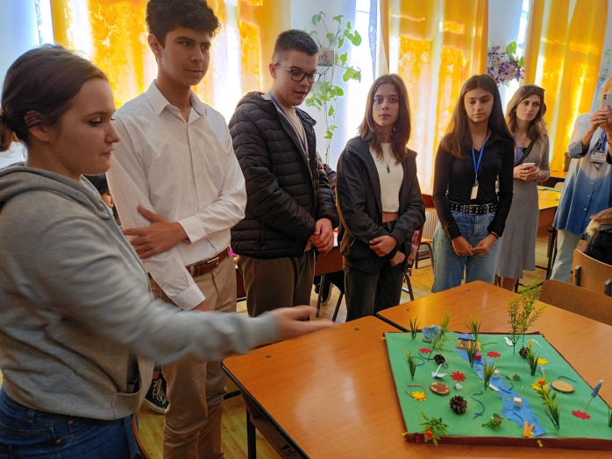
One of the practical activities, highly appreciated by the students, was the workshop where they made ecological models, in which all the mobility participants worked together to make models from recyclable material, small-scale models of frames or natural landscapes.
The students, led by the teaching staff, had as their theme the creation of models that represent ecological natural frameworks.

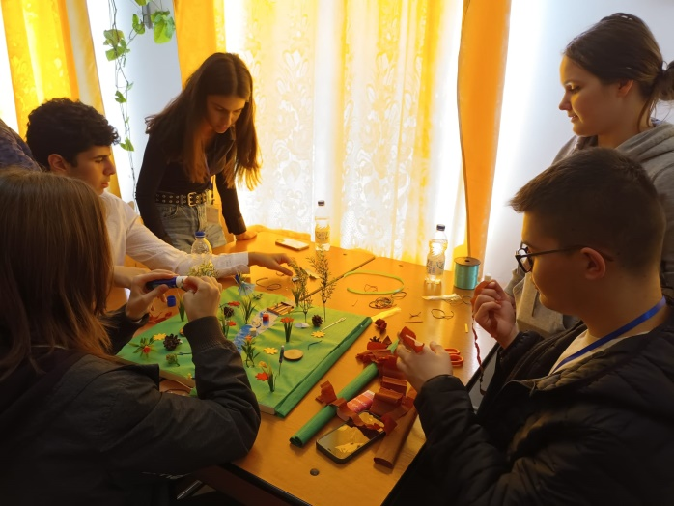
The students worked in groups and made ecological models from recyclable materials representing natural settings. Groups of students were made. In each group, students from each partner school were distributed, the activity succeeding in this way in achieving the goal of communication, collaboration and interaction between students, using the English language.
Groups of students and teachers collaborated and shared the available materials (polystyrene, crepe paper, glossy paper, colored paper, dry vegetation, wooden sticks, various ornaments). They debated ideas, opinions, points of view and agreed on ingenious, new, innovative models.
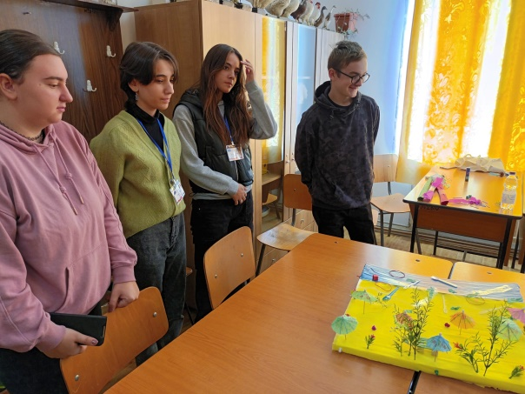
The activity had as its proposed, well-defined goal, the promotion and awareness of the importance of the principles of ecological education, which would sensitize the students and determine their real desire to protect the environment.
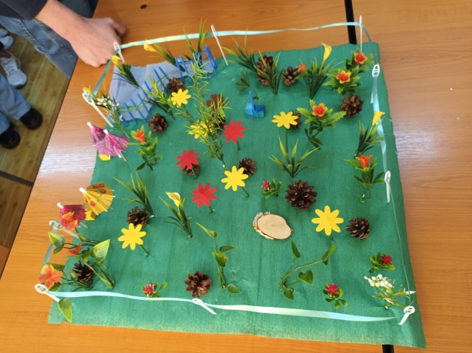
The main activities concerned the creation of models from recyclable materials, the organization of exhibitions of students' creations, exchanges of experience, exchanges of ideas, socialization, improving language skills, awareness of environmental issues and many others.
These are activities designed to make students aware that we need to save more, not to destroy the nature and what it offers us. In the current context of the energy crisis, the activity is all the more appropriate, drawing the attention of young people to the risks caused by waste. Thus, they are driven to find innovative ideas, make the most of resources and produce as little waste as possible.
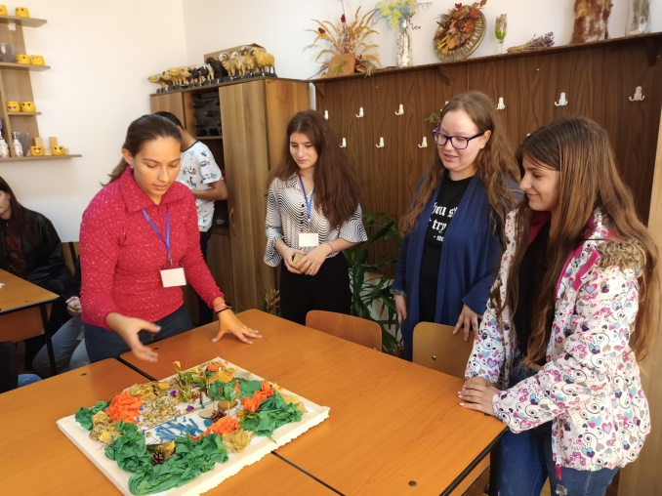
By carrying out these activities, we managed to attract attention, inform and educate students in order to be aware of environmental protection, and at the same time unite five nationalities, challenge them to debate, work and complement each other's ideas.
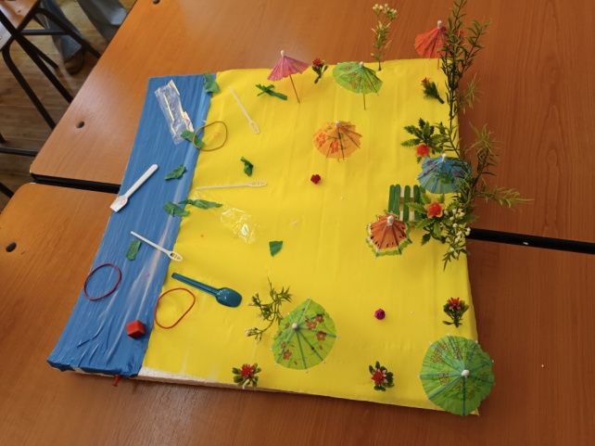

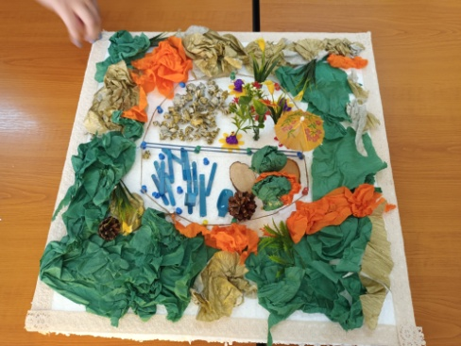

Thematic visit to the Visitor Center of Piatra Craiului National Park

Teacher Claudia Cozlosche, Liceul Tehnologic Costesti, Romania

The thematic visit to the Piatra Craiului National Park Visitor Center is a recommended activity for both teachers and students. The tour of the center involves a unique, virtual experience on Piatra Craiului.
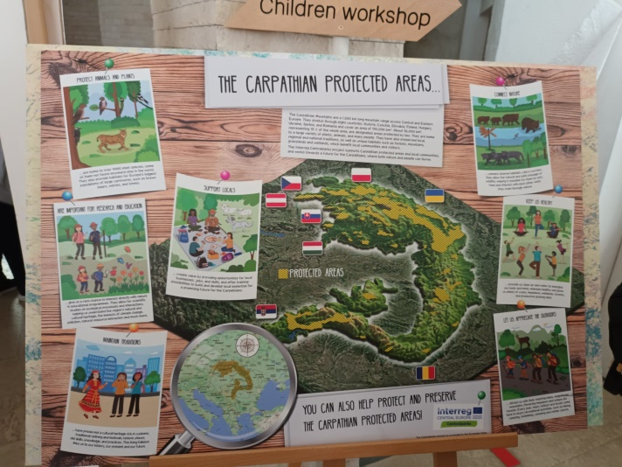
The purpose of the activity: the implementation of an educational program for students and teachers regarding the protection of natural and traditional values ​​in the Piatra Craiului National Park.
Through interactive strategies, students will be put in a position to observe, analyze, investigate phenomena and processes in the environment, practicing intellectual work skills at the same time as forming a responsible behavior towards the environment.

The visitor center of the Piatra Craiului National Park in Zărnești is an important attraction of the area, both for students - who have the opportunity to learn about the flora, fauna and geology of the area, and for teachers - who can gather new information about one of the most spectacular national parks in the country.
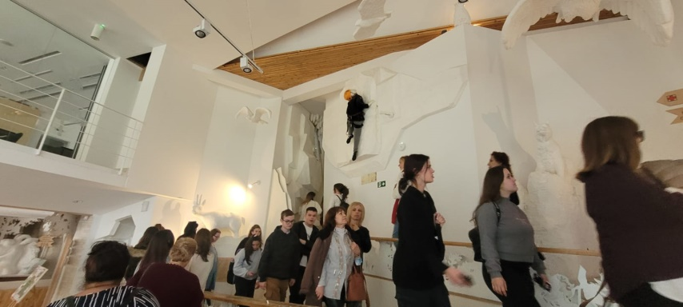

Students and teachers visited the Center of the Piatra Craiului National Park in Zărnești. The interior of the Visitor Center is designed as a circular route, which once completed provides information on the flora, fauna, geology, the ridge and grohotis area, the caves, the local communities and the tourist routes of the Piatra Craiului National Park.
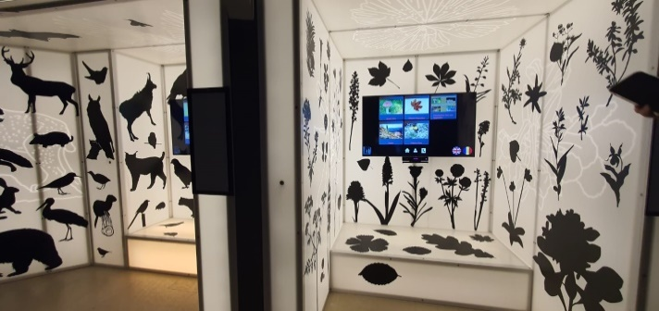
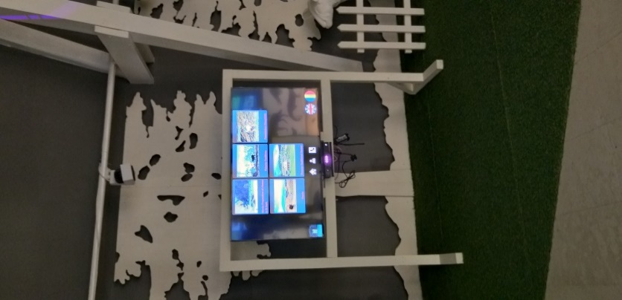
The exhibition space is designed in such a way as to provide visitors with unique and emotional experiences. Thus, thanks to the interactive way of transmitting text and image information, through monitors with LED and Kinect technology, lights and sounds, the participants found out and learned about the specific elements of the Piatra Craiului National Park. With the help of touch screen devices, visitors can see landscapes from Piatra Craiului and learn all the necessary information about the flora and wild animals that live here, but also about the rocks that make up the massif. I can also take a virtual tour of the tourist routes. All with a simple movement of the hand. The monitors offered information on various topics, presented in the form of short films, presentations, photo collections and puzzles. Also, inside the Visitor Center, visitors viewed a traditional stana, a cave with characteristic geological formations and a 3D model of the National Park on which maps can be projected on different themes, namely tourist routes, types of soil, types of rocks , types of habitats, categories of owners / administrators, land use and internal zoning of the national park.
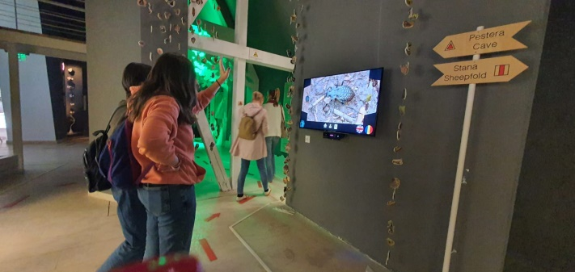
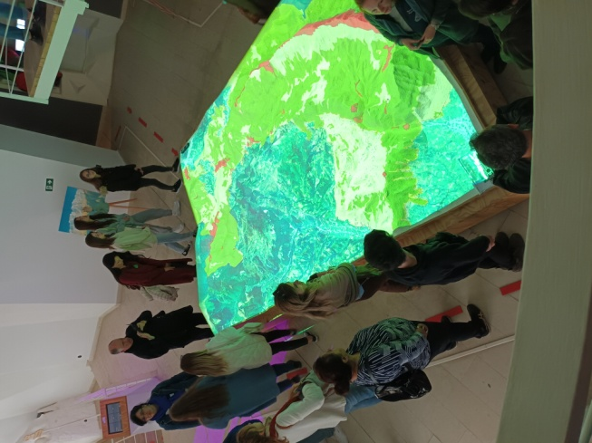

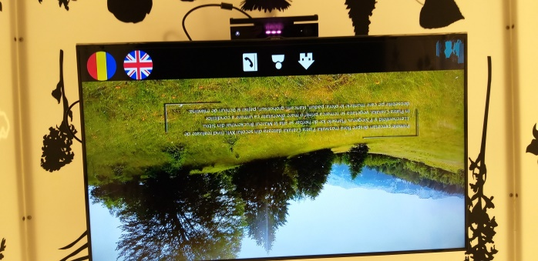

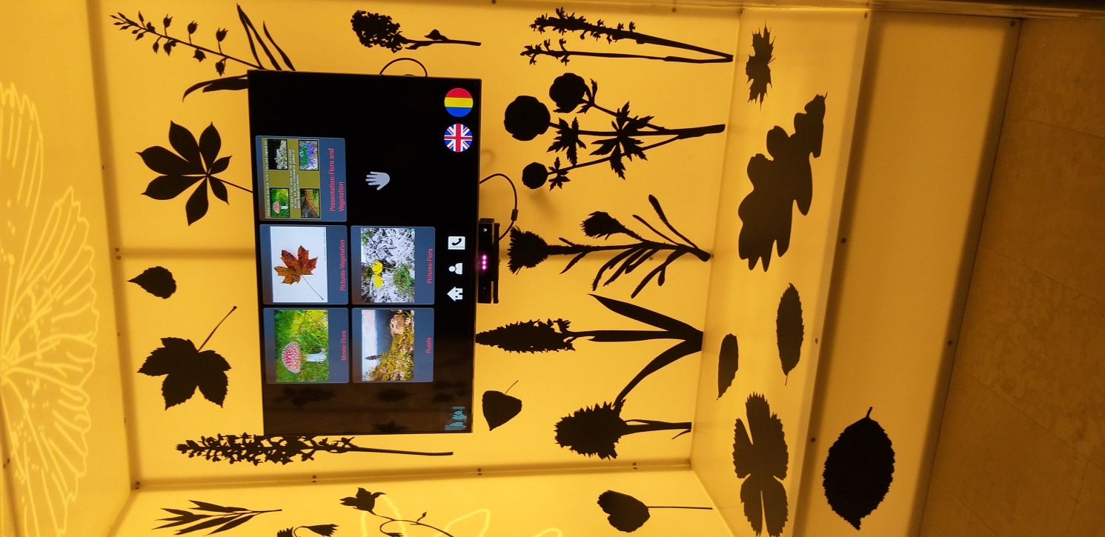
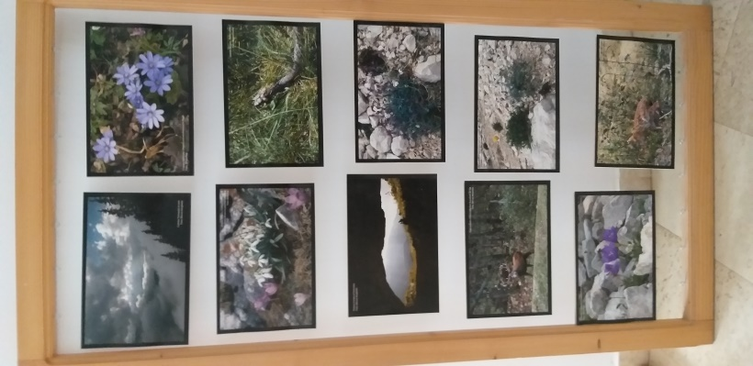
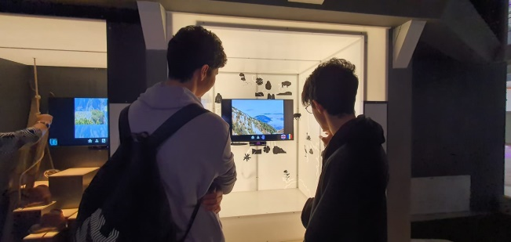
Wild animals were admired on the route that runs through the visitor center. These were not only seen, but also heard, a fact that brings an element of spectacularity and is certainly a great attraction for students.

The students were delighted with the visit to this educational center. From the karst phenomena, to the interaction with the fauna and flora of the natural park, everything is reproduced through models that provide details about the park.

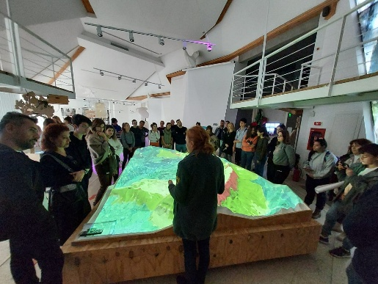
At the end of the activity, the students received brochures and leaflets about biodiversity conservation in Piatra Craiului National Park.
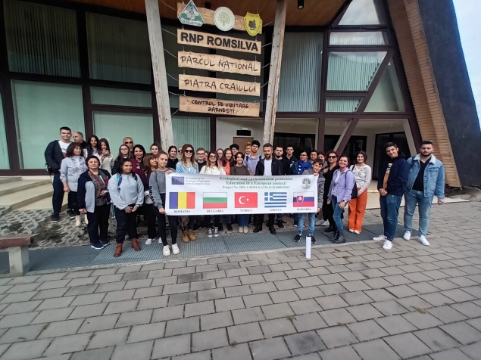

Greening activities

For a clean and healthy environment!

Teacher, Claudia Cozlosche, Liceul Tehnologic Costesti, Romania

The training activity took place outside the school, in nature. Outdoor education allows direct contact with nature.
Outdoor education is based on experience and practical activity. Outdoor activities represent a sum of learning experiences, a natural, relaxing, free environment, which inspires the child, helps him to enter into a relationship with others.
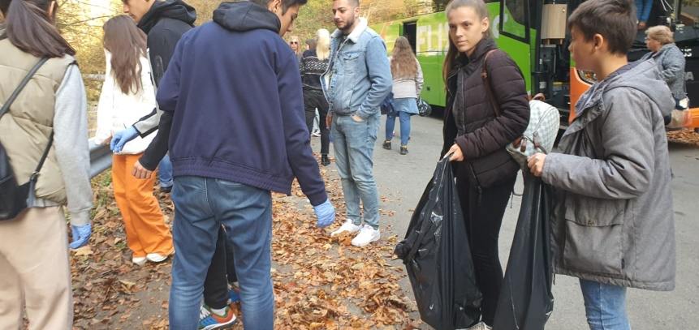

Purpose of the activity:
- Promoting a clean environment and implicitly protecting health;
- Increasing interest and active involvement in the field of environmental protection:
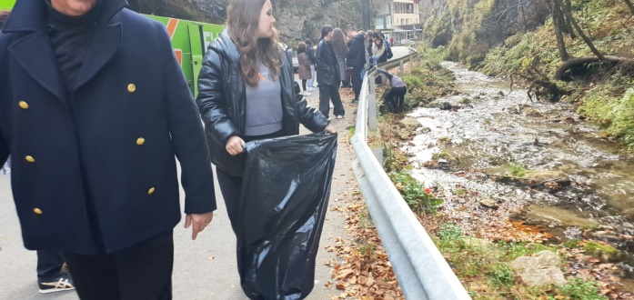
- Formation of a positive attitude towards nature;
- Development of feelings of love and protection of nature.

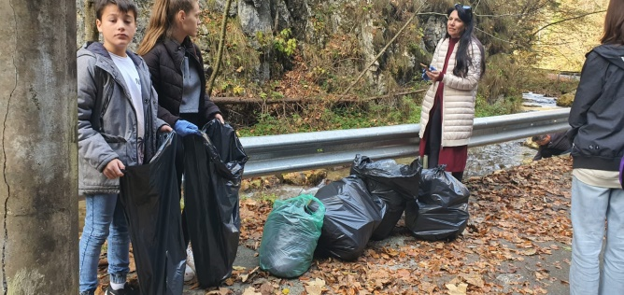
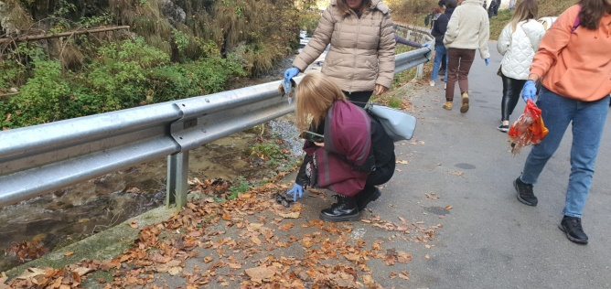

Objectives:
- Information, awareness, education and involvement of participants on the importance of keeping a clean environment.
The students together with the teachers participated in a cleaning activity in the Cheile Dambovicioarei area. The students received cleaning bags, disposable gloves and after a preliminary discussion, they understood the need to maintain cleanliness in the environment. Students armed (or equipped) with gloves and cleaning bags were divided into work teams and cleared the area of ​​waste. Students will want to have an equally clean and healthy environment for today's and tomorrow's generations, and for people to follow suit.
The practical activities carried out contribute fully to the education of the students.
The activity aims to stimulate respect for nature, the formation of beliefs, habits and behavioral skills as future citizens. The activity gave the students the opportunity to reflect on the attitude they should have towards nature.
Cultivating the household spirit, respect for those around and education for the environment in which they live were some of the objectives targeted during this activity.
In preparation for this action, the students discussed the importance of preserving the environment, the behavior of all citizens regarding the cleanliness of green areas and the involvement of institutions in this field. Theoretically, we all know how to behave, but reality has shown us that we still have a lot to work on in terms of environmental protection, that's why we will continue to carry out ecological activities.
Through the activity carried out, the following direct benefits were found:
- Develops practical skills and abilities;
- Ensures a harmonious physical condition;
- Develops self-discipline;
Completes formal education;
- Socialization;
- Education for a healthy life;
- Increasing self-esteem;
- Increasing self-confidence, the ability to integrate quickly in a group of children of the same age, developing leadership skills;
- I arouse interest in participating in new and complex tasks;
- Develop communication skills, being oriented towards cooperation and collaboration, without which the team's common goal cannot be achieved.

A clean environment, a healthy life!
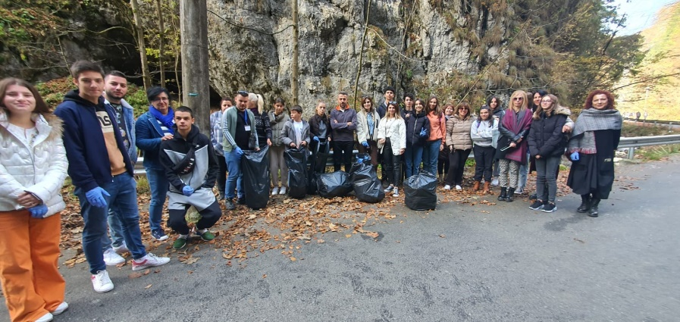

Thematic visit. "Alexandru Beldie" Visiting Center of

Bucegi Natural Park - Natura 2000 Sit (Bușteni)

Teacher Alexandra Oprea, Liceul Tehnologic Costesti, Romania

Located in the heart of Romania, between urban areas of major importance and close to the famous mountain resort - Sinaia, Bucegi Natural Park is an extremely popular protected area in our country and part of the international Natura 2000 network. Some of the most famous attractions associated with Bucegi Natural Park, besides the large bear population and breath-taking scenery, are the Sphinx and Babele, conglomerate rocks carved by wind erosion. Bucegi Natural Park was established in 2003, becoming a sanctuary for the preservation of traditional cultural landscapes, where sustainable human activities are part of nature. With an impressive biodiversity of fauna and flora, including endemic and rare species, this protected area has been a subject of study for local and international biologists since the 19th century.

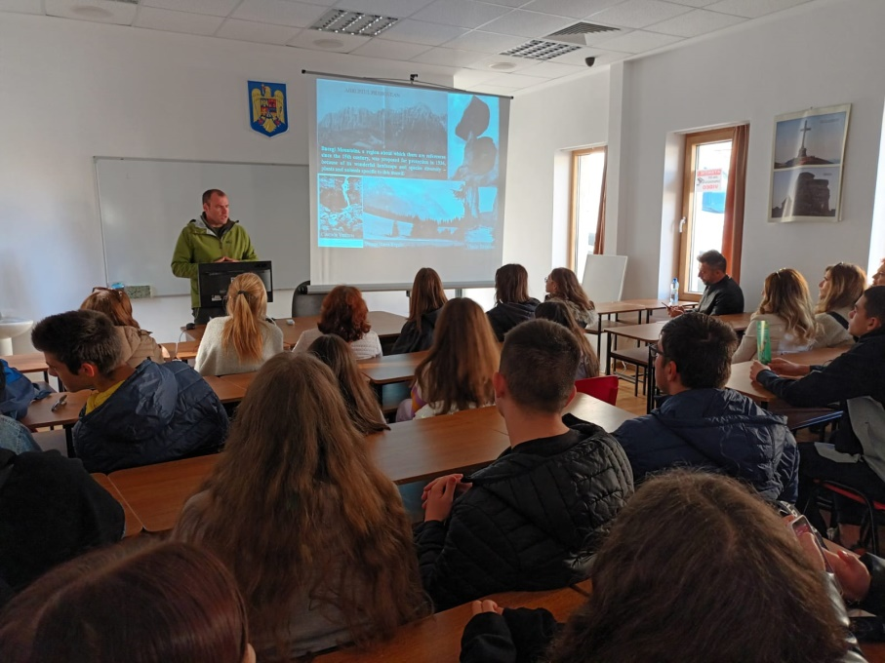
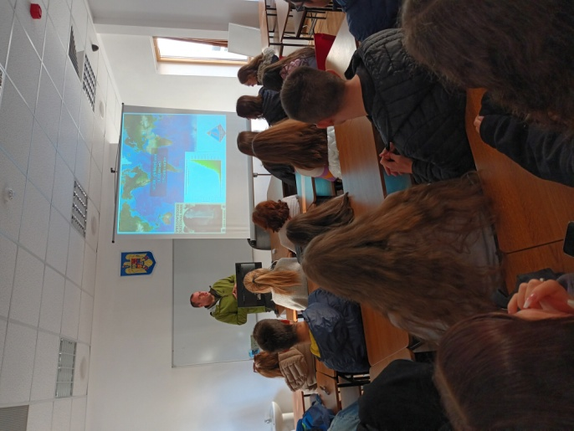
Students and teachers visited the Bucegi National Park Center. Then they participated in a training seminar on protecting biodiversity with practical applications for educational purposes.

The participants were informed about the natural heritage, flora, fauna, natural monuments, nature reserves in the Bucegi Natural Park as well as the tourist routes in Bucegi.
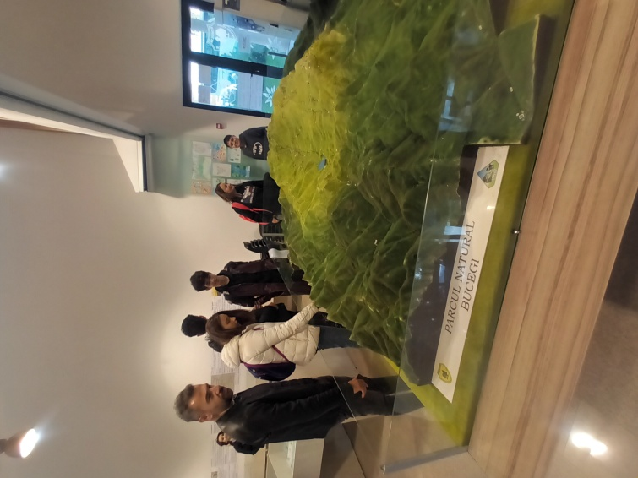
The students saw the most significant aspects of the flora and fauna of the Bucegi Massif. The multitude and diversity of exhibits – plants, birds and animals, many of which are rare species and varieties, monuments of nature, captured in their natural environment, superb alpine landscapes skilfully reproduced in photographic images and suggestive museum ensembles, unique plant associations and certain biocenoses.

The students saw the most significant aspects of the flora and fauna of the Bucegi Massif. The multitude and diversity of exhibits – plants, birds and animals, many of which are rare species and varieties, monuments of nature, captured in their natural environment, superb alpine landscapes skillfully reproduced in photographic images and in suggestive museum ensembles, unique plant associations and certain biocenoses.
The fauna of the park is diverse and represented by several species of mammals, birds, fish, amphibians and reptiles, some of which are protected by law.
The flora of the protected area consists of plant species distributed in tiers, in accordance with the geological structure, soil and climate characteristics, geomorphological structure or altitude.
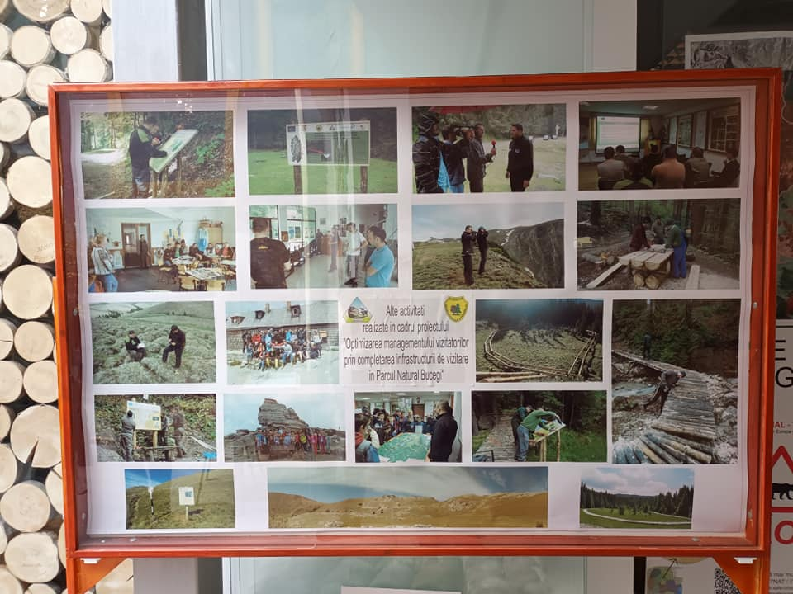
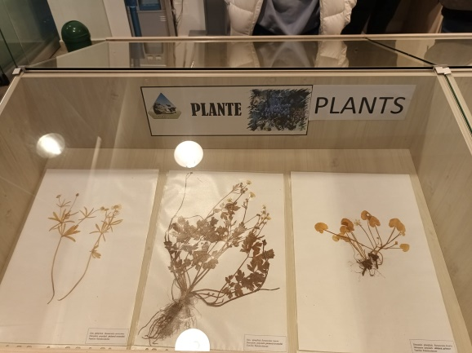
The Visitor Center benefits from a modern building, equipped to the highest quality standards. It is a small museum of the Bucegi Mountains and local traditions, with exhibition halls, insect collections, rock collections, fossils, vintage photographs of the nature of the area and more.
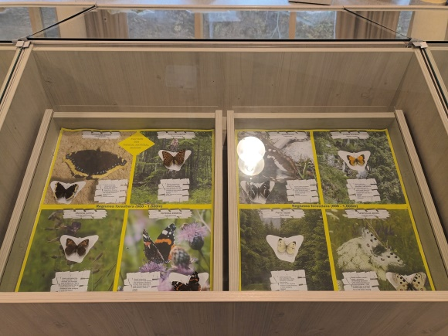
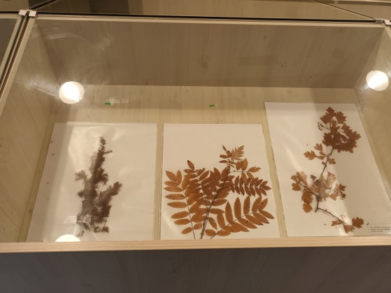
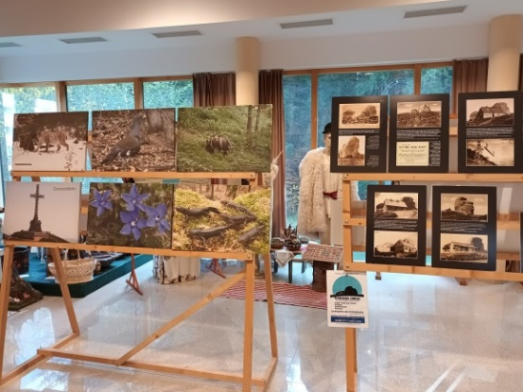
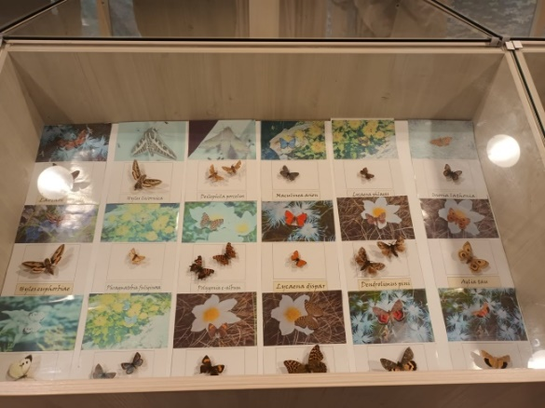

The Visitor Center has an information point, an exhibition space, a conference room equipped with a video projection screen, an audio system for conferences, a classroom equipped with a video projector, blackboard, computer and printer, microscopes and biology kits, administrative spaces, etc. The investment will contribute to the development of local economic activities, by promoting the area and natural values.
The Visitor Center also hosts thematic exhibitions of visual art, drawing, painting and photography.

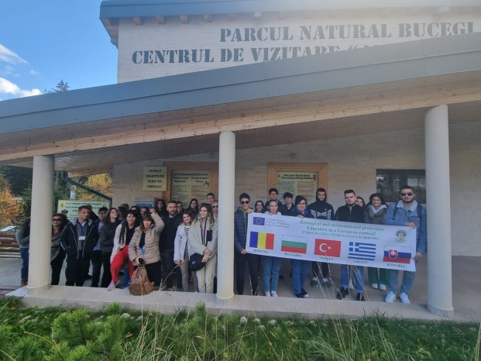

EXAMPLES OF GOOD PRACTICES IN EDUCATION FOR ECOLOGY AND ENVIRONMENTAL PROTECTION

Mobility in BULGARIA

“Who needs Nature most?”, “Planet vs. Plastics”
(Global Theme for Earth Day 2024) Workshop

Teacher, Veneta Velkova, 32. SUICHE “Sveti Kliment Ohridski”, Bulgaria

The workshop aimed to address the global themes for Earth Day 2024, focusing on the vital question of “Who needs Nature most?” and the urgent issue of “Planet vs. Plastics.”

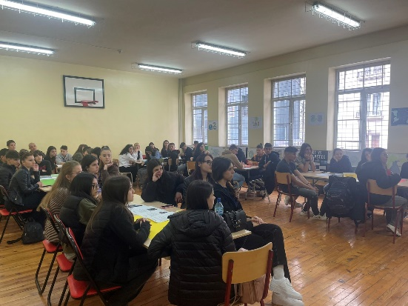
The objectives were:

1. Raise Awareness: Increase understanding of the importance of biodiversity and the impact of plastic pollution on ecosystems.

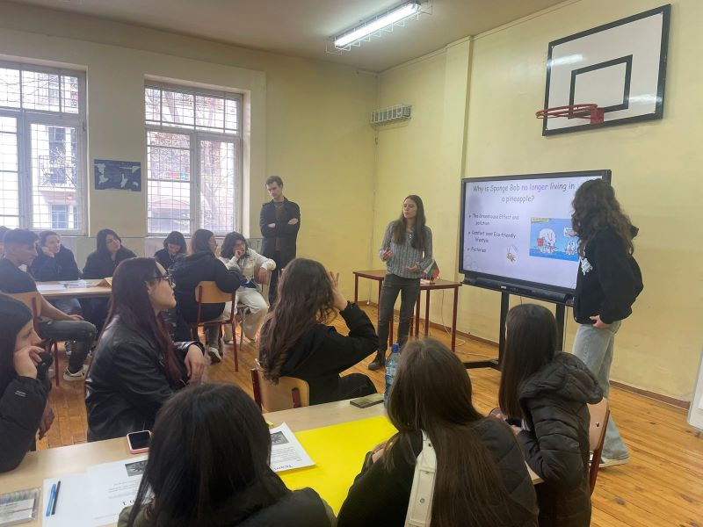
2. Promote Best Practices: Share effective strategies and actions that have been successful in different regions to combat plastic pollution and support nature conservation.

3. Encourage Collaboration: Foster partnerships and collaborative efforts among various stakeholders, including educators, students, environmental organizations, and policy-makers.
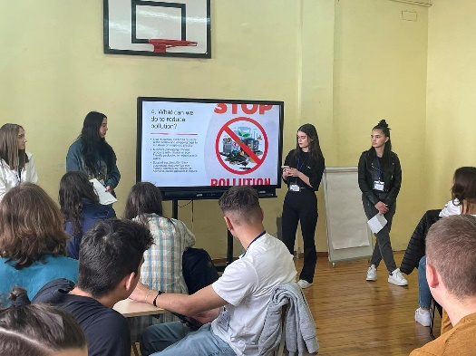
The students were divided in 6 international groups and they had to work together to investigate research, discuss, make pictures, draw pictures, prepare presentations and express their opinion.

We started with understanding the themes - “Who needs Nature most?” - Discussion on the interdependence between humans and nature; Case studies highlighting communities and ecosystems that rely heavily on biodiversity. - “Planet vs. Plastics” - Examination of the global plastic crisis; Impact of plastic pollution on marine and terrestrial life.
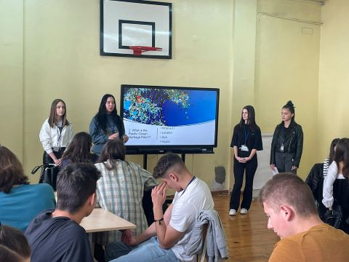
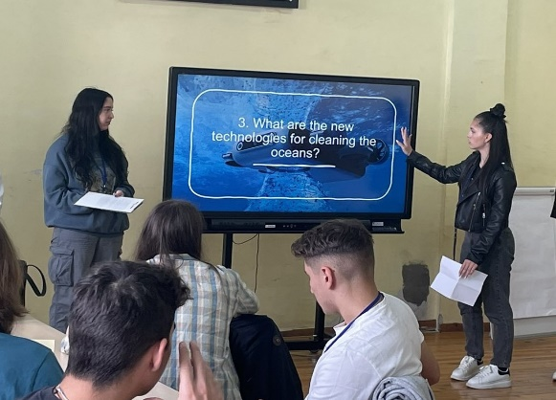
The students from the partner schools presented ppt presentations that they had prepared before coming to Bulgaria.

We continued with group discussion about successful initiatives in reducing plastic use and promoting recycling, community-driven conservation projects that protect local biodiversity, schools implementing biodiversity gardens and wildlife corridors on their grounds, towns that have successfully eliminated single-use plastics through community engagement. Each team chose a leader and a speaker who expressed the opinions and findings of their teams.
At the end of the workshop the participants had to complete a questionnaire to show what they know about plastic, its diversity, the associated environmental problems and possible solutions. link

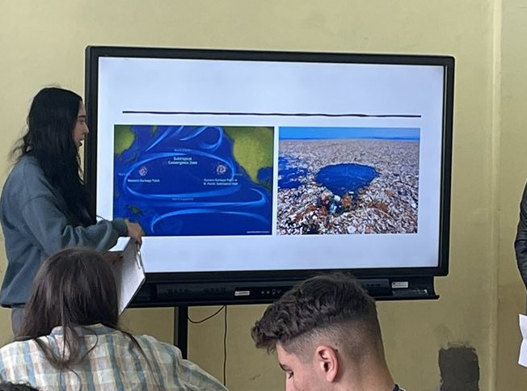
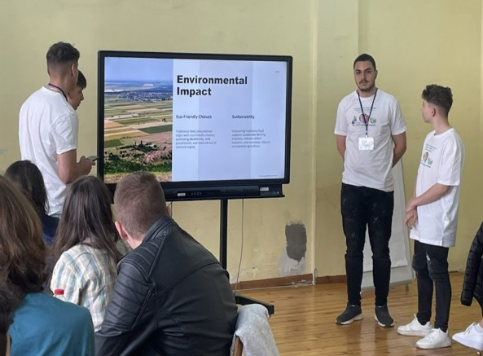

The workshop on “Who needs Nature most?” and “Planet vs. Plastics” aimed to empower participants with knowledge, skills, and networks to drive meaningful environmental change. By sharing best practices and fostering collaboration, we can collectively contribute to a more sustainable and resilient planet.

"I Am What I Eat"

Intercultural Cuisine Presentations on Balanced Diet

Teacher, Veneta Velkova, 32. SUICHE “Sveti Kliment Ohridski”, Bulgaria

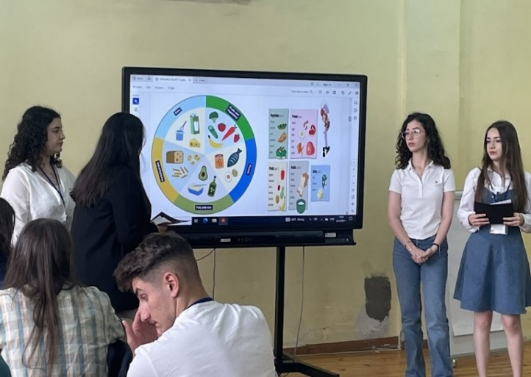
“I Am What I Eat" emphasizes the connection between our food choices and our overall health, well-being, and cultural identity. It encourages students to explore the nutritional value of different foods and understand how diverse cuisines contribute to a balanced diet. This approach can enhance students’ knowledge of nutrition while fostering an appreciation for cultural diversity through food.
The objectives were: - Promote Healthy Eating: Educate students on the importance of a balanced diet for overall health and well-being; - Cultural Awareness: Enhance students' understanding and appreciation of different cultures through their culinary practices; - Practical Skills: Develop students' abilities to prepare healthy meals and make informed dietary choices.
The students from the partner schools presented their national cuisine as part of healthy and balanced diet. Discussions followed.
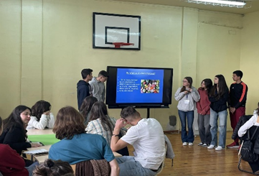

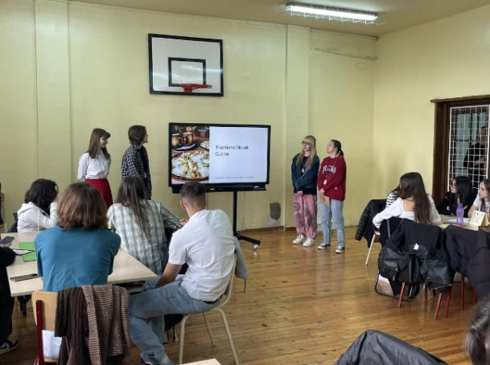
Conclusion at the end of discussion: By incorporating "I Am What I Eat" into school lessons, students gain a comprehensive understanding of the importance of a balanced diet and the rich diversity of global cuisines, fostering both health and cultural awareness.
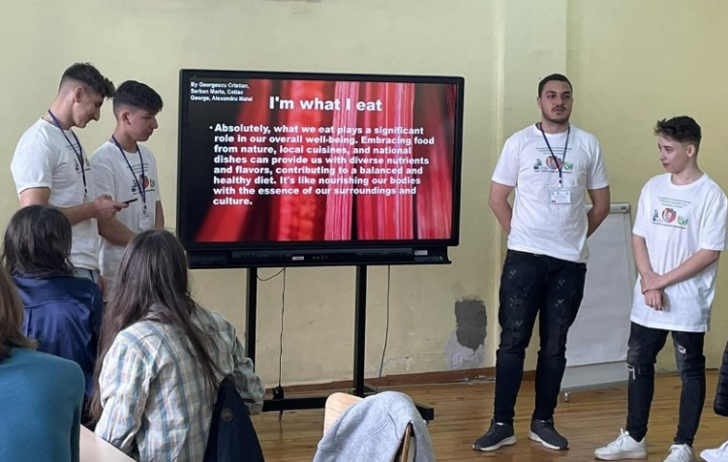

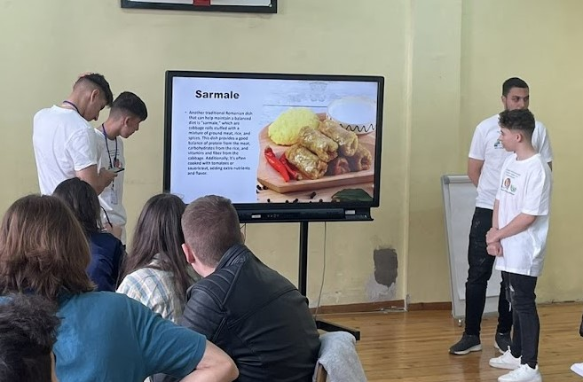

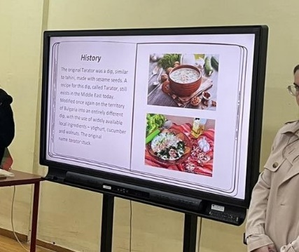

Workshop: “Recycled Art”

Teacher, Veneta Velkova, 32. SUICHE “Sveti Kliment Ohridski”, Bulgaria

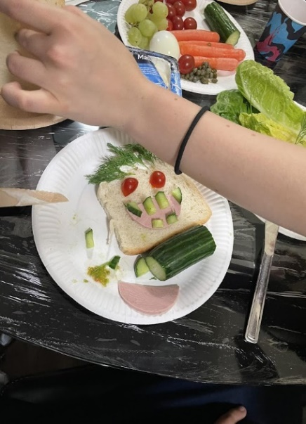
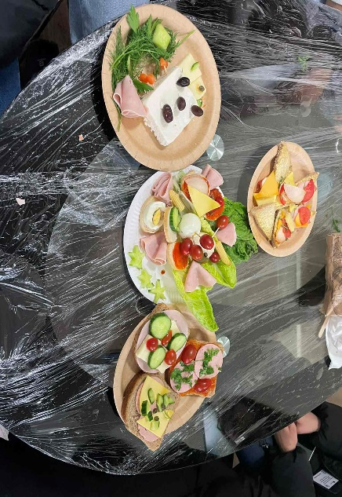
The "Recycled Art" workshop is an innovative and creative activity where students use leftover food and other recyclable materials to create works of art. This activity emphasizes the importance of sustainability, environmental awareness, and cultural exchange. By working in international groups, students enhance their collaborative skills and cultural understanding while expressing their creativity.
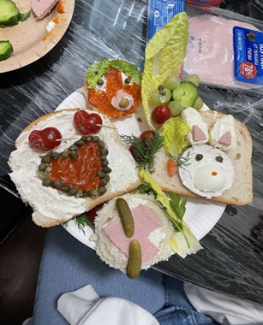

Objectives: - Promote Environmental Awareness: Teach students about the importance of recycling and reducing food waste; - Foster Creativity: Encourage students to think creatively and use unconventional materials to create art; - Enhance Collaboration: Improve teamwork and communication skills by working in international groups; - Cultural Exchange: Allow students to learn from each other’s cultural perspectives and artistic traditions; - Develop Problem-Solving Skills: Challenge students to come up with innovative solutions using limited resources.
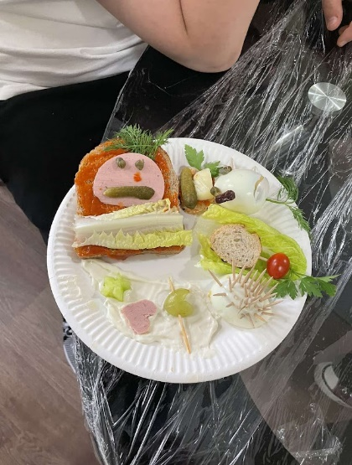
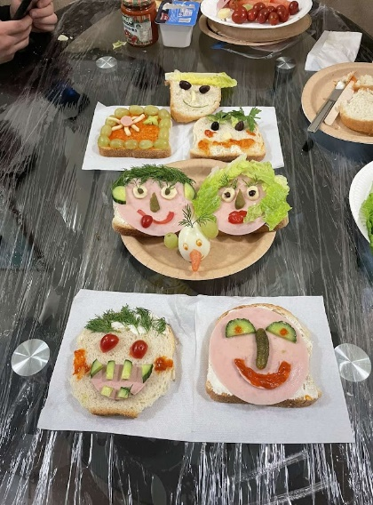
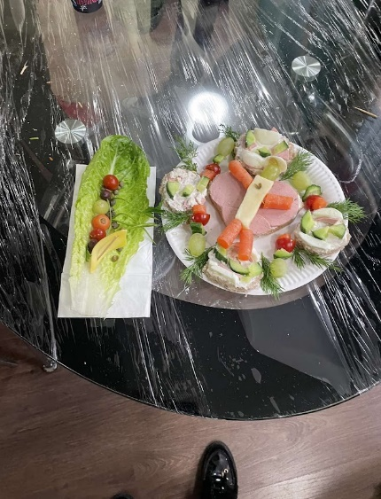

Workshop Activities: Introduction to Recycled Art, Group Formation and Brainstorming, Materials Collection, Art Creation, Presentation and Exhibition, Reflection and Feedback.
Students used leftover food to make art. They worked in international groups, creating works of art using a minimum of three objects. Students reflected on what they learned during the workshop, the challenges they faced, and how they overcame them.
The conclusion we made: By incorporating the "Recycled Art" workshop into school lessons, students will engage in a meaningful, hands-on activity that promotes sustainability, creativity, and cultural exchange. This workshop not only educates students about the importance of recycling but also encourages them to think creatively and work collaboratively in a diverse, international setting.

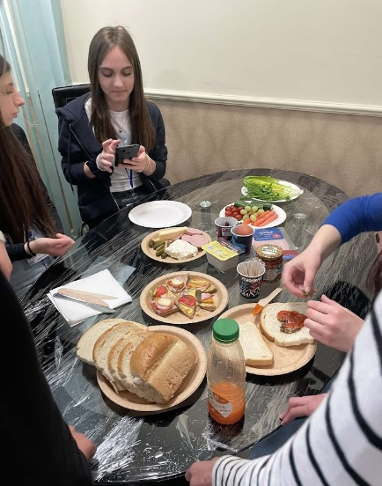
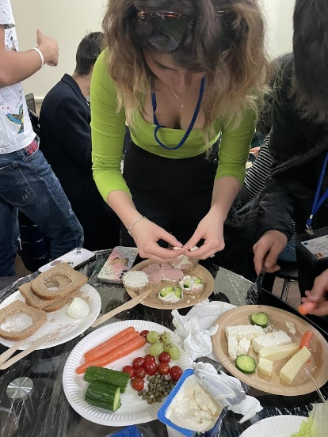

Thematic visit to Koprivshtitsa. Visiting the Museum of bread.
Workshop

Teacher,Veneta Velkova, 32. SUICHE “Sveti Kliment Ohridski”, Bulgaria

We had a culinary journey like no other at the Museum of Bread in Koprivshtitsa, Bulgaria! We immersed ourselves in the rich history and flavours of traditional Bulgarian bread-making, where every loaf tells a story. From ancient techniques to modern innovations, we witnessed the artistry behind every crust.
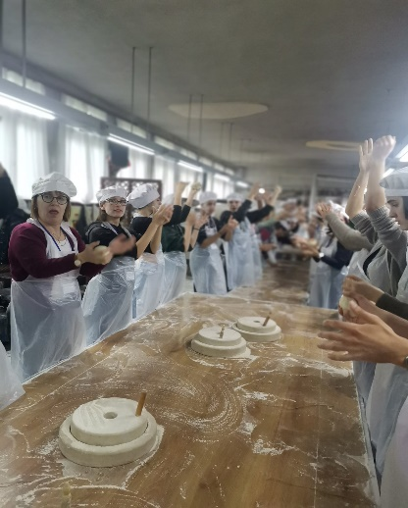
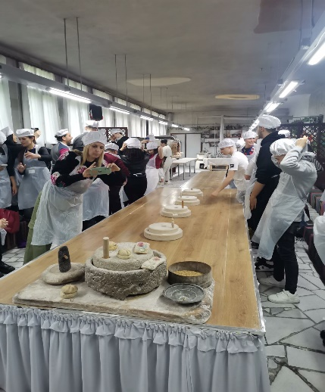
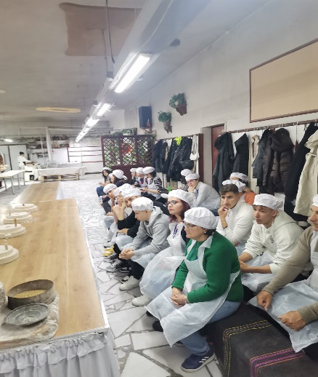

The museum was created by the Culinary Historian Academy, in it, among other commercial activities, everyone can learn about the types of bread that were once made, about the path of bread from wheat, through mills, flour, kneading and baking. We learned what a simid is, a samun, what a
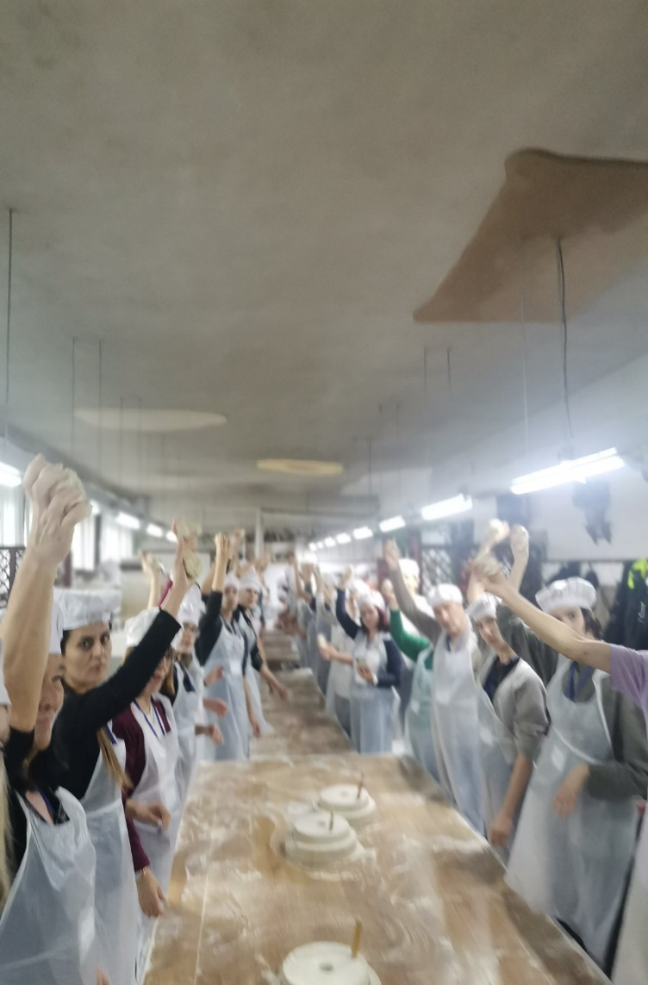
chromel is and how wheat was once manually ground with it. Wheat was ground with chromel long before mills.
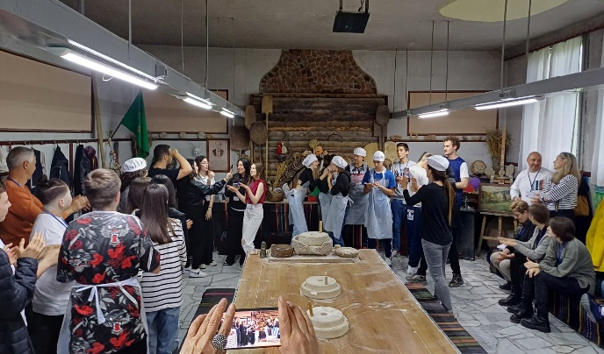

We understood how much effort was needed to grind wheat and get a handful of flour from it. How much more is needed for a sandwich, for example, which children receive in a hurry and without having known until now about the path of the bread from the grain to the slice.
At the Museum of Bread and Traditional Foods in Koprivshtitsa, at the Culinary Historian Academy and Bread House Koprivshtitsa, we experienced the making of bread. We baked Thracian bread with sprouted spelled in the museum's oven. We also learned how to plant herbs and vegetables in the museum garden.

“Life needs to be healthy”

Outdoor activities in the Mountain Vitosha and around Lake Pancharevo. Observation of the biodiversity. Workshop – using digital tools to identify different plant species.

Veneta Velkova, 32. SUICHE “Sveti Kliment Ohridski”, Bulgaria

The "Life Needs to be Healthy" initiative aimed to blend physical activity, environmental education, and digital literacy through engaging outdoor activities in Mountain Vitosha and around Lake Pancharevo. This program focused on observing biodiversity and using digital tools to identify various plant species, fostering a deeper understanding and appreciation of the natural world among participants.
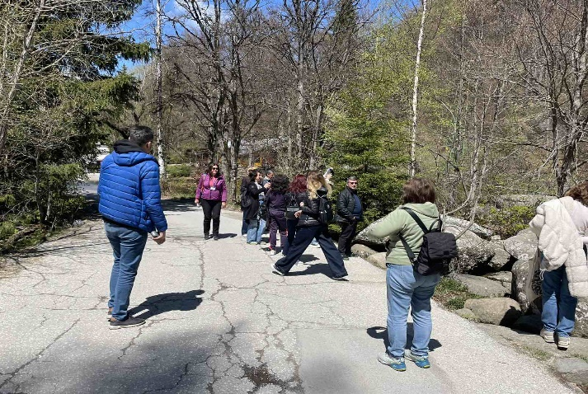

Our objectives were: - Promote Physical Activity: Encourage regular outdoor exercise through hiking and exploration; - Enhance Environmental Awareness: Educate participants about local biodiversity and the importance of conservation; - Develop Digital Literacy: Teach participants how to use digital tools for scientific observation and identification; - Encourage Teamwork and Collaboration: Strengthen social bonds through group activities and workshops.

Activities organised: Hiking and Biodiversity Observation to promote physical health and biodiversity awareness. We organized guided hikes through Mountain Vitosha and around Lake Pancharevo. Our guides (Mrs Eva Radeva and Mrs Radina Romanova) pointed out various plant species, birds, and other wildlife, discussing their ecological roles.
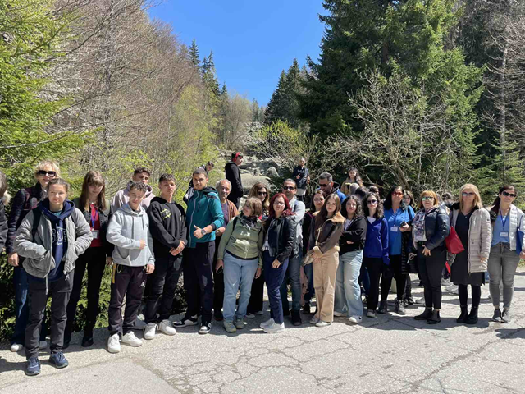

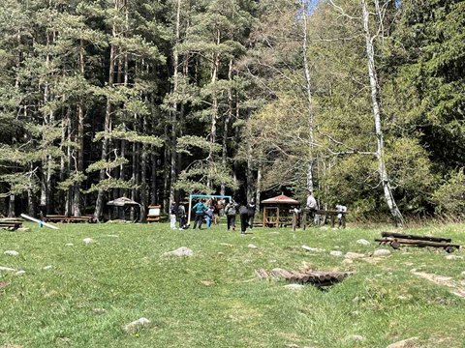
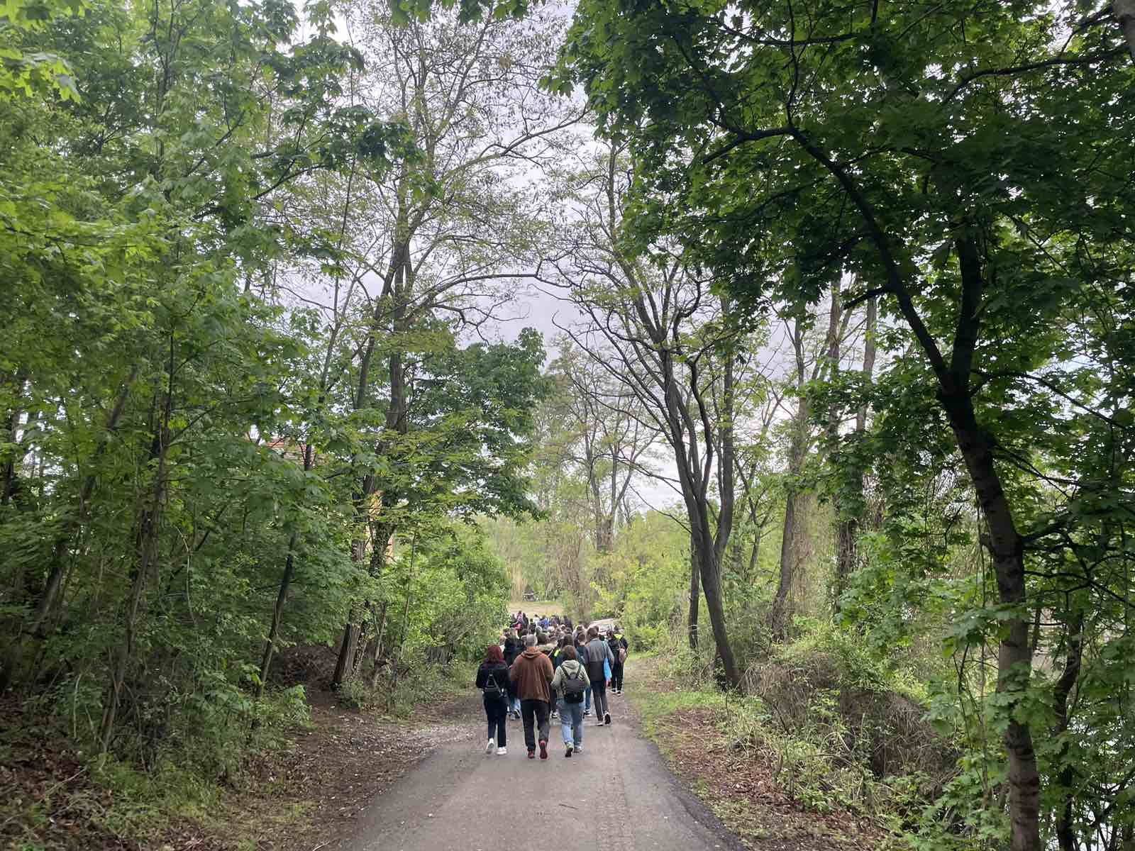

A workshop was conducted introducing participants to various digital tools and apps (e.g., PlantNet, iNaturalist, PlantSnap) for identifying plant species. We demonstrated how to use these tools effectively. The aim was to develop digital literacy and scientific observation skills.
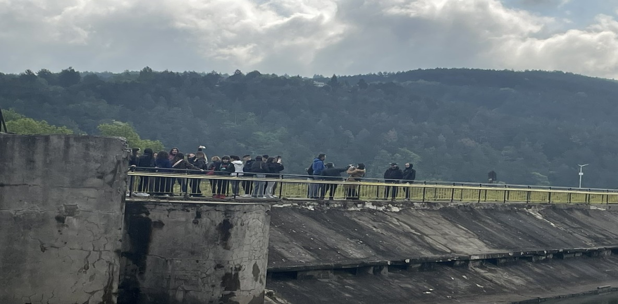

Biodiversity and Conservation Education to enhance understanding of local ecosystems and conservation efforts. We arranged short educational talks about the biodiversity of Mountain Vitosha and Lake Pancharevo, focusing on conservation strategies and challenges.

By integrating these activities into the "Life Needs to be Healthy" program, participants gained a holistic understanding of the interconnectedness of physical health, environmental stewardship, and digital literacy, all while enjoying the natural beauty of Mountain Vitosha and Lake Pancharevo.

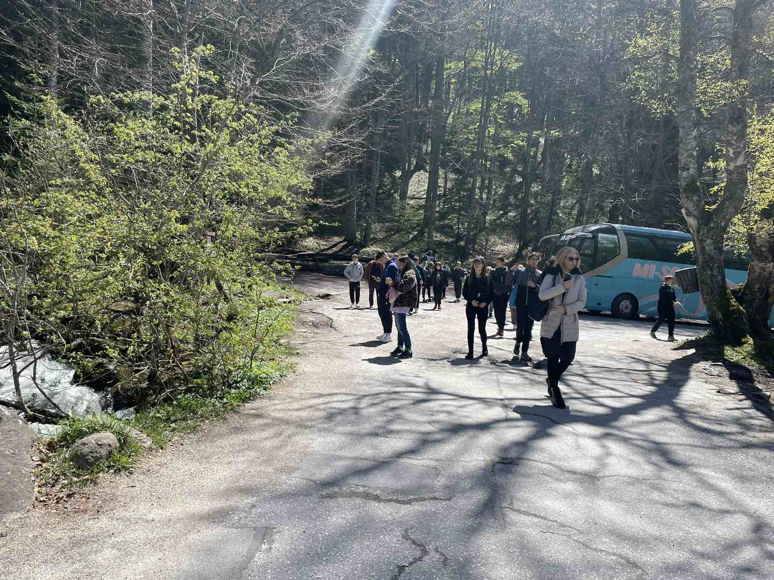

"We can Make a Difference!”
Workshop: Global Warming - Educate Yourself

Veneta Velkova, 32. SUICHE “Sveti Kliment Ohridski”, Bulgaria

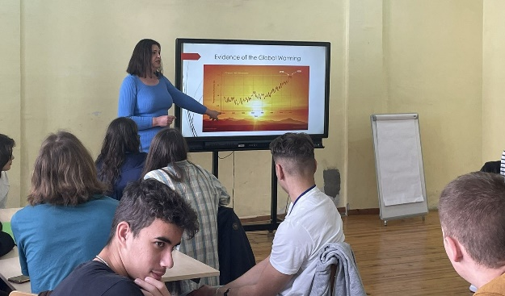
This workshop aimed to educate participants about global warming, its causes, impacts, and the actions individuals and communities can take to combat it. Through presentations and discussions, participants gained a comprehensive understanding of global warming and were empowered to make a difference.
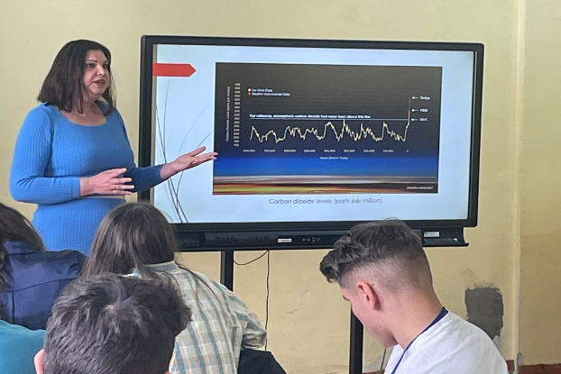
The students were divided in international teams that worked together to reach common decisions about actions to be taken and solutions to be made. The workshop was led by Mrs Eva Radeva. She provided a foundational explanation of global warming, using diagrams, videos, and animations to illustrate the evidence of global warming. Questions for discussion were put: What are the main human activities contributing to global warming? How can we observe its effects in our daily lives? After the discussions 5 presentations were prepared and shown to the participants.
The conclusions at the end of the workshop were:
“Global warming may be a big problem, but there are many little things we can do to make a difference. If we try, most of us can do our part to reduce the amount of greenhouse gases that we put into the atmosphere. Many greenhouse gases come from things we do every day. As we have learned, these greenhouse gases trap energy in the atmosphere and make the Earth warmer.”
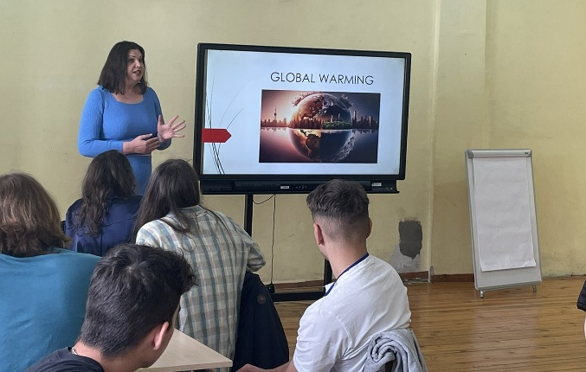
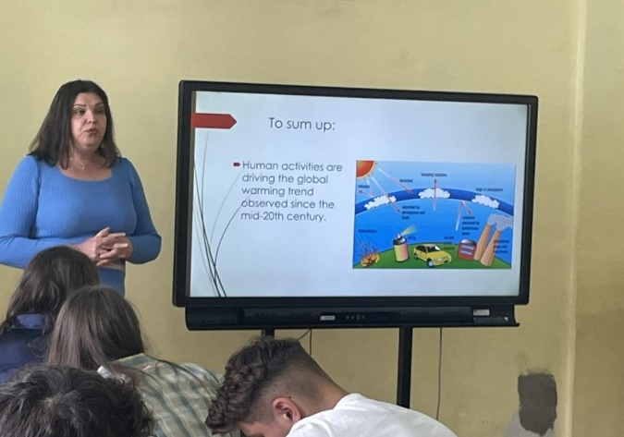
“Learning about the environment is very important; Save Electricity; Use Bike, Bus, and Walk; Plant Trees; Recycle.”

"We Can Make a Difference!” How to Teach Global Warming

Teaching global warming effectively requires a comprehensive approach that integrates scientific understanding, critical thinking, and active participation. The participants teachers worked together on the topic and prepared a structured guide on how to teach global warming to various audiences, with a focus on engaging and impactful methods.
1. Introduction to Global Warming
Objective: Provide a foundational understanding of global warming.
Activities: - Interactive Lecture: Explain the greenhouse effect, sources of greenhouse gases, and the evidence for global warming.

Visual Aids: Use diagrams, videos, and animations to illustrate how greenhouse gases trap heat in the atmosphere.

Discussion Questions: What are the main human activities contributing to global warming? How can we observe its effects in our daily lives?

2. Understanding the Science

Objective: Dive deeper into the scientific principles behind global warming.

Activities: - Hands-On Experiments: Conduct simple experiments to demonstrate the greenhouse effect, such as the “bottle experiment” with CO₂ and heat lamps;

Data Analysis: Analyze real climate data to understand trends in global temperatures, CO₂ levels, and other indicators.

3. Case Studies on Global Warming Impacts

Objective: Examine the real-world consequences of global warming.

Activities: - Group Projects: Assign students to research and present case studies on topics such as melting glaciers, sea-level rise, extreme weather events, and impacts on agriculture; - Role-Playing Simulations: Conduct simulations where students represent different stakeholders (e.g., government officials, farmers, scientists) to discuss responses to global warming impacts; - Field Trips: Visit local sites affected by climate change or organizations working on climate solutions.

4. Personal and Community Actions

Objective: Empower individuals to take actionable steps to combat global warming.

Activities: - Lifestyle Audits: Have students calculate their carbon footprints and identify ways to reduce them; - Eco-Challenges: Organize challenges to promote sustainable practices, such as reducing single-use plastics, conserving energy, or using public transportation; - Campaigns: Encourage students to create campaigns advocating for policy changes or raising awareness about global warming.

5. Using Digital Tools

Objective: Leverage technology to enhance understanding and engagement.

Activities: - Educational Apps: Introduce apps and online platforms that provide interactive learning experiences about climate change; - Virtual Reality: Use VR experiences to immerse students in environments affected by global warming; - Social Media Projects: Develop social media campaigns to share knowledge and inspire action on climate change.

6. Feedback and Reflection

Objective: Ensure continuous improvement and personal growth.

Activities: - Reflection Journals: Have students maintain journals to reflect on what they’ve learned and how they feel about global warming; - Peer Feedback: Create opportunities for students to give and receive feedback on their projects and ideas; - Surveys: Use surveys to gather feedback on the effectiveness of the lessons and activities.

7. Good Practices and Practical Examples

Objective: Learn from successful examples and replicate effective practices.

Activities: - Case Studies: Present case studies of successful climate education programs and initiatives; - Practical Projects: Showcase examples of project-based learning activities that address real-world challenges related to global warming; - Networking: Connect with other educators and organizations to share resources and ideas.

8. Conclusion

Objective: Summarize key takeaways and inspire ongoing action.

Activities: - Recap Sessions: Summarize the main points of each lesson and highlight the importance of ongoing learning and action; - Next Steps: Discuss how students can continue to learn about and take action on global warming; - Celebration: Celebrate the achievements of students and the progress made during the course.

By incorporating these elements into a curriculum, teachers can create a dynamic and engaging learning environment that not only educates but also empowers students to take meaningful action against global warming.

Themes Recap

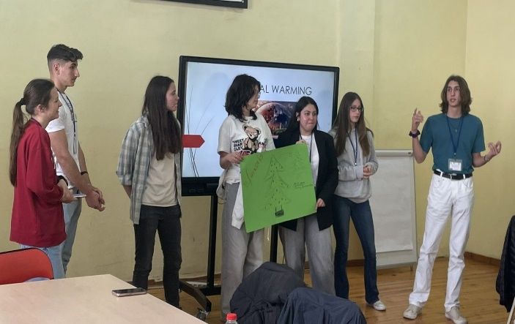
Students worked in groups to prepare presentations. Each group of students presented one theme of our meeting in a Poster in front of all the others. The session was led by Dr Dilyana Filipova.

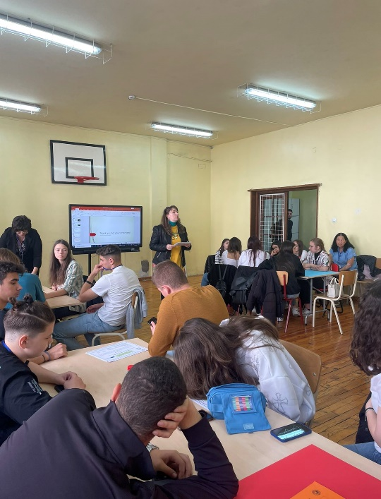

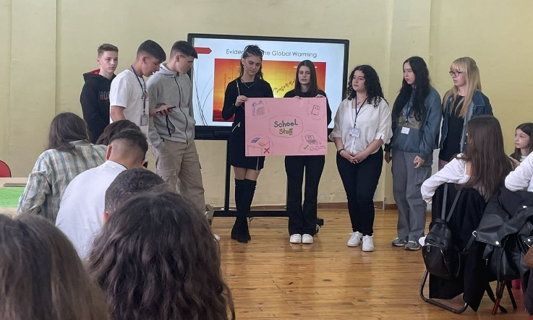

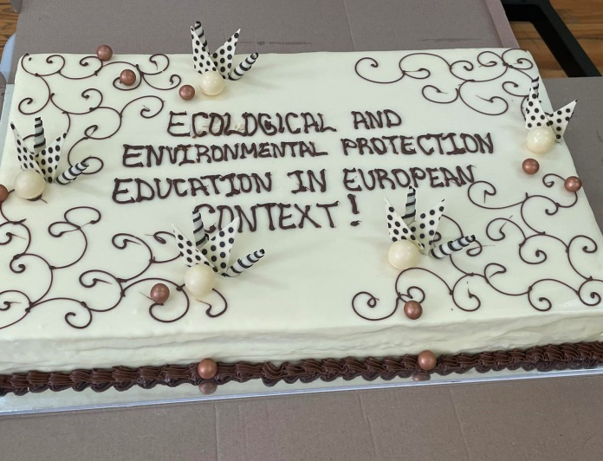
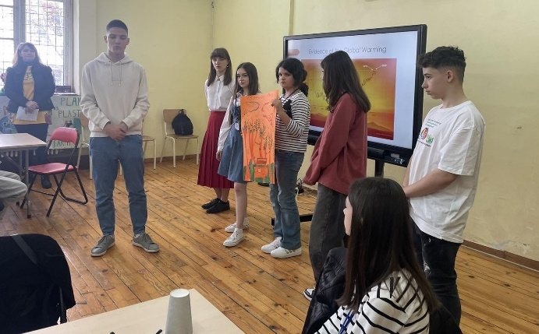
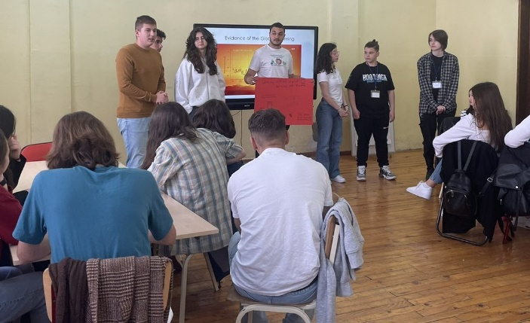

Other activities related to environmental protection

DETERMINATION OF SOIL pH USING THE DIGITAL pH meter

Teacher Georgeta MURESAN, Liceul Tehnologic Costesti, Romania

The soil is the main source of supplying plants with nutrients. We know from practice that some soils are fertile and others less so, and this depends on the ability of the soil to make nutrients and water available to plants in sufficient quantities to meet their needs. One of the factors that influence the fertility of the soil is its pH, and that's why I carried out, together with the ninth grade students, an experiment in which we determined the pH of the soil using soil samples from several localities in the south of Argeș County.
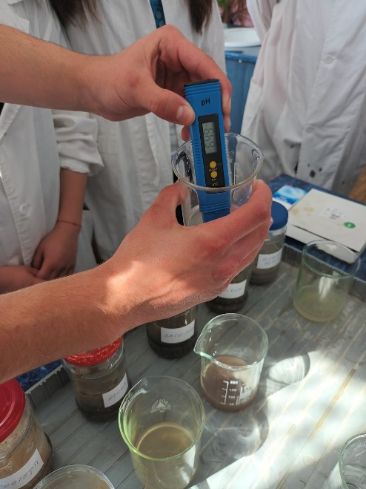
The liquid phase of the soil contains mineral substances – ions, acids, bases, salts – as well as organic substances and gases. The concentration of H+ and OH‒ ions in the soil solution determines the state of the acidic, basic or neutral reaction, which is conventionally expressed by pH. The acidity of the soil has an influence on the mobility of nutrient ions because on acidic soils their retention capacity decreases, instead on these soils hardly soluble compounds as well as substances that are toxic to plants are fixed more strongly. Neither a basic pH is beneficial for plants because in this case the fixing power of some nutrients increases, and the plants cannot assimilate them.
To conduct the experiments, the students brought soil samples from their home gardens. I mixed the soil with distilled water, then allowed the mixture to settle and filtered the solution. With the help of the digital pH-meter I determined the pH value for each case, and I put the obtained results on a map.
Next, with the help of the data from the attached table, we determined which crops grow best on each of the analyzed soils.

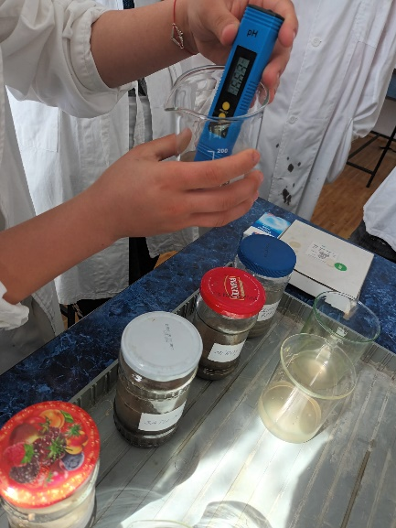
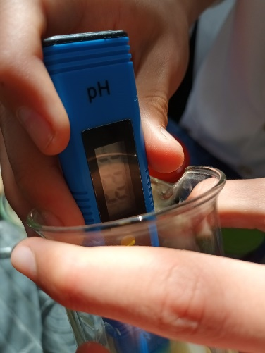
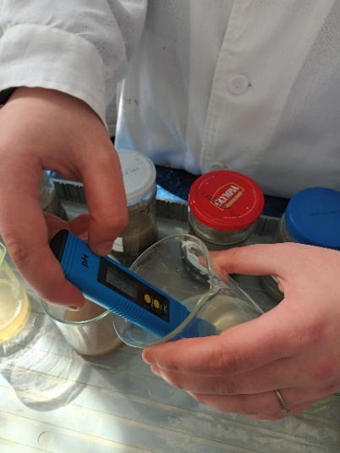

Soil pH map for several localities in the south of Argeș county

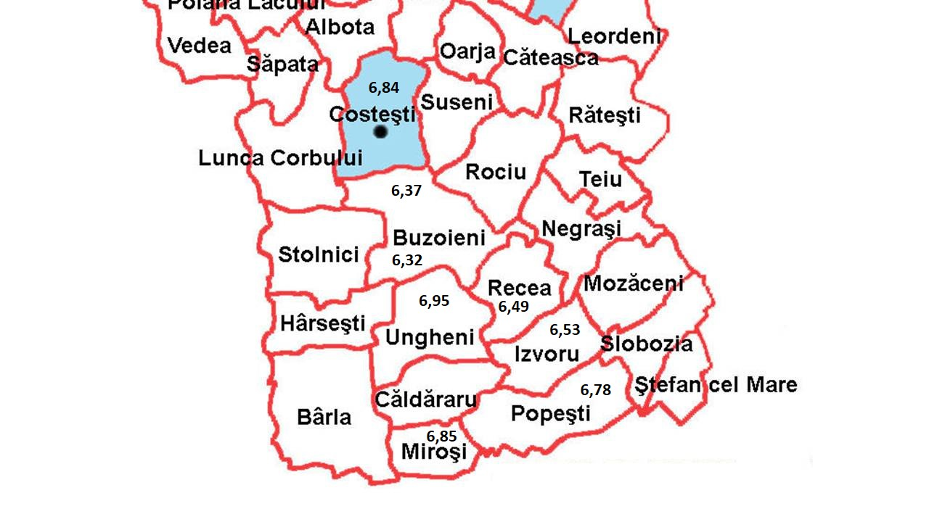

Plants grown in our country and the soil pH on which they grow best

In agriculture, soil pH measurement is often very useful in practice and in agrochemical research.

Planta | pH
 | 4,5 | 5 | 5,5 | 6 | 6,5 | 7 | 7,5 | 8 | 8,5 | 9 | 9,5 | 10
Potato
Oat
Rye
Beans
Green peas
Wheat
Maize
Barley
Tomato
Pumpkins
Cabbage
Cucumber
Carrot
Leek
Red cabbage
Citrus
Apple
Agris
Cultivated chestnut
Raspberry tree

PET WASTE RECYCLING

Teacher, Alexandra OPREA, Liceul Tehnologic Costesti, Romania

The purpose of the project:
The activities in this program aim to inform and document the students about the environmental problems generated by waste, the selective collection of waste and their delivery to local collection centers in order to be introduced into the recycling circuit.

The general objective of the project:
- the students' awareness of the environmental problems generated by packaging and waste from packaging (plastic waste and PET type packaging) and educating students in the spirit of environmentally friendly behavior, by directly participating in the collection of waste and handing it in for recycling and capitalization.

Target group:
Students from the Costeşti Technological High School, guided by the teaching staff and aimed at carrying out instructive-educational activities, with the aim of informing, educating and raising awareness of the students in relation to the impact of waste on the environment.

The objectives of the activities:
- involvement of students in selective waste collection activities on a voluntary basis;
- making students responsible for the selective collection of waste that contributes to the protection of nature and natural resources;
- promotion of volunteering;
- awareness of the importance of recycling and waste recovery.
- creating a cleaner and healthier environment for today's and tomorrow's generation;
- to act in the sense of selective collection and controlled storage of reusable materials by establishing a collection point for reusable materials.

